**Hackathon Challenge – DevOps Track**

**Duration:**

5-8 Hours

**Prerequisites:**

Azure Fundamentals

**Technologies**

[Azure DevOps, Azure Boards, Azure Pipelines, Azure Repos, Azure Artifacts, Azure Test Plans, Extension Marketplace](https://docs.microsoft.com/en-us/azure/devops/user-guide/what-is-azure-devops?view=azure-devops)

Table of Contents

Notes to Participants 5

Setup Hackathon Environment 6

Claim your Hackathon Credentials 6

Claim your Azure Passcode 7

Claim your Lab Service – Virtual Machine Credentials 8

Challenge 01 – Get Started with Azure DevOps 12

Task 01: Create an Azure DevOps organization 12

Create an Azure DevOps organization 12

Create an organization 13

Setup Organization Billing 14

Task 02: Set up Azure Boards using the Basic process 17

Create a Project 17

Create a team 18

Create the board 19

Define a sprint 20

Task 03: Setup the Environment 22

Run the template 22

Task 04: Plan a sprint using Delivery Plans 23

Install the Marketplace extension 23

Create a delivery plan 23

Add schedule milestone markers 24

Optimize the work schedule 25

Challenge 02: Build applications with Azure DevOps 28

Task 01: Get the sample application 28

Prepare Visual Studio Code 28

Configure Git 29

Get the source code 29

Create a fork 30

Clone your fork locally 30

Set the upstream remote 31

Open the project in the file explorer 31

Build and run the web app 32

Verify the application is running 32

Task 02: Set up your Azure DevOps environment 34

Run the template 34

Set your project's visibility 34

Move the work item to Doing 35

Task 03: Create a build pipeline with Azure Pipelines 38

Create the pipeline 38

Publish the result to the pipeline 44

Build multiple configurations by using templates 50

Task 04: Implement a code workflow in your build pipeline by using Git and GitHub 57

Set up your Azure DevOps environment 57

Create a pull request 65

Push a change through the pipeline 71

Push your local branch again 76

Add a build badge 77

Track your build history 79

Add a rule to require a review 81

Task 05: Run quality tests in your build pipeline by using Azure Pipelines 86

Set up your Azure DevOps environment 86

Add unit tests to your application 93

Add a testing widget to your dashboard 102

Perform code coverage testing 103

Fix a failed test 112

Task 06: Manage build dependencies with Azure Artifacts 123

Plan build dependencies for your pipeline 123

Set up your Azure DevOps environment 123

Get the Azure DevOps project 123

Create a package feed in Azure Artifacts 130

Reference the package from the application 136

Push a change to your package 139

Challenge 03: Deploy applications with Azure DevOps 145

Task 01: Create a release pipeline in Azure Pipelines 145

Set up your environment 145

Deploy the web application to Azure App Service 153

Create the dev environment 158

Monitor the health of your pipeline 163

Clean up Azure resources 164

Disable the pipeline 165

Task 02: Create a multistage pipeline by using Azure Pipelines 166

Set up your Azure DevOps environment 166

Run the template 166

Promote to the Dev stage 180

Promote to the Test stage 185

Promote to Staging 189

Clean up Azure resources 197

Disable the pipeline 199

Task 03: Run functional tests in Azure Pipelines 201

Set up your Azure DevOps environment 201

Run the UI tests locally and in the pipeline 215

Move the work item to Done 225

Disable the pipeline 225

Task 04: Run nonfunctional tests in Azure Pipelines 227

Set up your Azure DevOps environment 227

Run load tests in Azure Pipelines 240

Clean up Azure resources 248

Disable the pipeline 250

# Notes to Participants

Each Participants will be assigned dedicated Subscription and Resource Group. All the resources should be created under allocated Resource Group.

**Do not delete your Resource Group in order to clear the Resources. Deleting Resource Group will not allow you to continue your task.**

You need to replace your Employee ID with <<employeeId>> in small case for the resource name wherever mentioned.

For example, if your employee ID is **E123456** then you have to replace **SimpleVM<<employeeId>>** with **SimpleVMe123456** in order to create your Virtual Machine.

**Any unauthorised use of any resources other than mentioned in this document will leads to termination of your account and all the resources you have created will be deleted automatically.**

**Your account will not be activated once it got terminated any reason.**

# Setup Hackathon Environment

Please follow the below instruction carefully while setting up the Hackathon environment.

## Claim your Hackathon Credentials

You can claim your Azure passes from the below URL,

1. Navigate to <https://mshk2021.azurewebsites.net/hackathon/tcs/oct2021/devops>

**Note:**

Above URL will be active only during the Hackathon dates and have only limited number of credentials.

Make a note on the credentials separately in your local computer.

1. Enter your official email id and click Submit to claim your credentials

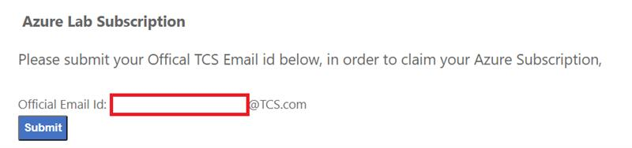

1. Note down the credentials allotted you

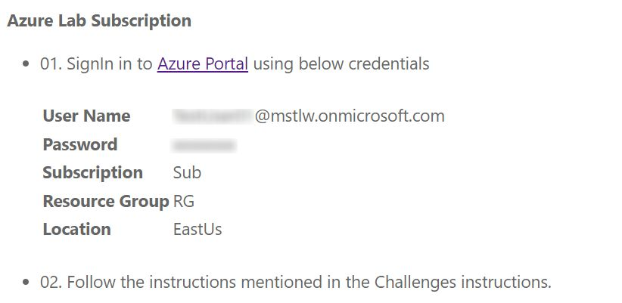

**Note:**

The Azure subscription credentials are subjected to availability. You will see following message in the website if all the available credentials are claimed.

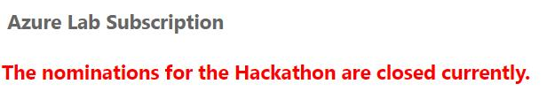

Hackathon are time bound and credentials are available only during the hackathon period. You can’t claim credentials before or after hackathon period and you will see the following message in the website.



## Claim your Azure Passcode

1. Open a browser and navigate to: www.microsoftazurepass.com

**It is recommended you close all browsers and open a new In-Private Browser session. Other log-ins can persist and cause errors during the activation step.**



1. Click the start button to get started.
2. You need to enter your user id claimed in last step (**For e.g.** [**xyz@mstlw.onmicrosoft.com**](mailto:xyz@mstlw.onmicrosoft.com)) and click “Next”. \***No corporate email ids or personal can be used to Sign in**\*



1. Click “Confirm” if the correct email address is listed.



1. Enter your promo code (claimed in the last step) in the Promo code box and click “Claim Promo Code”.



1. Enter your information in **Your Profile** and Select **Sign Up**.
2. It may take up to 5 minutes to process the redemption.
3. To check you available balance and usage details, navigate to <https://www.microsoftazuresponsorships.com/>

## Claim your Lab Service – Virtual Machine Credentials

1. Navigate to the <https://labs.azure.com/register/rm8ris2b> You don't need to use the registration URL after you complete the registration. Instead, use the URL: [https://labs.azure.com](https://labs.azure.com/). Internet Explorer 11 isn't supported yet.

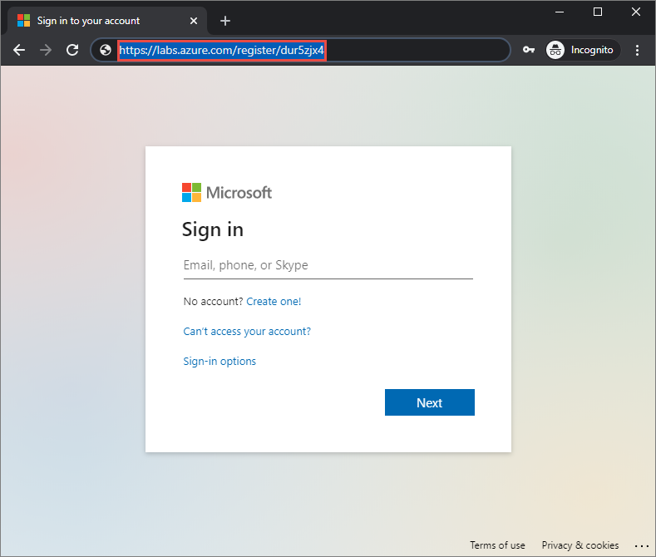

1. Sign in to the service using your azure account (xyz@mstlw.onmicrosoft.com) account to complete the registration.
2. Once registered, confirm that you see the virtual machine for the lab you have access to.

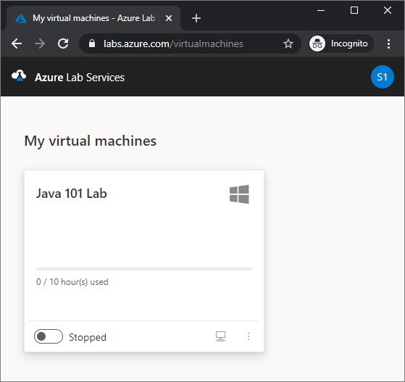

1. Wait until the virtual machine is ready. On the VM tile, notice the following fields:
   1. At the top of the tile, you see the **name of the lab**.
   2. To its right, you see the icon representing the **operating system (OS)** of the VM. In this example, it's Windows OS.
   3. The progress bar on the tile shows the number of hours used against the number of [quota hours](https://docs.microsoft.com/en-gb/azure/lab-services/how-to-configure-student-usage#set-quotas-for-users) assigned to you. This time is the additional time allotted to you in addition to the scheduled time for the lab.
   4. You see icons/buttons at the bottom of the tile to start/stop the VM, and connect to the VM.
   5. To the right of the buttons, you see the status of the VM. Confirm that you see the status of the VM is **Stopped**.

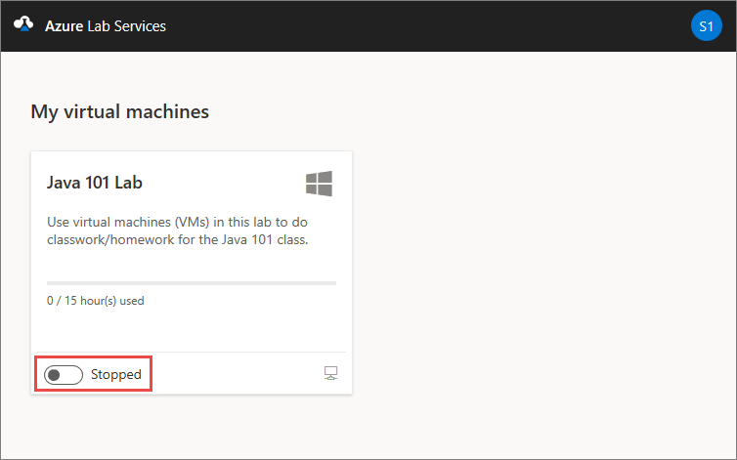

1. **Start** the VM by selecting the first button as shown in the following image. This process takes some time.

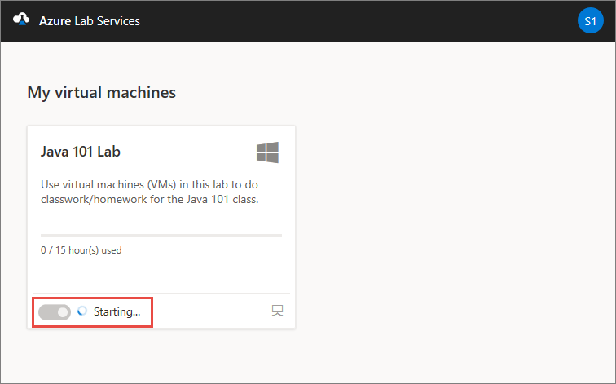

1. Confirm that the status of the VM is set to **Running**.

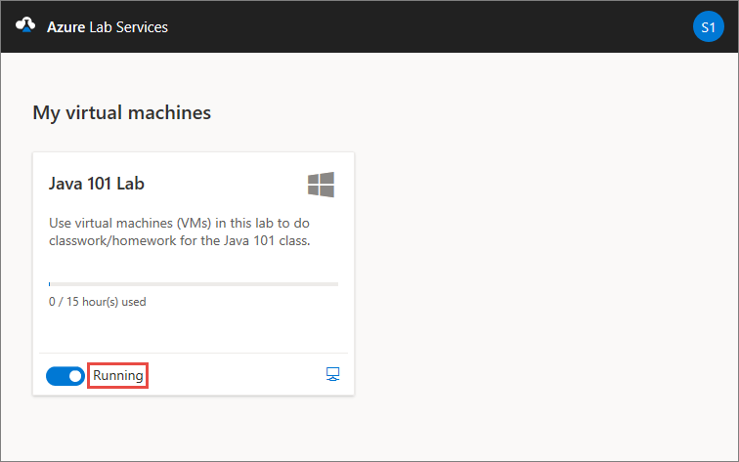

Notice that the icon of the first button changed to represent a **stop** operation. You can select this button to stop the VM.

1. Select the second button as shown in the following image to **connect** to the lab's VM.

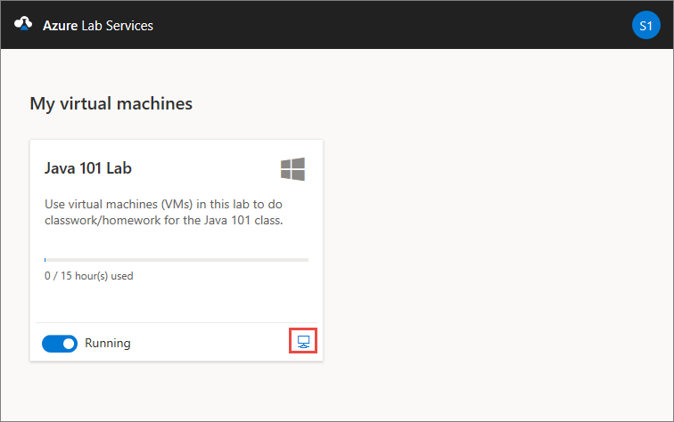

1. Save the **RDP** file to the hard disk. Open the RDP file to connect to the virtual machine. Use the following **user name** and **password** to sign in to the machine.

**User name:** vmuser

**Password:** P@$$w0rd!234

# Challenge 01 – Get Started with Azure DevOps

DevOps is the union of people, process, and products to enable continuous delivery of value to your end users. Azure DevOps is a set of services that gives you the tools you need to do just that. With Azure DevOps, you can build, test, and deploy any application, either to the cloud or on premises. DevOps practices that enable transparency, cooperation, continuous delivery and continuous deployment become embedded in your software development lifecycle.

## Task 01: Create an Azure DevOps organization

### Create an Azure DevOps organization

Follow along with the team by setting up your own free Azure DevOps organization:

1. Go to [dev.azure.com](https://dev.azure.com/).
2. Select the **Sign in to Azure DevOps**  link.

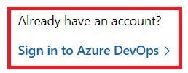

1. Sign in by using your **Microsoft azure account (**[**xyz@mstlw.onmicrosoft.com**](mailto:xyz@mstlw.onmicrosoft.com)**)** shared with you and complete the steps.

**Note:**

You may have a Microsoft account already. Typically, these end with hotmail.com or outlook.com.

1. Review the Terms of Service, Privacy Statement, and Code of Conduct, and select **Continue** if you agree to them.

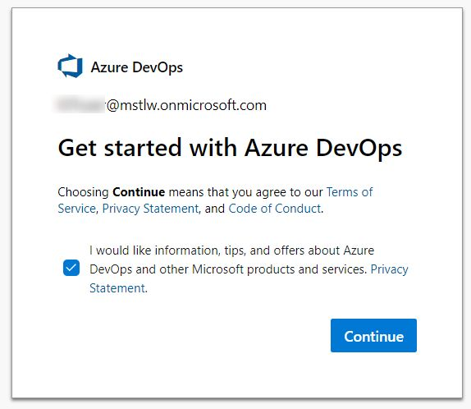

**Note:**

As the person creating the Azure DevOps organization, you will automatically become the owner. Please be considerate when deciding on your account name and avoid existing legal entities.

### Create an organization

Next, set up an organization. Here's how:

1. If you've never created an Azure DevOps organization, you'll see a window with a **Create new organization** screen.
2. In the Azure DevOps Terms of Service and Privacy notification window, select **Continue**.
3. Create an organization for the Microsoft Learn modules next to the **dev.azure.com/** field. If you're prompted that the name is already taken, just add employee id to the end to make it unique. For example, Tailspin-Org-<<employeeid>>.
4. Choose a location near you where your projects will be hosted.

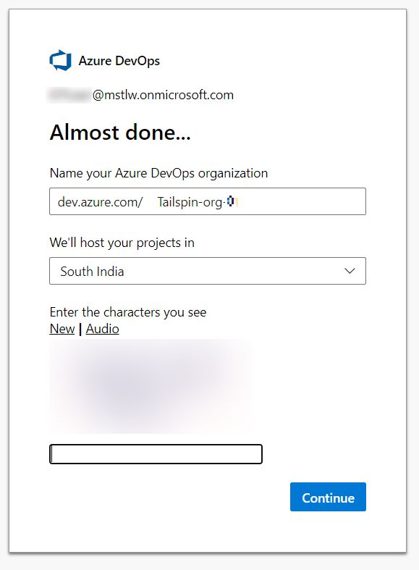

1. Select **Continue**.

### Setup Organization Billing

1. Sign in to your account at [dev.azure.com](https://dev.azure.com/).
2. Select **Organization Settings** at left bottom of the screen.

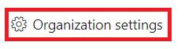

1. Select **Billing** under **General** from the left menu.
2. Select **Set up billing**

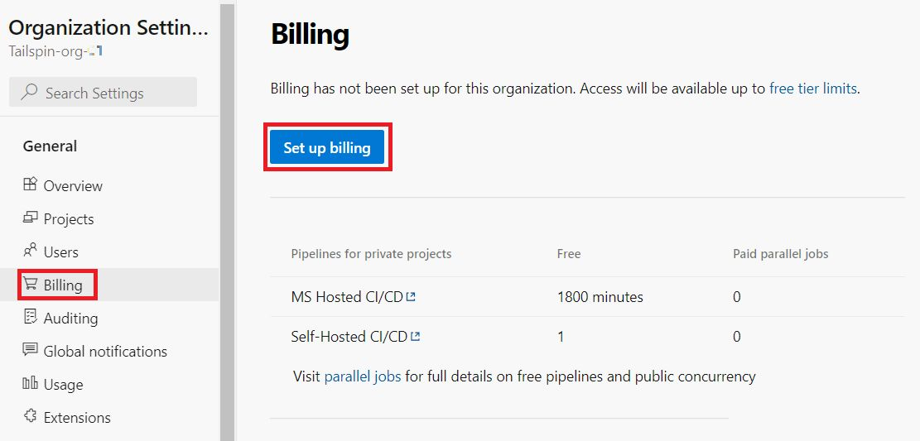

1. Under **Set up Billing,** Select the Subscription assigned to you and click **Save**.

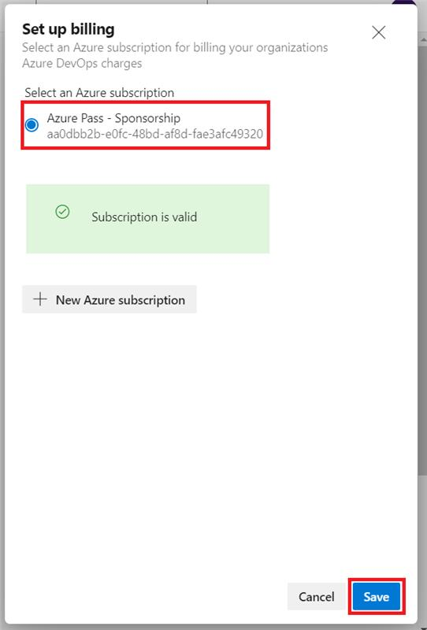

1. Change value of **MS Hosted CI/CD** under **Paid parallel jobs** to 1
2. Scroll down and Select **Save**.

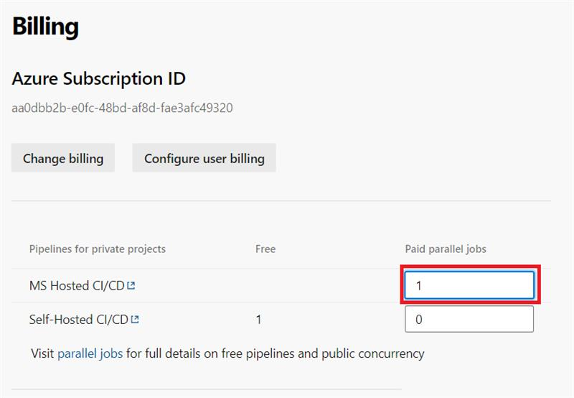

## Task 02: Set up Azure Boards using the Basic process

### Create a Project

1. Sign in to your account at [dev.azure.com](https://dev.azure.com/).
2. Select your organization.
3. If you have multiple projects, select **+ New project** or **Create a Project** dialog will open automatically.

The **Create a project** dialog box opens.

1. In the **Project name** field, enter **Space Game - web**.
2. In the **Description** field, enter **The Space Game website**.
3. Under **Visibility**, choose whether to make your project public or private. For now, you can select private.

Creators of open source projects will often choose public visibility so that others can view active issues and build status.

1. Select **Advanced**.
2. Under **Version control**, make sure that **Git** is selected. Under **Work item process**, make sure that **Basic** is selected.
3. Select **Create**.

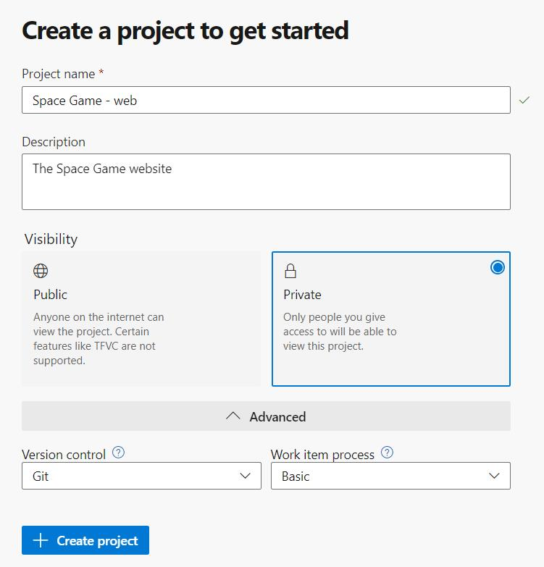

After just a few moments, you're taken to your new project.

### Create a team

Here you'll create a team for the project.

1. Select **Project settings** in the lower corner.
2. On the **Project details** page, under **General**, select **Teams**.

You see that a default team, based on the name of the project, **Space Game - web Team**, has been created. We'll use this team, but in practice you may have multiple teams that contribute to the same project.

1. Select **Space Game - web Team**.

You'll see that you're already a member of this team. Let's add more members.

.

### Create the board

1. In the column on the left, point to **Boards**, and select **Boards** from the menu that appears.
2. Select **Space Game - web Team boards**. A blank board appears.

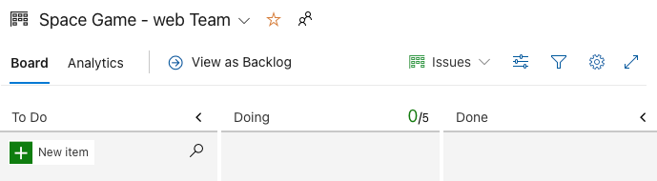

Recall that you're using the Basic process. The Basic process involves three task states: **To Do**, **Doing**, and **Done**.

If you choose a different process, such as Scrum, you'll see a layout that supports that process.

1. In the **To Do** column, select the green **+** button next to the **New item** field.
2. Enter **Stabilize the build server**, and then press Enter.
3. Select the ellipsis (**...**), and then select **Open**.
4. In the **Description** field, enter this text:

The build server keeps falling over. The OS requires security patches and updates. It's also a challenge to keep build tools and other software up to date.

1. Select **Save & Close**.
2. Follow the same steps for the next two items.

|  |  |
| --- | --- |
| **Title** | **Description** |
| Create a Git-based workflow | Migrate source code to GitHub and define how we'll collaborate. |
| Create unit tests | Add unit tests to the project to help minimize regression bugs. |

1. Drag **Stabilize the build server** to the top of the stack. Then, drag **Create a Git-based workflow** to the second item position. Your final board looks like this.

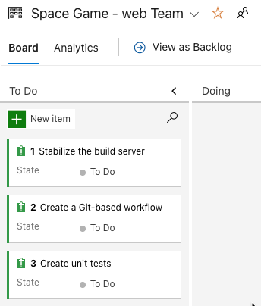

### Define a sprint

When you create an Azure Boards project, you get an initial sprint called **Sprint 1**. All you need to do is assign dates to the sprint and add tasks. Here's how to follow along with the team:

1. In the left-side column, select **Sprints**.

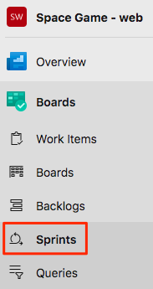

1. Select **Set dates** from the upper right.
2. Leave the name as **Sprint 1**.
3. In the **Start** date field, select the calendar and pick today's date.
4. In the **End** date field, select the calendar and pick the date two weeks from today.
5. Select **Save and Close**.

#### Assign tasks and set the iteration

An *iteration* is another name for a sprint.

You have an initial set of work items and a timeline for your first sprint. Here you'll connect work items to your sprint and assign the tasks to yourself.

1. Under **Boards**, select **Work items**.
2. Select **Stabilize the build server**.
3. In the **Iteration** dropdown, select **Sprint 1**.

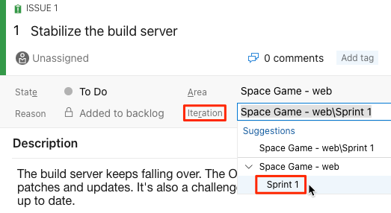

1. From the same window, select **Unassigned** and set yourself as the task owner and Click **Save**.

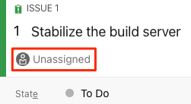

1. Repeat the process for the other two work items.
   * **Create a Git-based workflow**
   * **Create unit tests**

## Task 03: Setup the Environment

Here you make sure that your Azure DevOps organization is set up to complete the rest of this module. You set it up by running a template that creates a project in Azure DevOps.

### Run the template

Run a template that sets up your Azure DevOps organization.

[Click here to Run the template](https://azuredevopsdemogenerator.azurewebsites.net/?x-ms-routing-name=self&name=deliveryplans)

On the Azure DevOps Demo Generator site, follow these steps to run the template:

1. Select **Sign In** and accept the usage terms.
2. On the **Create New Project** page, select your Azure DevOps organization. Then enter a project name, such as *Space Game - web - Delivery plans*.

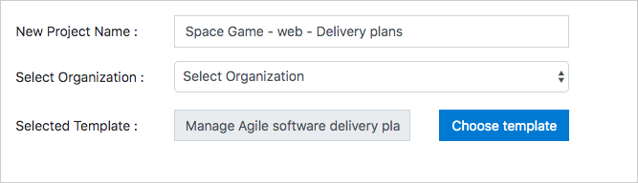

1. Select **Create Project**.

The template takes a few moments to run.

1. Select **Navigate to project** to go to your project in Azure DevOps.

## Task 04: Plan a sprint using Delivery Plans

Here you create a delivery plan and use it to plan a sprint in Azure DevOps.

To do this, you:

* Install the Delivery Plans extension.
* Create a delivery plan.
* Add team sprints and milestones.
* Rearrange work items to fit the overall schedule.

### Install the Marketplace extension

The Delivery Plans Marketplace extension provides the features needed to create and manage delivery plans. It integrates with Azure Boards to provide a seamless experience when planning work.

1. From a new browser tab, go to [marketplace.visualstudio.com](https://marketplace.visualstudio.com/).
2. On the **Azure DevOps** tab, search for "Delivery Plans".
3. Select **Delivery Plans** from the results.

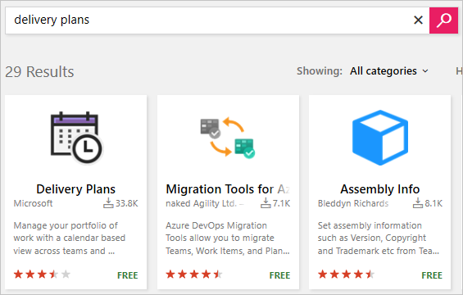

1. Select **Get it Free**.
2. Select your Azure DevOps organization from the drop-down box.
3. Select **Install**.

### Create a delivery plan

Delivery Plans adds a new **Plans** tab to Azure Boards. You can create as many delivery plans as you need to manage different aspects of your organization.

1. From Azure DevOps, navigate to your project.
2. Under **Boards**, select **Delivery Plans**.

**Important**

Ensure that you select **Delivery Plans**, and not **Plans**.

1. Select **New plan**.
2. In the form, enter these fields:
   * **Name**: *Space Game Delivery Plan*
   * Select the **Backlog items** backlog for the **Space Game Web Team**
   * Add the **Space Game Engine Team's Backlog items** backlog using the **Add team** option

Both the Web team and the Engine team share a common set of backlog items.

1. Select **Create**.

**Note**

The team project generated for this module uses the *Scrum* process and not the *Basic* process used in other modules in this learning path. While the Basic process uses *Issues*, the Scrum process uses *Backlog items*, which are functionally the same for the purposes of this module. You can use Delivery Plans with either process.

### Add schedule milestone markers

Milestone markers can be added to the delivery plan as reference points. These help you plan work within the context of significant or external dates. Let's add a few markers now. To do so:

1. Select your delivery plan.
2. In the top right toolbar, select **Settings**, and then, on the **Plan settings** pane, select **Markers**.

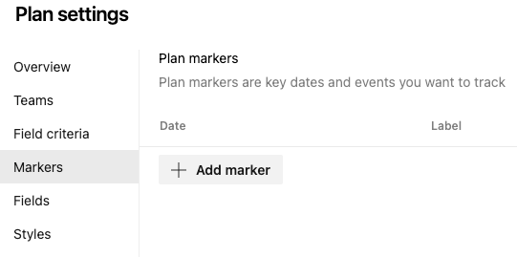

1. From the **Markers** tab, select **Add marker**.
2. In the form, enter these fields:
   * **Date**: Select a date one week from now
   * **Label**: Cliffchella
   * **Color**: Red

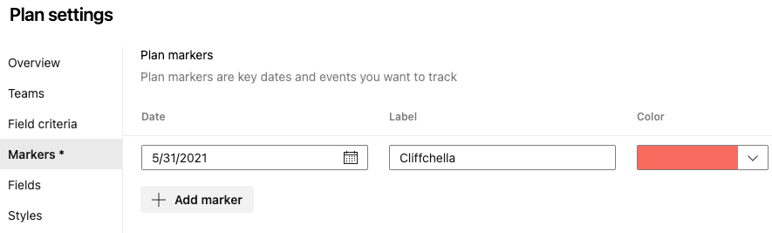

1. Repeat the process to add markers with labels, dates, and colors:
   * **Beta**: five weeks from today (blue)
   * **Annual company party**: six weeks from today (green)
2. Select **Save**.
3. Use the **Scroll calendar** and **Zoom out** controls to bring all markers into view.

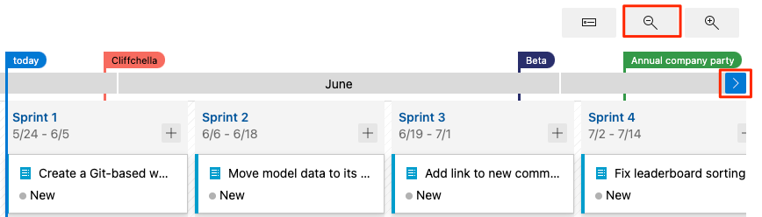

1. Select the **Beta** marker at the top of the design plan. A solid line shows the boundary of the beta milestone.

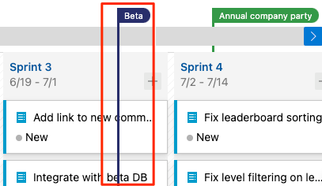

### Optimize the work schedule

1. Notice that there is a work item for the Web team to **Integrate with beta DB** that is scheduled to be completed before the beta will be ready. This will be a problem because this work item is dependent on that beta.
2. Drag the integration work item from **Sprint 3** to **Sprint 4** to ensure that its dependency will be available.
3. This change opens a significant amount of bandwidth in **Sprint 3**. Since that time is now available for productive work, drag the two **Fix** work items from **Sprint 4** back into **Sprint 3**.

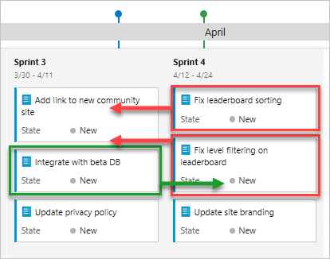

Your final sprint plan should look similar to this:

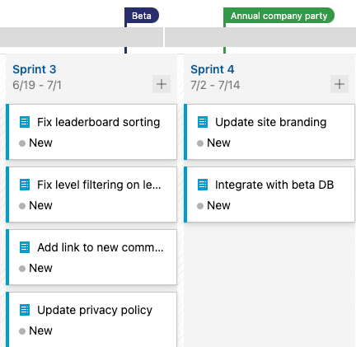

You've just completed some invaluable work that will impact the organization in a meaningful way. Management can feel confident that work will progress without foreseeable delays. And instead of waiting on dependencies to be delivered, teams will have always productive work to take on. Sure, things might change as circumstances develop, but at least now everyone knows where to go to stay up to date.

# Challenge 02: Build applications with Azure DevOps

Azure DevOps enables you to build, test, and deploy any application to any cloud or on premises. Learn how to configure build pipelines that continuously build, test, and verify your applications.

#### Prerequisites

You need to set up a development environment on your Windows, macOS, or Linux system. You need:

* An [Azure DevOps organization](https://dev.azure.com/)
* A [GitHub](https://github.com/join) account
* [Visual Studio Code](https://code.visualstudio.com/)
* [.NET 5.0 SDK](https://dotnet.microsoft.com/download/dotnet/5.0)
* [Git](https://git-scm.com/downloads)

This environment lets you complete the exercises in this and future modules. You can also use it to apply your new skills to your own projects.

**Note**

Keep in mind that you can use Azure DevOps to build and deploy almost any kind of application written in any language. In this module, you'll be working with a .NET application written in C#.

You don't need to be an expert in .NET or C# to complete this module. You can apply the patterns you learn here to your own projects that use your favorite programming languages and frameworks.

## Task 01: Get the sample application

Get ready to start building a CI pipeline with Microsoft Azure Pipelines. The first step is to build and run the *Space Game* web app on your local machine. Understanding how to build software locally will prepare you to repeat the process in the pipeline.

### Prepare Visual Studio Code

First, you'll set up Visual Studio Code so you can build the website locally and work with source files.

Visual Studio Code comes with an integrated terminal, so you can edit files and work from the command line all from one place.

1. Start Visual Studio Code.
2. On the **View** menu, select **Terminal**.
3. In the dropdown, select **bash**:

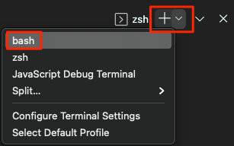

The terminal window lets you select any shell that's installed on your system, like Bash, Zsh, and PowerShell.

Here, you'll use Bash. Git for Windows provides Git Bash, which makes it easy to run Git commands.

**Note**

On Windows, if you don't see **bash** listed as an option, make sure you've installed [**Git**](https://git-scm.com/downloads) and then restart Visual Studio Code.

If you still don't see the **bash** option, see [**Integrated Terminal**](https://code.visualstudio.com/docs/editor/integrated-terminal) to manually configure your terminal settings.

1. To navigate to the directory you want to work from, like your home directory (~), run the cd command. You can select a different directory if you want.

cd ~

### Configure Git

If you're new to Git and GitHub, to associate your identity with Git and authenticate with GitHub, you'll first need to run a few commands.

[Set up Git](https://help.github.com/articles/set-up-git) explains the process in greater detail.

At a minimum, you'll need to complete the following steps. From the Visual Studio Code integrated terminal, run these commands.

1. [Set your username](https://help.github.com/articles/setting-your-username-in-git).
2. [Set your commit email address](https://help.github.com/articles/setting-your-commit-email-address-in-git).
3. [Cache your GitHub password](https://help.github.com/articles/caching-your-github-password-in-git).

**Note**

If you're already using two-factor authentication with GitHub, [**create a personal access token**](https://help.github.com/articles/creating-a-personal-access-token-for-the-command-line), and use your token in place of your password when prompted later.

Treat your access token like you would a password. Keep it in a safe place.

### Get the source code

Now, you'll get the source code from GitHub and set up Visual Studio Code so that you can run the app and work with source code files.

### Create a fork

The first step is to fork the *Space Game* web project so you can work with and modify the source files.

A *fork* is a copy of a GitHub repository. The copy exists in your account and enables you to make any changes you want without affecting the original project.

Although you can propose changes to the original project, here, you'll work with the *Space Game* web project as though it were the original project owned by different team.

To fork the *Space Game* web project into your GitHub account:

1. In a web browser, go to [GitHub](https://github.com/), and sign in.
2. Go to the [Space Game](https://github.com/MicrosoftDocs/mslearn-tailspin-spacegame-web) web project.
3. Select **Fork**:

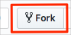

1. To fork the repository into your account, follow the instructions.

### Clone your fork locally

You now have a copy of the *Space Game* web project in your GitHub account. Now you'll download, or *clone*, a copy to your computer so you can work with it.

A clone, just like a fork, is a copy of a repository. When you clone a repository, you can make changes, verify they work as you expect, and then upload those changes back to GitHub. You can also synchronize your local copy with changes other authenticated users have made to GitHub's copy of your repository.

To clone the *Space Game* web project to your computer:

1. Go to your fork of the *Space Game* web project on GitHub.
2. Select **Code**. Then, from the **HTTPS** tab, select the button next to the URL that's shown to copy the URL to your clipboard.

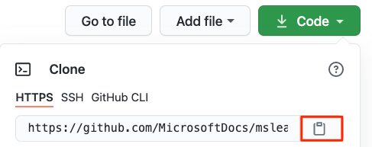

1. In Visual Studio Code, go to the terminal window, and run the git clone command. Replace the URL that's shown here with the contents of your clipboard:

git clone https://github.com/your-name/mslearn-tailspin-spacegame-web.git

1. Move to the mslearn-tailspin-spacegame-web directory. This is the root directory of your repository.

cd mslearn-tailspin-spacegame-web

### Set the upstream remote

A *remote* is a Git repository where team members collaborate (like a repository on GitHub). Here you list your remotes and add a remote that points to Microsoft's copy of the repository so that you can get the latest sample code.

1. To list your remotes, run this git remote command.

git remote -v

You see that you have both fetch (download) and push (upload) access to your repository:

origin https://github.com/username/mslearn-tailspin-spacegame-web.git (fetch)

origin https://github.com/username/mslearn-tailspin-spacegame-web.git (push)

*Origin* specifies your repository on GitHub. When you fork code from another repository, it's common to name the original remote (the one you forked from) as *upstream*.

1. To create a remote named *upstream* that points to the Microsoft repository, run this git remote add command.

git remote add upstream https://github.com/MicrosoftDocs/mslearn-tailspin-spacegame-web.git

1. Run git remote a second time to see the changes:

git remote -v

You see that you still have both fetch (download) and push (upload) access to your repository. You also now have fetch access from the Microsoft repository:

origin https://github.com/username/mslearn-tailspin-spacegame-web.git (fetch)

origin https://github.com/username/mslearn-tailspin-spacegame-web.git (push)

upstream https://github.com/MicrosoftDocs/mslearn-tailspin-spacegame-web.git (fetch)

### Open the project in the file explorer

In Visual Studio Code, your terminal window points to the root directory of the *Space Game* web project. To view its structure and work with files, from the file explorer, you'll now open the project.

1. The easiest way to open the project is to reopen Visual Studio Code in the current directory. To do so, run the following command from the integrated terminal:

code -r .

You see the directory and file tree in the file explorer.

1. Reopen the integrated terminal. The terminal places you at the root of your web project.

If the code command fails, you need to add Visual Studio Code to your system PATH. To do so:

1. In Visual Studio Code, select F1 or select **View** > **Command Palette** to access the command palette.
2. In the command palette, enter *Shell Command: Install 'code' command in PATH*.
3. Repeat the previous procedure to open the project in the file explorer.

### Build and run the web app

Now that you have the web app, you can build and run it locally.

1. In Visual Studio Code, navigate to the terminal window, and to build the app, run this dotnet build command.

dotnet build --configuration Release

**Note**

If the dotnet command is not found, review the prerequisites at the start of this module. You may need to install the .NET SDK.

.NET projects typically come with two build configurations: Debug and Release. Debug builds aren't optimized for performance. They make it easier for you to trace through your program and troubleshoot issues. Here, you select the Release configuration just to see the web app in action.

1. From the terminal window, to run the app, run this dotnet run command.

dotnet run --configuration Release --no-build --project Tailspin.SpaceGame.Web

.NET solution files can contain more than one project. The --project argument specifies the project for the *Space Game* web app.

### Verify the application is running

In development mode, the *Space Game* web site is configured to run on port 5000.

From a new browser tab, to see the running app, navigate to http://localhost:5000.

You see this:

#### Verify the application is running

In development mode, the *Space Game* web site is configured to run on port 5000.

From a new browser tab, to see the running app, navigate to http://localhost:5000.

You see this:

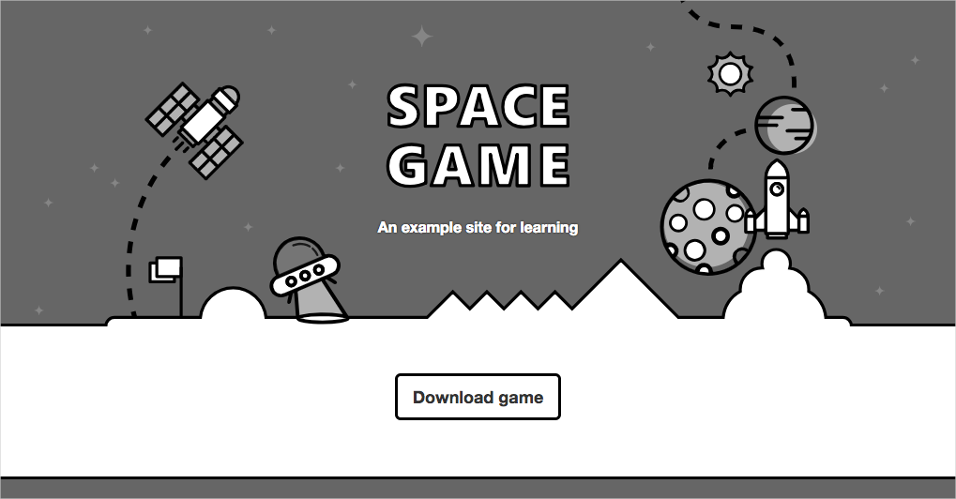

**Tip**

If you see an error in your browser that's related to a privacy or certificate error, to stop the running app, select Ctrl+C from your terminal.

Next, run dotnet dev-certs https --trust and select **Yes** when prompted. For more information, [**see this blog post**](https://www.hanselman.com/blog/DevelopingLocallyWithASPNETCoreUnderHTTPSSSLAndSelfSignedCerts.aspx).

After your computer trusts your local SSL certificate, to see the running app, run the dotnet run command a second time and go to http://localhost:5000 from a new browser tab.

You can interact with the page, including the leaderboard. When you select a player's name, you see details about that player.

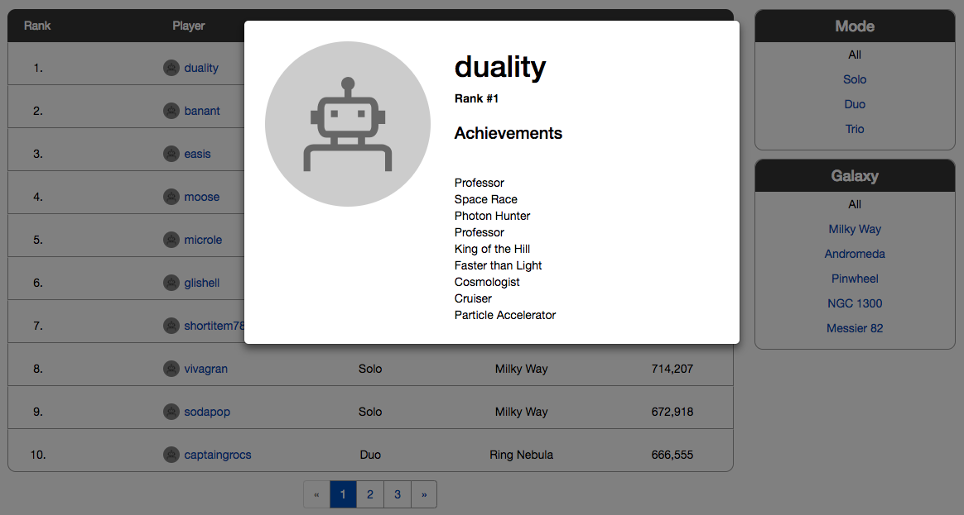

When you're finished, return to the terminal window, and to stop the running app, and select Ctrl+C.

## Task 02: Set up your Azure DevOps environment

Here, you make sure that your Azure DevOps organization is set up to complete the rest of this module. You do this by running a template that creates a project for you in Azure DevOps.

### Run the template

To set up everything in your Azure DevOps organization, run a template.

[Click here to Run the template](https://azuredevopsdemogenerator.azurewebsites.net/?x-ms-routing-name=self&name=create-build-pipeline)

On the Azure DevOps Demo Generator site, to run the template, perform these steps.

1. Select **Sign In**, and accept the usage terms.
2. On the **Create New Project** page, select your Azure DevOps organization, and enter a project name, like *Space Game - web - Pipeline*. Next, select **Create Project**.

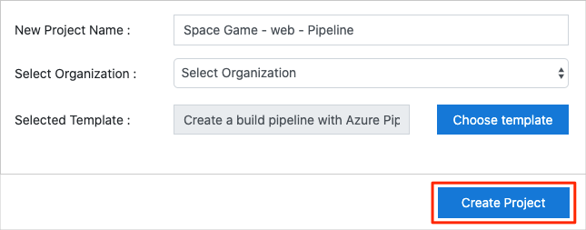

It takes a moment for the template to run.

1. To go to your project in Azure DevOps, select **Navigate to project**.

### Set your project's visibility

Your fork of the *Space Game* repository on GitHub is initially public. The Azure DevOps template creates a project that's initially private.

A public GitHub repository is accessible to everyone, whereas a private repository is accessible to you and the people you share it with. In both cases, only collaborators can commit changes to a GitHub repository.

A project on Azure DevOps works the same way. Users who aren't signed in to the service have read-only access to public projects. Private projects require users to be granted access to the project and signed in to access the services.

For learning purposes, you don't need to change any of these settings right now. But for your own projects, you need to decide what visibility and access you want to provide to others. For example, if your project is open source, you might make both your GitHub repository and your Azure DevOps project public. If your project is closed source, you would likely make both your GitHub repository and your Azure DevOps project private.

Later, you can use these resources to help you decide which option is best for your project:

* [What is a public project?](https://docs.microsoft.com/en-us/azure/devops/organizations/public/about-public-projects)
* [Quickstart: Change the project visibility, public or private](https://docs.microsoft.com/en-us/azure/devops/organizations/public/make-project-public)
* [Setting repository visibility](https://help.github.com/github/administering-a-repository/setting-repository-visibility)

### Move the work item to Doing

In this section, you'll assign a work item to yourself on Azure Boards that relates to this module. You'll also move the work item to the **Doing** state. In practice, you and your team would create work items at the start of each sprint, or work iteration.

Assigning work in this way gives you a checklist to work from. It gives others on your team visibility into what you're working on and how much work is left. It also helps the team enforce Work in Progress limits, or WIP limits, so the team doesn't take on too much work at any given time.

Recall that the team settled on these seven top issues:

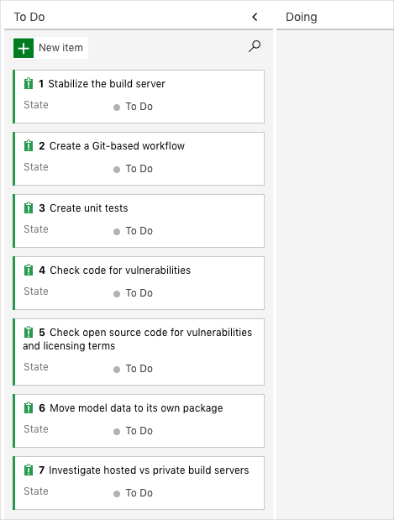

**Note**

Within an Azure DevOps organization, work items are numbered sequentially. In your project, the number that's assigned to each work item might not match what you see here.

You'll now move the first item, **Stabilize the build server** to the **Doing** column, and assign yourself to the work item.

Recall that **Stabilize the build server** relates to fixing the team's existing build server, which runs on spare hardware in the office. The goal is to see if build services on Azure Pipelines can simplify build server maintenance.

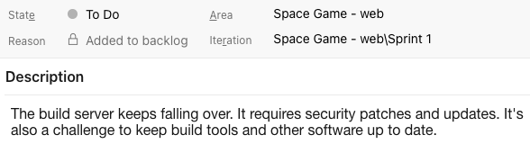

To set up the work item:

1. In Azure DevOps, navigate to **Boards**, and from the menu, select **Boards**.

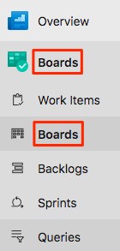

1. In the **Stabilize the build server** work item, at the bottom of the card, select the down arrow. Then assign the work item to yourself.

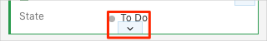

1. Move the work item from the **To Do** column to the **Doing** column:

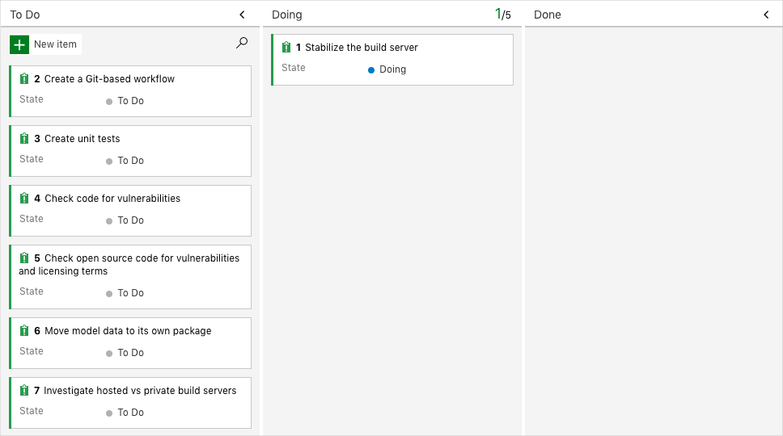

At the end of this module, you'll move the card to the **Done** column after you've completed the task.

## Task 03: Create a build pipeline with Azure Pipelines

### Create the pipeline

1. In Azure DevOps, go to your project.
2. Either from the project page or from the left pane, select **Pipelines**.
3. Select **Create Pipeline**.
4. On the **Connect** tab, select **GitHub**.

When prompted, enter your GitHub credentials.

1. On the **Select** tab, select your **mslearn-tailspin-spacegame-web** repository.
2. To install the Azure Pipelines app, you might be redirected to GitHub. If so, scroll to the bottom, and select **Approve and install**.
3. On the **Configure** tab, select **ASP.NET Core**.

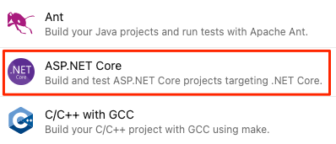

**Note**

If you don't see this option, select **Show more**. Don't select **ASP.NET Core (.NET Framework)**.

1. On the **Review** tab, note the initial build configuration.

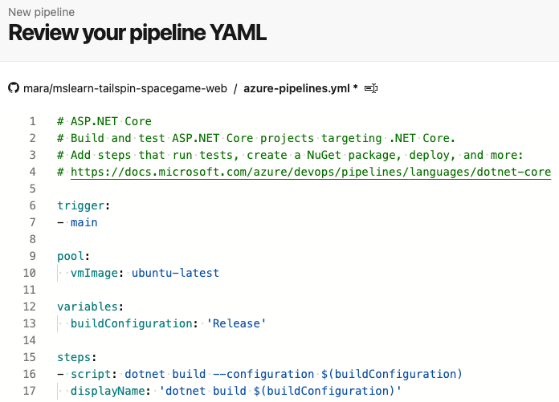

This is a very basic configuration that Azure DevOps provides for you based on your app type, ASP.NET Core.

1. On the **Review** tab, select **Save and run**. Next, to commit your changes to GitHub and start the build, select **Save and run** a second time.

#### Add build tasks

Now that you have a working build process, you can start to add build tasks.

Remember that you're working from the main branch. To hold your work, you'll now create a branch named build-pipeline. The branch gives you a place to experiment, and get your build working completely without affecting the rest of the team.

You can add build tasks to *azure-pipelines.yml* directly from Azure Pipelines. Azure Pipelines will commit your changes directly to your branch. Here, you'll modify *azure-pipelines.yml* locally and push, or upload, your changes to GitHub. Doing it this way lets you practice your Git skills. Watch the pipeline automatically build the app when you push up changes.

In practice, you might add build tasks one at a time, push up your changes, and watch the build run. Here, you'll add all the build tasks we identified earlier at one time.

**Note**

You're about to run a few Git commands. Don't worry if you're new to Git. We'll show you what to do. We'll also go into more detail about Git in future modules.

1. In Visual Studio Code, go to the integrated terminal.
2. To fetch the latest changes from GitHub and update your main branch, run this git pull command.

git pull origin main

You see from the output that Git fetches a file named *azure-pipelines.yml*. This is the starter pipeline configuration that Azure Pipelines created for you. When you set up the pipeline, Azure Pipelines adds this file to your GitHub repository.

1. To create a branch named build-pipeline, run this git checkout command.

git checkout -B build-pipeline

1. In Visual Studio Code, modify *azure-pipelines.yml* as you see here:

trigger:

- '*'

pool:

vmImage: 'ubuntu-20.04'

demands:

- npm

variables:

buildConfiguration: 'Release'

steps:

- task: UseDotNet@2

displayName: 'Use .NET SDK 5.x'

inputs:

packageType: sdk

version: '5.x'

- task: Npm@1

displayName: 'Run npm install'

inputs:

verbose: false

- script: './node_modules/.bin/node-sass Tailspin.SpaceGame.Web/wwwroot --output Tailspin.SpaceGame.Web/wwwroot'

displayName: 'Compile Sass assets'

- task: gulp@1

displayName: 'Run gulp tasks'

- script: 'echo "$(Build.DefinitionName), $(Build.BuildId), $(Build.BuildNumber)" > buildinfo.txt'

displayName: 'Write build info'

workingDirectory: Tailspin.SpaceGame.Web/wwwroot

- task: DotNetCoreCLI@2

displayName: 'Restore project dependencies'

inputs:

command: 'restore'

projects: '**/*.csproj'

- task: DotNetCoreCLI@2

displayName: 'Build the project - Release'

inputs:

command: 'build'

arguments: '--no-restore --configuration Release'

projects: '**/*.csproj'

The demands section beneath pool specifies that you need npm, the Node.js package manager, installed on the build system.

Under the steps section, you see the build tasks that maps to each of the script commands that we identified earlier.

Azure Pipelines provides built-in build tasks that map to many common build activities. For example, the DotNetCoreCLI@2 task maps to the dotnet command-line utility. The pipeline uses DotNetCoreCLI@2 two times: one time to restore, or install, the project's dependencies, and one time to build the project.

Remember that not all build activities map to a built-in task. For example, there's no built-in task that runs the node-Sass utility, or writes build info to a text file. To run general system commands, you use the CmdLine@2 or script task. The pipeline uses the script task because it's a common shortcut for CmdLine@2.

In the build step that writes information about the build to a file, notice these elements:

* + $(Build.DefinitionName)
  + $(Build.BuildId)
  + $(Build.BuildNumber)

These elements are built-in variables that the system provides for use in your pipelines.

* + $(Build.DefinitionName) specifies the name of the build pipeline. For example, "SpaceGame-Web-CI."
  + $(Build.BuildId) is a numeric identifier for the completed build, like 115.
  + $(Build.BuildNumber) is name of the completed build. You can configure the format, but by default the build number includes the current date followed by the build number for that day. An example build number is "20190329.1."

You can also define your own variables, which you'll do soon.

You might have also noticed the UseDotNet@2 task, which is the first build step. developer remembered that her build script didn't install required build tools. Although the build agent comes with a number of .NET SDK versions, this task lets her easily specify the version she needs to use on the build agent.

1. From the integrated terminal, to add *azure-pipelines.yml* to the index, commit the change, and push the change up to GitHub, run the following Git commands. These steps are similar to steps you performed earlier.

**Tip**

Before you run these Git commands, remember to save *azure-pipelines.yml*.

git add azure-pipelines.yml

git commit -m "Add build tasks"

git push origin build-pipeline

This time, you push the build-pipeline branch, not the main branch, to GitHub.

Pushing the branch to GitHub triggers the build process in Azure Pipelines.

1. In Azure Pipelines, go to your build. To do so, on the side of the page, select **Pipelines**, and then select your pipeline. You see your commit message and that the build is running using the code from the build-pipeline branch.

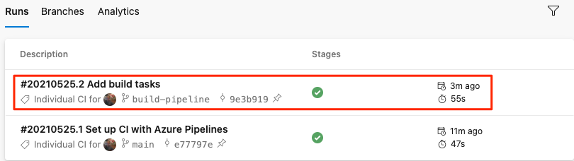

**Tip**

If you don't see the build right away, wait a few moments, or refresh the page.

1. Select your build and trace the build tasks as they run.

For example, here's what happens when the gulp@1 task runs to perform the gulp tasks that minify JavaScript and CSS assets:

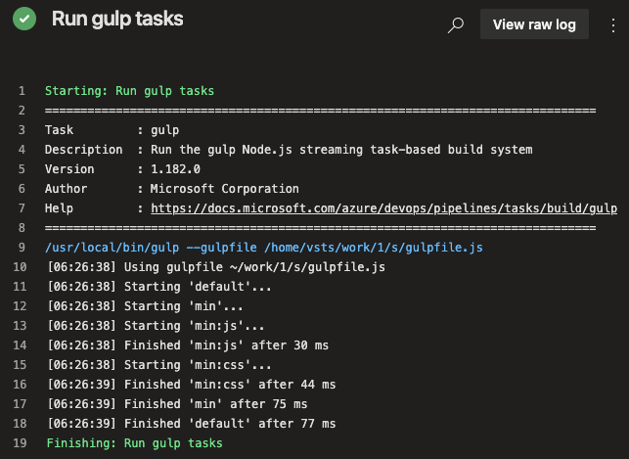

If any step fails, you'll see the error in the output so you can diagnose and repair the failure.

Earlier, you ran a more minimal build configuration. This time, when the build is completed, you see a more complete set of tasks needed to build the app.

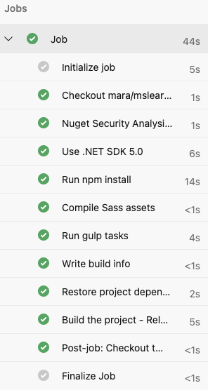

1. After your build is completed, select any of the steps to see the overall progression of the build. From there, you can jump to the build logs or the associated change on GitHub.

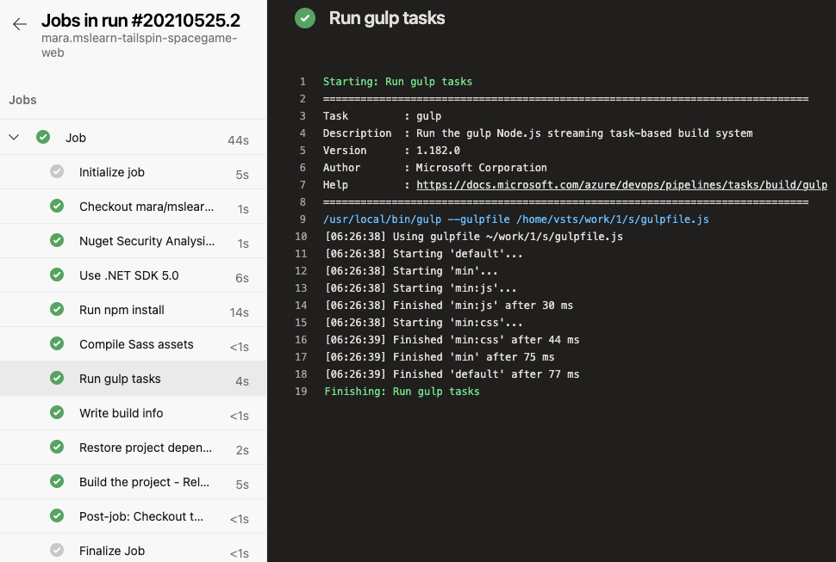

### Publish the result to the pipeline

At this point, you can build the *Space Game* web project through the pipeline.

But where do the results of the build go? Right now, the output of the build remains on the temporary build server

You can store build artifacts in Azure Pipelines so they're later available to others on your team after the build completes. That's what you'll do here. As a bonus, you'll also refactor the build configuration to use variables to make the configuration easier to read and keep up to date.

**Note**

Azure Pipelines enables you to automatically deploy the built app to a testing or production environment running in the cloud or in your datacenter.

#### Publish the build to the pipeline

In .NET, you can package your app as a .zip file. You can then use the built-in PublishBuildArtifacts@1 task to publish the .zip file to Azure Pipelines.

1. In Visual Studio Code, modify *azure-pipelines.yml* as you see here:

trigger:

- '*'

pool:

vmImage: 'ubuntu-20.04'

demands:

- npm

steps:

- task: UseDotNet@2

displayName: 'Use .NET SDK 5.x'

inputs:

version: '5.x'

- task: Npm@1

displayName: 'Run npm install'

inputs:

verbose: false

- script: './node_modules/.bin/node-sass Tailspin.SpaceGame.Web/wwwroot --output Tailspin.SpaceGame.Web/wwwroot'

displayName: 'Compile Sass assets'

- task: gulp@1

displayName: 'Run gulp tasks'

- script: 'echo "$(Build.DefinitionName), $(Build.BuildId), $(Build.BuildNumber)" > buildinfo.txt'

displayName: 'Write build info'

workingDirectory: Tailspin.SpaceGame.Web/wwwroot

- task: DotNetCoreCLI@2

displayName: 'Restore project dependencies'

inputs:

command: 'restore'

projects: '**/*.csproj'

- task: DotNetCoreCLI@2

displayName: 'Build the project - Release'

inputs:

command: 'build'

arguments: '--no-restore --configuration Release'

projects: '**/*.csproj'

- task: DotNetCoreCLI@2

displayName: 'Publish the project - Release'

inputs:

command: 'publish'

projects: '**/*.csproj'

publishWebProjects: false

arguments: '--no-build --configuration Release --output $(Build.ArtifactStagingDirectory)/Release'

zipAfterPublish: true

- task: PublishBuildArtifacts@1

displayName: 'Publish Artifact: drop'

condition: succeeded()

This version of *azure-pipelines.yml* looks like the previous version, but it adds two additional tasks.

The first task uses the DotNetCoreCLI@2 task to *publish*, or package, the app's build results (including its dependencies) into a folder. The zipAfterPublish argument specifies to add the built results to a .zip file.

The second task uses the PublishBuildArtifacts@1 task to publish the .zip file to Azure Pipelines. The condition argument specifies to run the task only when the previous task succeeds. succeeded() is the default condition, so you don't need to specify it. But we show it here to show its use.

1. From the integrated terminal, add *azure-pipelines.yml* to the index, commit the change, and push the change up to GitHub.

**Tip**

Before you run these Git commands, remember to save *azure-pipelines.yml*.

git add azure-pipelines.yml

git commit -m "Add publish tasks"

git push origin build-pipeline

1. As you did earlier, from Azure Pipelines, trace the build through each of the steps.
2. When the pipeline completes, go back to the summary for the build.
3. Under **Related** there is **1 published**.

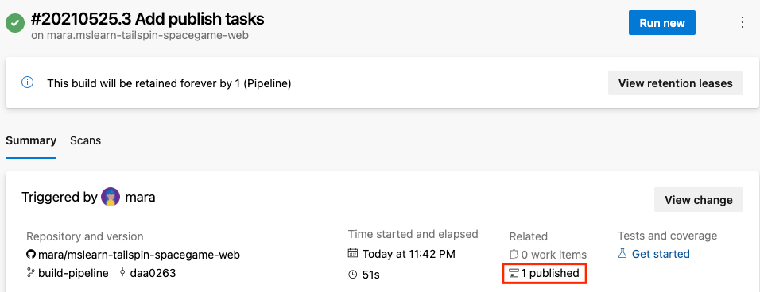

1. Select the artifact.
2. Expand the drop folder.

You see a *.zip* file that contains your built app and its dependencies:

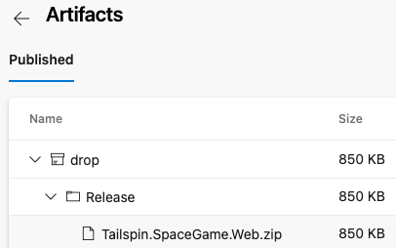

If you want to try an optional exercise, you can download this *.zip* file to your computer, and explore its contents.

#### Define variables to enhance readability

Variables enable you to define values one time and refer to those values throughout your pipeline. Azure Pipelines replaces each variable with its current value when the pipeline runs.

Just like in other programming languages, variables enable you to do things like:

* Define values that might change between runs of your pipeline.
* Store information that's repeated throughout your pipeline, like a version number or a file path, in one place. That way, you don't need to update all occurrences when your needs change.

Azure Pipelines provides a number of built-in variables. These variables describe aspects of the build process, like the build identifier and the directory names where your software is built and staged.

You can also define your own variables. Here's an example that shows a variable named buildConfiguration that defines the Release build configuration.

variables:

buildConfiguration: 'Release'

Use variables when you repeat the same value multiple times or when a value, like a dependency version, might change.

You don't need to create a variable for every piece of your build configuration. In fact, too many variables can make your pipeline code harder for others to read and understand.

Take a moment to examine *azure-pipelines.yml*. Notice that these values are repeated:

* Build configuration: Release
* Location of the **wwwroot** directory: Tailspin.SpaceGame.Web/wwwroot
* .NET SDK version: 5.x

You now use variables to define these values one time. You then reference the variables throughout the pipeline.

1. In Visual Studio Code, modify *azure-pipelines.yml* as you see here:

trigger:

- '*'

pool:

vmImage: 'ubuntu-20.04'

demands:

- npm

variables:

buildConfiguration: 'Release'

wwwrootDir: 'Tailspin.SpaceGame.Web/wwwroot'

dotnetSdkVersion: '5.x'

steps:

- task: UseDotNet@2

displayName: 'Use .NET SDK $(dotnetSdkVersion)'

inputs:

version: '$(dotnetSdkVersion)'

- task: Npm@1

displayName: 'Run npm install'

inputs:

verbose: false

- script: './node_modules/.bin/node-sass $(wwwrootDir) --output $(wwwrootDir)'

displayName: 'Compile Sass assets'

- task: gulp@1

displayName: 'Run gulp tasks'

- script: 'echo "$(Build.DefinitionName), $(Build.BuildId), $(Build.BuildNumber)" > buildinfo.txt'

displayName: 'Write build info'

workingDirectory: $(wwwrootDir)

- task: DotNetCoreCLI@2

displayName: 'Restore project dependencies'

inputs:

command: 'restore'

projects: '**/*.csproj'

- task: DotNetCoreCLI@2

displayName: 'Build the project - $(buildConfiguration)'

inputs:

command: 'build'

arguments: '--no-restore --configuration $(buildConfiguration)'

projects: '**/*.csproj'

- task: DotNetCoreCLI@2

displayName: 'Publish the project - $(buildConfiguration)'

inputs:

command: 'publish'

projects: '**/*.csproj'

publishWebProjects: false

arguments: '--no-build --configuration $(buildConfiguration) --output $(Build.ArtifactStagingDirectory)/$(buildConfiguration)'

zipAfterPublish: true

- task: PublishBuildArtifacts@1

displayName: 'Publish Artifact: drop'

condition: succeeded()

Notice the variables section, which defines these variables:

* + buildConfiguration. Specifies the build configuration.
  + wwwrootDir. Specifies the path to the **wwwroot** directory.
  + dotnetSdkVersion. Specifies the .NET SDK version to use.

To reference these variables, you use the $() syntax just as you do for built-in variables. Here's the step that runs node-Sass to convert Sass files to CSS. To obtain the path to the **wwwroot** directory, it references the wwwrootDir variable.

- script: './node_modules/.bin/node-sass $(wwwrootDir) --output $(wwwrootDir)'

displayName: 'Compile Sass assets'

The script command uses the variable to define both the source directory for Sass files and the directory in which to write CSS files. It also uses the variable to define the task name that's shown in the user interface.

1. From the integrated terminal, add *azure-pipelines.yml* to the index, commit the change, and push the change up to GitHub.

git add azure-pipelines.yml

git commit -m "Refactor common variables"

git push origin build-pipeline

1. From Azure Pipelines, trace the build through each of the steps.

You see that the variables are replaced with their values when the build runs. For example, here's the UseDotNet@2 task that sets the .NET SDK version to use.

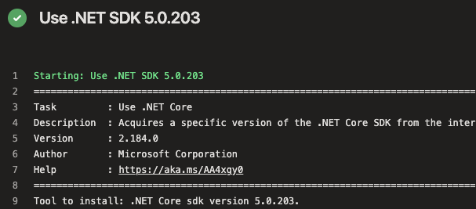

As before, to see the artifact when the build completes, you can navigate to the build summary.

Congratulations! You've successfully used Azure Pipelines and created your first build artifact.

### Build multiple configurations by using templates

In the previous exercises, you implemented a pipeline that builds the *Space Game* website. You started with a script that performs each build action and mapped each action to its corresponding pipeline task. The output of the pipeline is a *.zip* file that contains the compiled web app.

In this exercise, you use a template to define build tasks that can build any configuration defined in the project file. Templates enable you to define your logic one time and then reuse it several times. Templates combine the content of multiple YAML files into a single pipeline.

Consider the following tasks that build and publish the *Space Game* web project's Release configuration. (Don't add this code to your *azure-pipelines.yml* file.)

- task: DotNetCoreCLI@2

displayName: 'Build the project - Release'

inputs:

command: 'build'

arguments: '--no-restore --configuration Release'

projects: '**/*.csproj'

- task: DotNetCoreCLI@2

displayName: 'Publish the project - Release'

inputs:

command: 'publish'

projects: '**/*.csproj'

publishWebProjects: false

arguments: '--no-build --configuration Release --output $(Build.ArtifactStagingDirectory)/Release'

zipAfterPublish: true

To build the Debug configuration, you might repeat these two tasks, but replace Release with Debug.

Doing so would give you the result you're looking for, but what happens when your build becomes more complex or your requirements change? You'd need to manually locate and change both variations of each build task. After you added the additional build requirements, you'd also need to create two tasks, one for the Debug configuration and one for Release, to satisfy those requirements.

A better solution is to use a template.

#### What are templates?

A *template* enables you to define common build tasks one time and reuse those tasks multiple times.

You call a template from the parent pipeline as a build step. You can pass parameters into a template from the parent pipeline.

#### Define the template

Remember that a template enables you to define common build tasks one time and reuse those tasks multiple times. You call a template from its parent template as a build step, and pass parameters into a template from the parent pipeline.

You'll now create a template that can build any configuration that's defined in the project file.

1. From the Visual Studio Code integrated console, at the root of your project, create a *templates* directory.

mkdir templates

In practice, you can put a template file in any location. You don't need to put them in the *templates* directory.

1. In Visual Studio Code, select **File > New File**. Next, to save the blank file as *build.yml* in your project's *templates* directory, select **File > Save**. (For example, *~/mslearn-tailspin-spacegame-web/templates*.)

**Important**

As before, in Windows, in the **Save as type** list, select **YAML**.

1. In Visual Studio Code, add this code to *build.yml*.

parameters:

buildConfiguration: 'Release'

steps:

- task: DotNetCoreCLI@2

displayName: 'Build the project - ${{ parameters.buildConfiguration }}'

inputs:

command: 'build'

arguments: '--no-restore --configuration ${{ parameters.buildConfiguration }}'

projects: '**/*.csproj'

- task: DotNetCoreCLI@2

displayName: 'Publish the project - ${{ parameters.buildConfiguration }}'

inputs:

command: 'publish'

projects: '**/*.csproj'

publishWebProjects: false

arguments: '--no-build --configuration ${{ parameters.buildConfiguration }} --output $(Build.ArtifactStagingDirectory)/${{ parameters.buildConfiguration }}'

zipAfterPublish: true

These tasks look like the ones you defined earlier to build and publish the app. But in a template, you work with input parameters differently than you work with normal variables. Here are two differences:

* + In a template file, you use the parameters section instead of variables to define inputs.
  + In a template file, you use ${{ }} syntax instead of $() to read a parameter's value. When you read a parameter's value, you include the parameters section in its name. For example, ${{ parameters.buildConfiguration }}.

#### Call the template from the pipeline

You'll now call the template that you just built from the pipeline. You'll do so one time for the Debug configuration and then repeat the process for the Release configuration.

1. In Visual Studio Code, modify *azure-pipelines.yml* as you see here.

trigger:

- '*'

pool:

vmImage: 'ubuntu-20.04'

demands:

- npm

variables:

buildConfiguration: 'Release'

wwwrootDir: 'Tailspin.SpaceGame.Web/wwwroot'

dotnetSdkVersion: '5.x'

steps:

- task: UseDotNet@2

displayName: 'Use .NET SDK $(dotnetSdkVersion)'

inputs:

version: '$(dotnetSdkVersion)'

- task: Npm@1

displayName: 'Run npm install'

inputs:

verbose: false

- script: './node_modules/.bin/node-sass $(wwwrootDir) --output $(wwwrootDir)'

displayName: 'Compile Sass assets'

- task: gulp@1

displayName: 'Run gulp tasks'

- script: 'echo "$(Build.DefinitionName), $(Build.BuildId), $(Build.BuildNumber)" > buildinfo.txt'

displayName: 'Write build info'

workingDirectory: $(wwwrootDir)

- task: DotNetCoreCLI@2

displayName: 'Restore project dependencies'

inputs:

command: 'restore'

projects: '**/*.csproj'

- template: templates/build.yml

parameters:

buildConfiguration: 'Debug'

- template: templates/build.yml

parameters:

buildConfiguration: 'Release'

- task: PublishBuildArtifacts@1

displayName: 'Publish Artifact: drop'

condition: succeeded()

This file looks like the original, except that it replaces the build and publish tasks with calls to the template that performs the same tasks.

You see that the template is called one time for each configuration. To pass the configuration name to the template, each template task uses the parameters argument.

#### Run the pipeline

You'll now push your changes to GitHub and see the pipeline run.

1. From the integrated terminal, add *azure-pipelines.yml* and **templates/build.yml** to the index, commit the changes, and push the changes up to GitHub.

git add azure-pipelines.yml templates/build.yml

git commit -m "Support build configurations"

git push origin build-pipeline

1. From Azure Pipelines, trace the build through each of the steps, as you did earlier.

As the pipeline runs, you see that the process expands the tasks within the template. The tasks that build and publish the project are run two times, once for each build configuration.

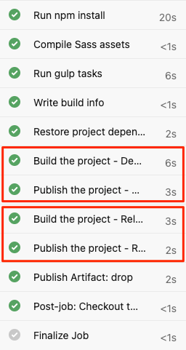

1. When the build completes, go back to the summary page, and select the published artifact as you did before. Expand the drop folder.

You see that the pipeline produces a *.zip* file for both the Debug configuration and the Release configuration.

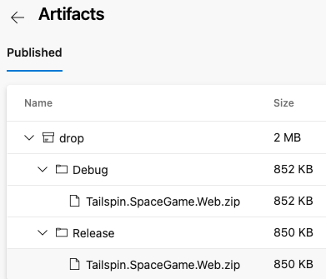

#### Merge the branch into main

At this point, you have a working build pipeline that accomplishes everything needs for right now.

In practice, you'd submit a *pull request* that merges your build-pipeline branch into the main branch.

We'll skip that step for now. In the next module, you'll learn some ways to collaborate with your team on GitHub, including how to submit, review, and merge pull requests.

#### Move the work item to Done

You'll now move the work item you assigned to yourself earlier in this module, **Stabilize the build server**, to the **Done** column.

In practice, "Done" often means that your users have working software. Here, you'll mark this work as complete because you have a working build system on Azure Pipelines.

At the end of each Sprint, or work iteration, you and your team might hold a retrospective meeting. At these meetings, you share the work you completed, what went well during the Sprint, and what could be improved.

To complete the work item:

1. From Microsoft Azure DevOps, navigate to **Boards**, and from the menu, select **Boards**.
2. Move the **Stabilize the build server** work item from the **Doing** column to the **Done** column:

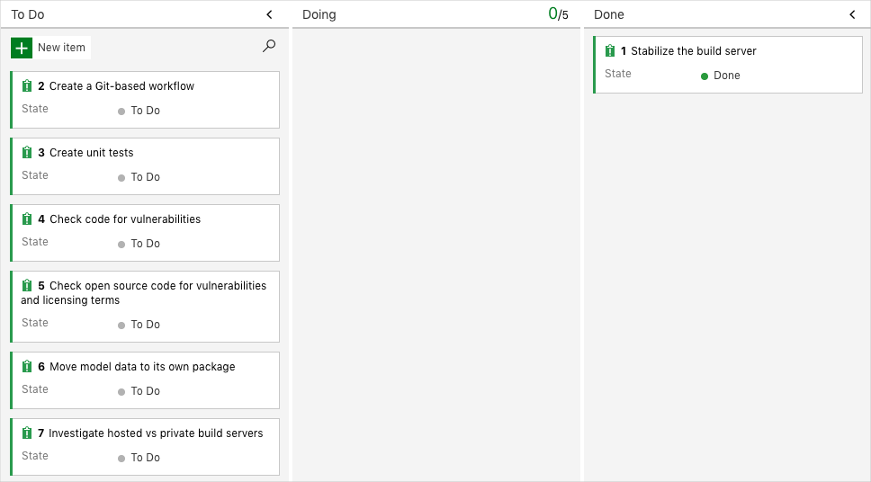

#### Disable the pipeline

This option disables the pipeline so that it doesn't process further build requests. You can re-enable the build pipeline later if you want to. Select this option if you want to keep your Azure DevOps project and your build pipeline for future reference.

To disable the pipeline:

1. In Azure Pipelines, navigate to your pipeline.
2. From the dropdown, select **Settings**.

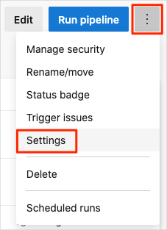

1. Under **Processing of new run requests**, select **Disabled** and then select **Save**.

Your pipeline will no longer process build requests.

## Task 04: Implement a code workflow in your build pipeline by using Git and GitHub

In previous task, you created a basic but complete build configuration for an ASP.NET Core web application.

In this module, you extend this build configuration by implementing a code collaboration strategy that uses Git and GitHub.

Elite performers deploy code more frequently and experience much faster lead times than other performers. To become elite performers, developers need a way to work with source code and share their changes with others. Collaboration is a key DevOps value, and a source control system that fosters cooperation is a great DevOps tool.

Although Azure DevOps works with various kinds of source control, many developers choose Git because it's a distributed system that enables all contributors to have their own copy of the work. In this module, you use Git's branching and merging capabilities to more efficiently work with other developers. You also use GitHub, because it provides a central location for teams to host their projects and share their work.

### Set up your Azure DevOps environment

Run a template that sets up everything for you in your Azure DevOps organization.

[Click here to Run the template](https://azuredevopsdemogenerator.azurewebsites.net/?x-ms-routing-name=self&name=implement-code-workflow)

To run the template, on the Azure DevOps Demo Generator site, do the following:

1. Select **Sign In**, and accept the usage terms.
2. On the **Create New Project** page, select your Azure DevOps organization, and then enter a project name, such as *Space Game - web - Workflow*.
3. Select **Fork repository on GitHub**, and then select **Authorize**. If a window appears, authorize access to your GitHub account.

**Important**

You need to select this option for the template to connect to your GitHub repository. Select it even if you've already forked the *Space Game* website project. The template uses your existing fork.

1. Select **Create Project**.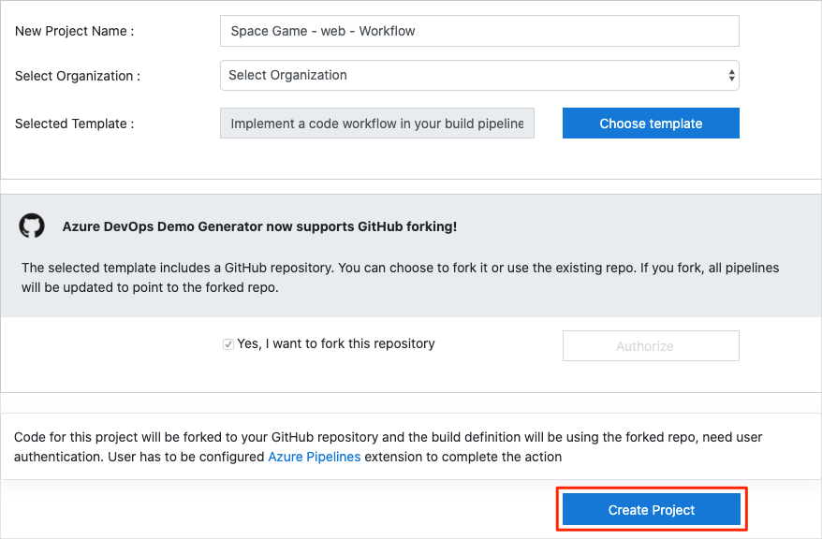

It takes a few moments for the template to run.

1. Select **Navigate to project** to go to your project in Azure DevOps.

#### Move the work item to Doing

In this section, you assign yourself a work item that relates to this module on Azure Boards. You also move the work item to the **Doing** state. In practice, you and your team would create work items at the start of each sprint, or work iteration.

Assigning work in this way gives you a checklist to work from. It gives others on your team visibility into what you're working on and how much work is left. It also helps the team enforce work in process (WIP) limits so that the team doesn't take on too much work at one time.

Recall that the team settled on these seven top issues:



**Note**

Within an Azure DevOps organization, work items are numbered sequentially. In your project, the number that's assigned to each work item might not match what you see here.

Here you move the second item, **Create a Git-based workflow**, to the **Doing** column and assign yourself to the work item.

Recall that **Create a Git-based workflow** relates to moving to a code workflow that enables better collaboration among team members.

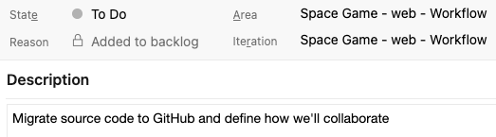

#### To set up the work item:

1. In Azure DevOps, go to **Boards** and then, in the left pane, select **Boards**.



1. In the **Create a Git-based workflow** work item, select the **To Do** down arrow, and then assign the work item to yourself.



1. Drag the work item from the **To Do** column to the **Doing** column.

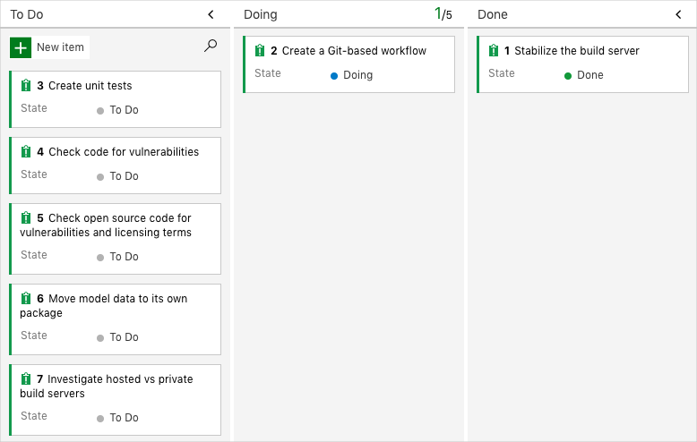

At the end of this module, after you've completed the task, you'll move the card to the **Done** column.

#### Set up the project locally

Here, you load the *Space Game* project in Visual Studio Code, configure Git, clone your repository locally, and set the upstream remote so that you can download starter code.

**Note**

If you're already set up with the **[mslearn-tailspin-spacegame-web](https://github.com/MicrosoftDocs/mslearn-tailspin-spacegame-web" \t "az-portal)** project locally, you can move to the next section.

1. Start Visual Studio Code.
2. On the **View** menu, select **Terminal**.
3. In the dropdown, select **bash**:



The terminal window lets you select any shell that's installed on your system, like Bash, Zsh, and PowerShell.

Here, you'll use Bash. Git for Windows provides Git Bash, which makes it easy to run Git commands.

**Note**

On Windows, if you don't see **bash** listed as an option, make sure you've installed [**Git**](https://git-scm.com/downloads) and then restart Visual Studio Code.

If you still don't see the **bash** option, see [**Integrated Terminal**](https://code.visualstudio.com/docs/editor/integrated-terminal) to manually configure your terminal settings.

1. To navigate to the directory you want to work from, like your home directory (~), run the cd command. You can select a different directory if you want.

cd ~

#### Configure Git

If you're new to Git and GitHub, to associate your identity with Git and authenticate with GitHub, you'll first need to run a few commands.

[Set up Git](https://help.github.com/articles/set-up-git) explains the process in greater detail.

At a minimum, you'll need to complete the following steps. From the Visual Studio Code integrated terminal, run these commands.

1. [Set your username](https://help.github.com/articles/setting-your-username-in-git).
2. [Set your commit email address](https://help.github.com/articles/setting-your-commit-email-address-in-git).
3. [Cache your GitHub password](https://help.github.com/articles/caching-your-github-password-in-git).

**Note**

If you're already using two-factor authentication with GitHub, [**create a personal access token**](https://help.github.com/articles/creating-a-personal-access-token-for-the-command-line), and use your token in place of your password when prompted later.

Treat your access token like you would a password. Keep it in a safe place.

#### Get the source code

Now, you'll get the source code from GitHub and set up Visual Studio Code so that you can run the app and work with source code files.

#### Create a fork

The first step is to fork the *Space Game* web project so you can work with and modify the source files.

A *fork* is a copy of a GitHub repository. The copy exists in your account and enables you to make any changes you want without affecting the original project.

Although you can propose changes to the original project, here, you'll work with the *Space Game* web project as though it were the original project owned by different team.

To fork the *Space Game* web project into your GitHub account:

1. In a web browser, go to [GitHub](https://github.com/), and sign in.
2. Go to the [Space Game](https://github.com/MicrosoftDocs/mslearn-tailspin-spacegame-web) web project.
3. Select **Fork**:



1. To fork the repository into your account, follow the instructions.

#### Clone your fork locally

You now have a copy of the *Space Game* web project in your GitHub account. Now you'll download, or *clone*, a copy to your computer so you can work with it.

A clone, just like a fork, is a copy of a repository. When you clone a repository, you can make changes, verify they work as you expect, and then upload those changes back to GitHub. You can also synchronize your local copy with changes other authenticated users have made to GitHub's copy of your repository.

To clone the *Space Game* web project to your computer:

1. Go to your fork of the *Space Game* web project on GitHub.
2. Select **Code**. Then, from the **HTTPS** tab, select the button next to the URL that's shown to copy the URL to your clipboard.



1. In Visual Studio Code, go to the terminal window, and run the git clone command. Replace the URL that's shown here with the contents of your clipboard:

git clone https://github.com/your-name/mslearn-tailspin-spacegame-web.git

1. Move to the mslearn-tailspin-spacegame-web directory. This is the root directory of your repository.

cd mslearn-tailspin-spacegame-web

#### Set the upstream remote

A *remote* is a Git repository where team members collaborate (like a repository on GitHub). Here you list your remotes and add a remote that points to Microsoft's copy of the repository so that you can get the latest sample code.

1. To list your remotes, run this git remote command.

git remote -v

You see that you have both fetch (download) and push (upload) access to your repository:

origin https://github.com/username/mslearn-tailspin-spacegame-web.git (fetch)

origin https://github.com/username/mslearn-tailspin-spacegame-web.git (push)

*Origin* specifies your repository on GitHub. When you fork code from another repository, it's common to name the original remote (the one you forked from) as *upstream*.

1. To create a remote named *upstream* that points to the Microsoft repository, run this git remote add command.

git remote add upstream https://github.com/MicrosoftDocs/mslearn-tailspin-spacegame-web.git

1. Run git remote a second time to see the changes:

git remote -v

You see that you still have both fetch (download) and push (upload) access to your repository. You also now have fetch access from the Microsoft repository:

origin https://github.com/username/mslearn-tailspin-spacegame-web.git (fetch)

origin https://github.com/username/mslearn-tailspin-spacegame-web.git (push)

upstream https://github.com/MicrosoftDocs/mslearn-tailspin-spacegame-web.git (fetch)

#### Open the project in the file explorer

In Visual Studio Code, your terminal window points to the root directory of the *Space Game* web project. To view its structure and work with files, from the file explorer, you'll now open the project.

1. The easiest way to open the project is to reopen Visual Studio Code in the current directory. To do so, run the following command from the integrated terminal:

code -r .

You see the directory and file tree in the file explorer.

1. Reopen the integrated terminal. The terminal places you at the root of your web project.

If the code command fails, you need to add Visual Studio Code to your system PATH. To do so:

1. In Visual Studio Code, select F1 or select **View** > **Command Palette** to access the command palette.
2. In the command palette, enter *Shell Command: Install 'code' command in PATH*.
3. Repeat the previous procedure to open the project in the file explorer.

You're now set up to work with the *Space Game* source code and your Azure Pipelines configuration from your local development environment.

### Create a pull request

In this unit, you practice the process of submitting a pull request and merging your changes into the main branch so that everyone can benefit from your work.

In previous task, you created a Git branch named build-pipeline, where you defined a basic build pipeline for the *Space Game* website. Recall that your build definition goes in a file named *azure-pipelines.yml*.

Although your branch produces a build artifact, that work exists only on the build-pipeline branch. You need to merge your branch into main.

Recall that a *pull request* tells the other developers that you have code ready to review, if necessary, and you want your changes merged into another branch, such as main.

#### Create a branch and add starter code

Although you could use the build pipeline you built in the previous module, let's create a new branch, named code-workflow, that's based off of main so that you can practice the process from the beginning. If you completed the previous module, your branch includes a basic but complete build configuration in your *azure-pipelines.yml* file. If you haven't completed the previous module, you will create the file.

1. In Visual Studio Code, open the integrated terminal.
2. Switch to the main branch.

git checkout main

1. Ensure that you have the latest version of the code from GitHub.

git pull origin main

1. Create a branch named code-workflow.

git checkout -B code-workflow

The -b argument specifies to create a new branch if it doesn't exist. Omit the -b argument when you want to switch to an existing branch.

By default, your new branch builds on the previous branch from where you ran the git checkout command. Here, the parent branch is main. But the parent branch can be another one, such as a feature branch someone else started that you want to build on or experiment with.

It's now safe to make whatever changes you need, because you're on your own local branch. If you want to see which branch you're on, run git branch -v.

1. From the file explorer, open *azure-pipelines.yml* and replace its contents with this:

trigger:

- '*'

pool:

vmImage: 'ubuntu-20.04'

demands:

- npm

variables:

buildConfiguration: 'Release'

wwwrootDir: 'Tailspin.SpaceGame.Web/wwwroot'

dotnetSdkVersion: '5.x'

steps:

- task: UseDotNet@2

displayName: 'Use .NET SDK $(dotnetSdkVersion)'

inputs:

version: '$(dotnetSdkVersion)'

- task: Npm@1

displayName: 'Run npm install'

inputs:

verbose: false

- script: './node_modules/.bin/node-sass $(wwwrootDir) --output $(wwwrootDir)'

displayName: 'Compile Sass assets'

- task: gulp@1

displayName: 'Run gulp tasks'

- script: 'echo "$(Build.DefinitionName), $(Build.BuildId), $(Build.BuildNumber)" > buildinfo.txt'

displayName: 'Write build info'

workingDirectory: $(wwwrootDir)

- task: DotNetCoreCLI@2

displayName: 'Restore project dependencies'

inputs:

command: 'restore'

projects: '**/*.csproj'

- task: DotNetCoreCLI@2

displayName: 'Build the project - $(buildConfiguration)'

inputs:

command: 'build'

arguments: '--no-restore --configuration $(buildConfiguration)'

projects: '**/*.csproj'

- task: DotNetCoreCLI@2

displayName: 'Publish the project - $(buildConfiguration)'

inputs:

command: 'publish'

projects: '**/*.csproj'

publishWebProjects: false

arguments: '--no-build --configuration $(buildConfiguration) --output $(Build.ArtifactStagingDirectory)/$(buildConfiguration)'

zipAfterPublish: true

- task: PublishBuildArtifacts@1

displayName: 'Publish Artifact: drop'

condition: succeeded()

This configuration resembles the basic one you created previously. For brevity, it builds only your project's Release configuration.

**Note**

You have this file if you did the previous module. If you didn't do the previous module, create the file in the root of your repository.

#### Push your branch to GitHub

Here, you push your code-workflow branch to GitHub and watch Azure Pipelines build the application.

1. In the terminal, run git status to see what uncommitted work exists on your branch:

git status

You see that *azure-pipelines.yml* has been modified. You'll commit that to your branch shortly, but you first need to make sure that Git is tracking this file. This is called *staging* the file.

Only staged changes are committed when you run git commit. Next, you run the git add command to add *azure-pipelines.yml* to the staging area, or index.

1. Run the following git add command to add *azure-pipelines.yml* to the staging area:

git add azure-pipelines.yml

1. Run the following git commit command to commit your staged file to the code-workflow branch.

git commit -m "Add the build configuration"

The -m argument specifies the commit message. The commit message becomes part of a changed file's history. It helps reviewers understand the change as well as help future maintainers understand how the file changed over time.

**Tip**

The best commit messages complete the sentence, "If you apply this commit, you will ..."

If you omit the -m argument, Git brings up a text editor where you can detail the change. This option is useful when you want to specify a commit message that spans multiple lines. The text up to the first blank line specifies the commit title.

1. Run this git push command to push, or upload, the code-workflow branch to your repository on GitHub.

git push origin code-workflow

1. As an optional step, go to your project in Azure Pipelines and trace the build as it runs.

This build is called a *CI build*. Your pipeline configuration uses what's called a *trigger* to control which branches participate in the build process. Here, "*" specifies all branches.

trigger:

- '*'

Later, you'll see how to control your pipeline configuration to build from only the branches that you need.

You see that the build completes successfully and produces an artifact that contains the built web application.

#### Create a pull request

Here, you create a pull request for your branch.

1. In a browser, sign in to [GitHub](https://www.github.com/).
2. Go to your **mslearn-tailspin-spacegame-web** repository.
3. In the **Branch** drop-down list, select your code-workflow branch.

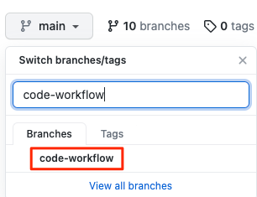

1. To start your pull request, select **Contribute** and then **Open pull request**.

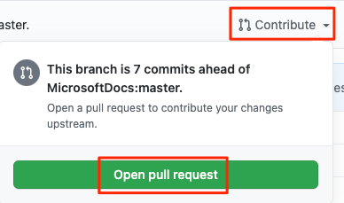

1. Ensure that the **base** specifies your forked repository and not the Microsoft repository.

Your selection looks like this:



**Important**

This step is important because you can't merge your changes into the Microsoft repository. Make sure that the base repository points to your GitHub account and not MicrosoftDocs.

If you end up with a pull request against MicrosoftDocs, simply close the pull request and repeat these steps.

This process involves an extra step because you're working from a forked repository. When you work directly with your own repository, and not a fork, your main branch is selected by default.

1. Enter a title and description for your pull request.
   * Title: *Configure Azure Pipelines*
   * Description: *This pipeline configuration builds the application and produces a build for the Release configuration.*
2. To complete your pull request, select **Create pull request**.

This step does not merge any code. It tells others that you have changes that you are proposing be merged into main.

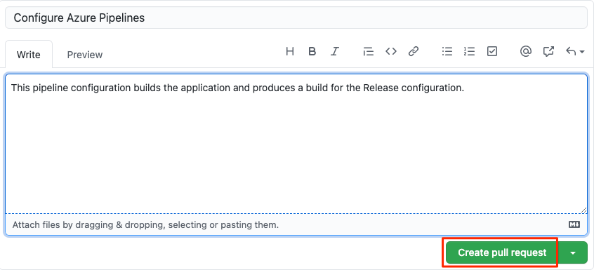

The pull request window is displayed. You can see that the build status in Azure Pipelines is configured to appear as part of the pull request. That way, you and others can view the status of the build as it's running.

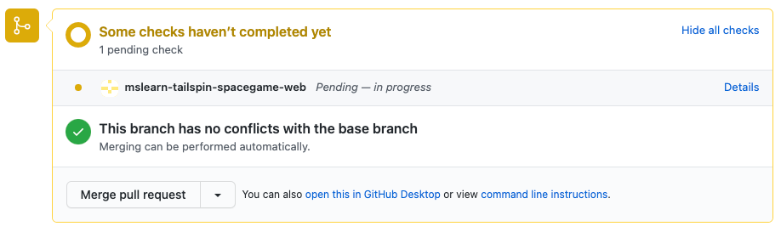

Just like when you push a branch to GitHub, a pull request, by default, triggers Microsoft Azure Pipelines to build your application.

**Tip**

If you don't see the build status appear right away, wait a few moments or refresh the page.

1. Optionally, select the **Details** link, and then trace the build as it moves through the pipeline.

You can hand off your build to the next step in the process, such as QA. Later, you can configure the pipeline to push your change all the way out to your QA lab or production.

1. Go back to your pull request on GitHub.

Wait for the build to complete. You're now ready to merge your pull request.

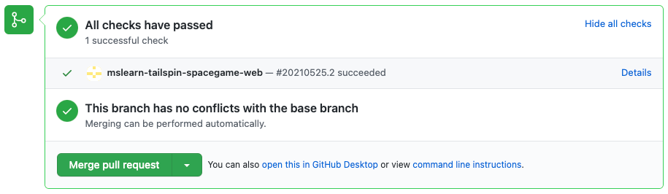

1. Select **Merge pull request**, and then select **Confirm merge**.
2. To delete the code-workflow branch from GitHub, select **Delete branch**.

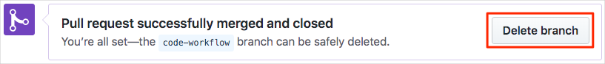

It's completely safe to delete a branch from GitHub after you've merged your pull request. In fact, it's a common practice, because the branch is no longer needed. The changes are merged and you can still find the details about the changes on GitHub or from the command line. Deleting a merged branch also helps others see only the work that's currently active.

Git branches are meant to be short-lived. After you merge a branch, you don't push additional commits onto it or merge it a second time. In most cases, every time you start on a new feature or bug fix, you start with a clean branch that's based on the main branch.

Deleting a branch on GitHub doesn't delete that branch from your local system. To do that, you would pass the -d switch to the git branch command.

#### How many times is a change built?

The answer depends on how your build configuration is defined. Azure Pipelines enables you to define *triggers* that specify which events cause builds to happen. You can control which branches get built or even which files trigger the build.

As an example, let's say that you want a build to happen when a change is pushed to GitHub on any Git branch. But you don't want the build to happen when the only changes are to files in your project's *docs* folder. You might include this trigger section in your build configuration:

trigger:

branches:

include:

- '*' # build all branches

paths:

exclude:

- docs/* # exclude the docs folder

By default, a build is triggered when a change is pushed to any file on any branch.

A *continuous integration* (CI) build is a build that runs when you push a change to a branch.

A *pull request* (PR) build is a build that runs when you open a pull request or when you push additional changes to an existing pull request.

The changes you make through the code-workflow branch are built under three conditions:

* A CI build happens when you push changes to the code-workflow branch.
* A PR build happens when you open a pull request on the code-workflow branch against the main branch.
* A final CI build happens after the pull request is merged to main.

PR builds help you verify that your proposed changes *will* work correctly after they're merged to main or another target branch.

The final CI build verifies that the changes are still good after the PR was merged.

As an optional step, go to Azure Pipelines and watch the final CI build happen on the main branch.

### Push a change through the pipeline

In this unit, you practice the complete code workflow by pushing a small change to the *Space Game* website to GitHub.

#### Fetch the latest main branch

In the previous unit, you created a pull request and merged your code-workflow branch into the main branch on GitHub. Now you need to pull the changes to main back to your local branch.

The git pull command fetches the latest code from the remote repository and merges it into your local repository. This way, you know you're working with the latest codebase.

1. In your terminal, run git checkout main to switch to the main branch.

git checkout main

1. To pull down the latest changes, run this git pull command:

git pull origin main

You can view the list of files that were changed. As an optional step, you can open the *azure-pipelines.yml* file to verify that it contains your complete build configuration.

Recall that a Git repository where team members collaborate (such as on GitHub) is called a *remote*. Here, *origin* specifies your repository on GitHub.

Later, you'll fetch starter code from the Microsoft GitHub repository, known as *upstream*.

#### Build and run the web application

To ensure that you have a working copy to start your changes, build and run the web application locally.

1. In Visual Studio Code, go to the terminal window and run the following dotnet build command to build the application:

dotnet build --configuration Release

1. Run the following dotnet run command to run the application:

dotnet run --configuration Release --no-build --project Tailspin.SpaceGame.Web

**Tip**

If you see an error in your browser that's related to a privacy or certificate error, select Ctrl+C from your terminal to stop the running application.

Then run dotnet dev-certs https --trust and select **Yes** when prompted. Or [**see this blog post**](https://www.hanselman.com/blog/DevelopingLocallyWithASPNETCoreUnderHTTPSSSLAndSelfSignedCerts.aspx) for more information.

After your computer trusts your local SSL certificate, run the dotnet run command a second time and go to http://localhost:5000 from a new browser tab to see the running application.

#### Verify that the application is running

In development mode, the *Space Game* website is configured to run on port 5000.

In a new browser tab, navigate to http://localhost:5000 to see the running application.

You see this:



You can interact with the page, including the leaderboard. When you select a player's name, you see details about that player.

When you're finished, return to the terminal window and select Ctrl+C to stop the running application.

#### Create a feature branch

In this section, you create a Git branch so that you can work on files without affecting anyone else. No one will even know you're working on those files until you push them to the remote repository.

To create a branch, you use the git checkout command and give your branch a name, just like you did in the previous part.

Before you create a branch, it's a good idea to adhere to a naming convention. For example, if your branch is for working on a new feature, you might use feature/<branch-name>. For a bug fix, you could use bugfix/<bug-number>. In this example, your branch name will be feature/home-page-text.

In your terminal, run the following git checkout command:

git checkout -B feature/home-page-text

Like before, the feature/home-page-text is based off of main.

#### Make changes and test it locally

1. In Visual Studio Code, open *Index.cshtml* in the *Tailspin.SpaceGame.Web/Views/Home* directory.
2. Look for this text near the top of the page:

<p>An example site for learning</p>

**Tip**

Visual Studio Code also provides an easy way to search for text in files. To access the search pane, select the magnifying glass icon in the side pane.

1. Replace the text in the previous step with the following "mistyped" text, and then save the file:

<p>Welcome to the oficial Space Game site!</p>

Note that the word "oficial" is intentionally mistyped. We'll address that error later in this module.

1. In your terminal, run the following dotnet build command to build the application:

dotnet build --configuration Release

1. Run the following dotnet run command to run the application:

dotnet run --configuration Release --no-build --project Tailspin.SpaceGame.Web

1. On a new browser tab, go to http://localhost:5000 to see the running application.

You can see that the home page contains the updated text.

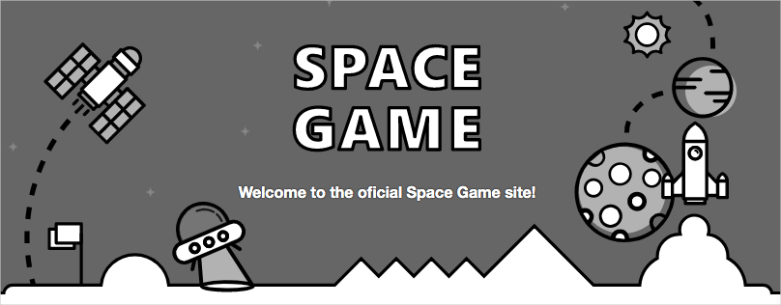

When you're finished, return to the terminal window, and then press Ctrl+C to stop the running application.

#### Commit and push your branch

Here you'll stage your changes to *Index.cshtml*, commit the change to your branch, and push your branch up to GitHub.

1. Run git status to check to see whether there are uncommitted changes on your branch.

git status

You see that *Index.cshtml* has been modified. Like before, the next step is to make sure that Git is tracking this file. This is called *staging* the file.

1. Run the following git add command to stage *Index.cshtml*.

git add Tailspin.SpaceGame.Web/Views/Home/Index.cshtml

1. Run the following git commit command to commit your staged file to the feature/home-page-text branch.

git commit -m "Improve the text at the top of the home page"

1. Run this git push command to push, or upload, the feature/home-page-text branch to your repository on GitHub.

git push origin feature/home-page-text

1. Just as before, you can locate your branch on GitHub from the branch drop-down box.

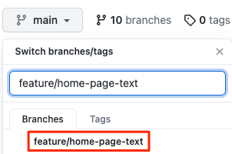

#### Watch Azure Pipelines build the application

Just as you did previously, Azure Pipelines automatically queues the build when you push changes to GitHub.

As an optional step, trace the build as it moves through the pipeline, and verify that the build succeeds.

#### Synchronize any changes to the main branch

While you were busy working on your feature, there might have been changes made to the remote main branch. Before you create a pull request, it's common practice to get the latest from the remote main branch.

To do this, you first check out, or switch to, the main branch. You then merge the remote main branch with your local main branch.

Next, you check out your feature branch. Then you merge your feature branch with the main branch.

Let's try the process now.

1. In your terminal, run this git checkout command to check out the main branch:

git checkout main

1. To download the latest changes to the remote main branch and merge those changes into your local main branch, run this git pull command:

git pull origin main

Because no one actually made any changes to your main branch, the following command tells you that everything is already up-to-date.

From https://github.com/username/mslearn-tailspin-spacegame-web

* branch main -> FETCH_HEAD

Already up to date.

1. To check out your feature branch, run git checkout.

git checkout feature/home-page-text

1. Merge your feature branch with main.

git merge main

Again, because no one actually made any changes to your main branch, you see that everything is still up to date.

Already up to date.

If you did incorporate any changes, you would want to test your application again to make sure that everything is still working.

### Push your local branch again

When you incorporate changes from the remote repository into your local feature branch, you need to push your local branch back to the remote repository a second time.

Although you didn't incorporate any changes from the remote repository, let's practice the process to see what happens.

1. Run this git push command to push your changes to GitHub:

git push origin feature/home-page-text

Once again, the response says that you're already up-to-date since no changes were made.

Everything up-to-date

#### Submit a pull request

In this section, you submit a pull request just as you did previously.

1. In a browser, sign in to [GitHub](https://www.github.com/).
2. Go to your **mslearn-tailspin-spacegame-web** repository.
3. In the drop-down list, select your feature/home-page-text branch.
4. To start your pull request, select **Contribute** and then **Open pull request**.
5. Ensure that the **base** drop-down list specifies your repository and not the Microsoft repository.



**Important**

Again, this step is important because you can't merge your changes into the Microsoft repository.

When you work directly with your own repository, and not a fork, your main branch is selected by default.

1. Enter a title and a description for your pull request.
   * **Title**: *Improve the text at the top of the home page*
   * **Description**: *Received the latest home page text from the product team.*
2. To complete your pull request, select **Create pull request**.

This step doesn't merge any code. It tells others that you have changes that you're proposing to merge.

The pull request window is displayed. As before, a pull request triggers Azure Pipelines to build your application by default.

1. Optionally, select the **Details** link or go to your project on Azure DevOps and watch the pipeline run.
2. When the build is finished, go back to your pull request on GitHub.
3. Select **Merge pull request**, and then select **Confirm merge**.
4. Select **Delete branch** to delete the feature/home-page-text branch from GitHub.

### Add a build badge

It's important for members of the team to know the status of the build. An easy way to quickly determine the build status is to add a build badge to the *README.md* file on GitHub. Let's check in on the team to see how it's done.

#### What is a build badge?

A *badge* is part of Microsoft Azure Pipelines. It has methods you can use to add an SVG image that shows the status of the build on your GitHub repository.

Most GitHub repositories include a file named *README.md*, which is a Markdown file that includes essential details and documentation about your project. GitHub renders this file on your project's home page.

Here's an example build badge:



For this exercise, you make your build badge visible to everyone. This might not be a good idea for your private projects since your build information will be made available to the public.

To make sure your build badge is visible:

1. In Azure DevOps, navigate to your organization.
2. Select **Organization settings** from the bottom corner.
3. Under **Pipelines**, select **Settings**.
4. Turn off **Disable anonymous access to badges**.

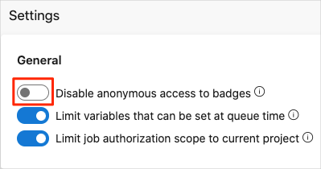

You need to make a similar change to your project:

1. Go to your project.
2. Navigate to **Project settings** from the bottom corner.
3. Under **Pipelines**, select **Settings**.
4. Turn off **Disable anonymous access to badges**.

#### Add the build badge

#### Up until now, you created Git branches locally to make changes to the Space Game project. You can also propose changes directly through GitHub. In this section, you do that to set up your status badge.

1. In Azure DevOps, in the left pane, select **Pipelines**, and then select your pipeline.
2. Select the ellipsis (...) in the upper right, and then select **Status badge**.



1. Under **Sample Markdown**, select the **Copy** button to copy the Markdown code to the clipboard.
2. In GitHub, go to your project.
3. Make sure you're on the main branch. In the files area, open the *README.md* file.
4. Select the pencil icon to open the file in the editor.
5. At the top of the page, add a blank line, and then paste the contents of the clipboard.
6. Select the **Preview** tab to see your proposed changes.

GitHub renders the Markdown file and shows you the build badge.

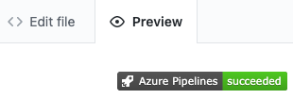

#### Commit your changes to main

#### In this section, you commit your changes to the main branch on GitHub.

1. Scroll to the bottom of the page and specify a commit message, such as "Add build badge".

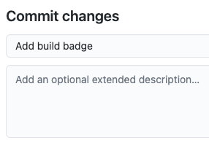

1. Leave the **Commit directly to the main branch** option selected, and then select **Commit changes** to commit your changes to the main branch.

Your badge is displayed on the *README.md* page.



This process is a more basic way to merge code into GitHub. Instead of committing directly, you could have created a pull request with your changes for others to review.

In practice, you would switch to the main branch and pull the latest changes from GitHub the next time you need to add a feature or address a bug.

### Track your build history

An easy way to track important events in your Microsoft Azure DevOps project is to create a dashboard. A dashboard enables team members and observers to understand and track build trends at a glance.

In this unit, you set up a dashboard and add widgets to track your build history.

#### What's the dashboard?

The dashboard is a customizable area in Azure DevOps where you can add widgets and extensions to help you visualize areas of your DevOps solution. For example, you can add a widget to:

* Show the history of your builds over time.
* Give you a *burn down* view of the work in progress.
* Show you the current pull requests.

#### Add a build history widget to the dashboard

1. In Azure DevOps, select **Overview**, and then select **Dashboards**.

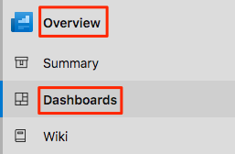

1. Select **Add a widget**.
2. In the **Add widget** pane, search for **Build History**.
3. Drag the **Build History** tile to the canvas.
4. Select the gear icon to configure the widget.
   1. Keep the **Build History** title.
   2. In the **Pipeline** drop-down list, select your pipeline.
   3. Keep **All branches** selected.
5. Select **Save**.
6. Select **Done Editing**.

The **Build History** widget is displayed on the dashboard.

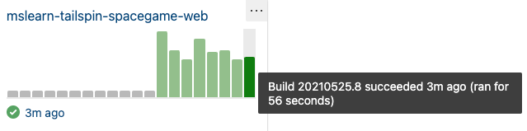

1. Hover over each build to view the build number, when the build was completed, and the elapsed build time.

Each build succeeded, so the bars on the widget are all green. If the build had failed, it would appear in red.

1. Select one of the bars to drill down into that build.

To display more widgets, select the **Extension Gallery** link at the bottom of the **Add Widget** pane.

### Add a rule to require a review

In this unit, you set up a rule on GitHub that requires a reviewer to approve changes before they can be merged into the main branch. As a bonus, you'll also fix the typing error on the *Space Game* website's home page.

Currently, the team allows anyone who makes a pull request to merge the code into the main branch. Because no review is required, it's possible for incorrect or unstable code to creep in.

#### Set up approvals

In this section, you set up a rule on GitHub that requires at least one reviewer to approve a pull request before it can be merged into the main branch. You set up the rule and then verify that it works by pushing up a fix to the typing error that developer made earlier.

#### Add the rule

1. In GitHub, go to your *Space Game* project repository.
2. Select the **Settings** tab near the top of the page.
3. On the menu, select **Branches**.
4. Make sure that **main** is selected as your default branch.
5. Select **Add rule**.
6. Under **Branch name pattern**, enter **main**.
7. Select the **Require pull request reviews before merging** check box.
8. Keep the **Required approving reviews** value at **1**.
9. Select **Create**.
10. Select **Save changes**.

**Note**

At the bottom of the list of choices is an option named **Include Administrators**. This option requires repository administrators to follow the rule. You don't set that, because you're an administrator of your repository and there isn't another reviewer. In this unit, for learning purposes, you review and approve your own pull requests.

#### Submit the fix

In this section, you submit a fix to the typing error on the home page. Recall that the word "official" is mistyped as "oficial".



1. In Visual Studio Code, go to the terminal.
2. To check out the main branch, run git checkout:

git checkout main

1. To pull down the latest changes to the main branch from GitHub, run git pull:

git pull origin main

You can see that two files are updated:

* + **README.md**: Contains the Markdown code for displaying the build badge.
  + **Index.cshtml**: Contains the updated home page text, which includes the typing error.

1. To fix the error, create and check out a branch:

git checkout -B bugfix/home-page-typo

1. In File Explorer, open **Index.cshtml**.
2. Locate the error.

<p>Welcome to the oficial Space Game site!</p>

1. Change the line to correct the error.

<p>Welcome to the official Space Game site!</p>

1. Save the file.
2. In the terminal, stage and commit the change.

git status

git add Tailspin.SpaceGame.Web/Views/Home/Index.cshtml

git commit -m "Fix typing error on the home page"

In practice, you would ordinarily build and run the site locally to verify the change. In this unit, for the sake of brevity, let's skip that step.

1. Push the branch to GitHub.

git push origin bugfix/home-page-typo

#### Test the rule

1. In GitHub, locate and select the bugfix/home-page-typo branch.

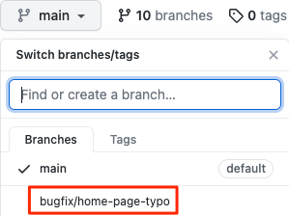

1. To start your pull request, select **Contribute** and then **Open pull request**.
2. Set your forked repository as the base repository.



1. Select **Create pull request**.

You can see that a human review is required before you can merge the change.

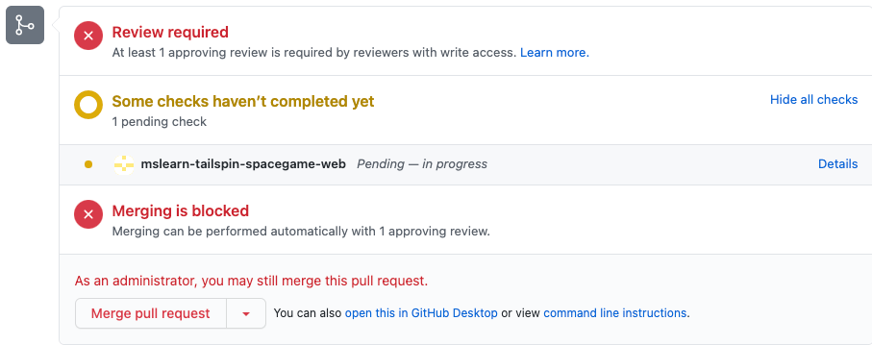

In practice, you would assign a team member to review your change. In this unit, for learning purposes, you merge your own pull request.

1. To merge the pull request, select **Merge pull request**.
2. Select the **Use your Administrator privileges to merge this pull request** check box, and then select **Confirm merge**.

Your change is merged.

1. To delete the bugfix/home-page-typo branch, select **Delete branch**.

#### Move the work item to Done

In this section, you move the work item that you previously assigned to yourself, **Create a Git-based workflow**, to the **Done** column.

In practice, the definition of "Done" often means that working software is in the hands of your users. In this unit, for learning purposes, you mark this work as complete, because you and the Tailspin team have started an improved code workflow that uses Git and GitHub.

At the end of each sprint, or work iteration, you and your team might hold a retrospective meeting in which you share the work you completed, what went well in the sprint, and what could be improved.

To complete the work item:

1. In Microsoft Azure DevOps, select **Boards**.
2. Drag the **Create a Git-based workflow** work item from the **Doing** column to the **Done** column.

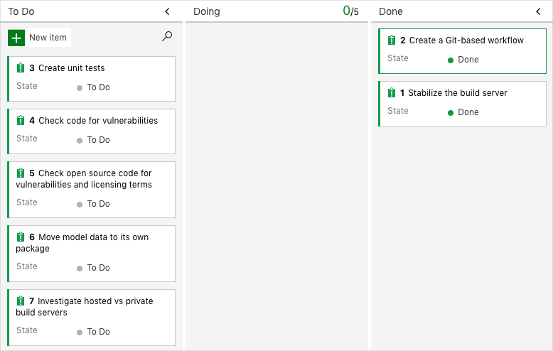

#### Disable the pipeline

Each module in this learning path provides a template that you can run to create a clean environment for the duration of the module.

Running multiple templates creates multiple Microsoft Azure Pipelines projects, each pointing to the same GitHub repository. This action can cause multiple pipelines to run each time you push a change to your GitHub repository. This action, in turn, can cause you to run out of free build minutes on our hosted agents. Therefore, it's important to disable or delete your pipeline before you move on to the next module.

#### Disable the pipeline

This option disables the pipeline so that it doesn't process further build requests. You can reenable the build pipeline later if you want to. Choose this option if you want to keep your DevOps project and your build pipeline for future reference.

To disable the pipeline:

1. In Azure Pipelines, navigate to your pipeline.
2. From the drop-down menu, select **Settings**:



1. Under **Processing of new run requests**, select **Disabled** and then select **Save**.

Your pipeline will no longer process build requests.

## Task 05: Run quality tests in your build pipeline by using Azure Pipelines

Set up automated testing in your pipeline to improve code quality.

As you add a feature to your app, how do you *know* whether the feature will work correctly, given all possible interactions? How do you know that the feature works well with and doesn't break other features? How do you know that your code is maintainable and can be easily understood by others?

You could run the app locally and try a few inputs, but that takes time and doesn't cover all cases. Plus, repeatedly testing existing features gets tedious and time consuming as you add new features.

This module demonstrates how to set up automated testing to help ensure that your latest feature works and that you haven't broken anything along the way.

### Set up your Azure DevOps environment

Here, you make sure that your Azure DevOps organization is set up to complete the rest of this module. You do this by running a template that creates a project for you in Azure DevOps.

The modules in this learning path form a progression, where you follow the Tailspin web team through their DevOps journey. For learning purposes, each module has an associated Azure DevOps project.

#### Run the template

Run a template that sets up everything for you in your Azure DevOps organization.

[Click here to Run the template](https://azuredevopsdemogenerator.azurewebsites.net/?x-ms-routing-name=self&name=run-quality-tests)

To run the template, on the Azure DevOps Demo Generator site, do the following:

1. Select **Sign In**, and accept the usage terms.
2. On the **Create New Project** page, select your Azure DevOps organization, and then enter a project name, such as *Space Game - web - Tests*.
3. Select **Fork repository on GitHub**, and then select **Authorize**. If a window appears, authorize access to your GitHub account.

**Important**

You need to select this option for the template to connect to your GitHub repository. Select it even if you've already forked the *Space Game* website project. The template uses your existing fork.

1. Select **Create Project**.

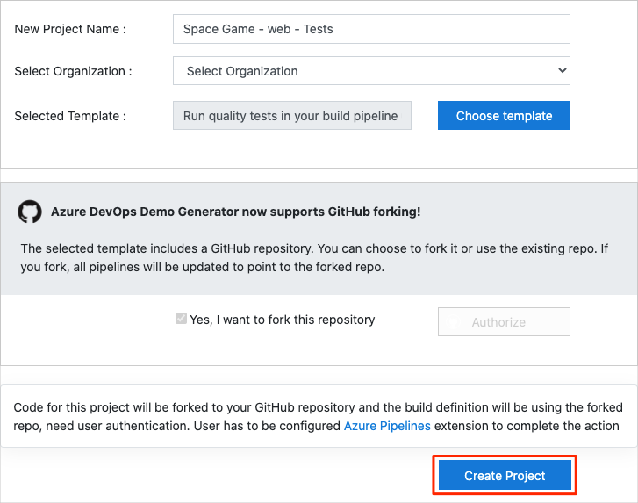

It takes a few moments for the template to run.

1. Select **Navigate to project** to go to your project in Azure DevOps.

#### Move the work item to Doing

In this section, you assign yourself a work item that relates to this module on Azure Boards. You also move the work item to the **Doing** state. In practice, you and your team would create work items at the start of each sprint, or work iteration.

Assigning work in this way gives you a checklist to work from. It gives others on your team visibility into what you're working on and how much work is left. It also helps the team enforce work in process (WIP) limits so that the team doesn't take on too much work at one time.

Recall that the team settled on these seven top issues:



**Note**

Within an Azure DevOps organization, work items are numbered sequentially. In your project, the number that's assigned to each work item might not match what you see here.

Here you move the third item, **Create unit tests**, to the **Doing** column and assign yourself to the work item.

Recall that **Create unit tests** relates to running unit tests during the build so that Tester doesn't have to deal with so many regression bugs when they tests out new builds.

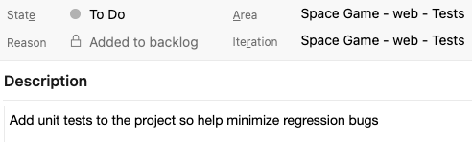

To set up the work item:

1. In Azure DevOps, go to **Boards** and then, in the left pane, select **Boards**.



1. In the **Create unit tests** work item, select the **To Do** down arrow, and then assign the work item to yourself.



1. Drag the work item from the **To Do** column to the **Doing** column.

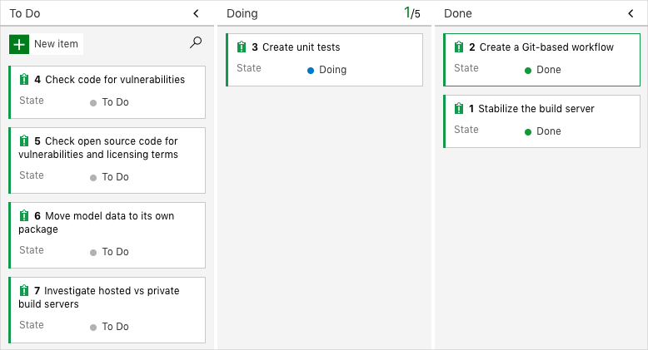

At the end of this module, after you've completed the task, you'll move the card to the **Done** column.

#### Set up the project locally

Here, you load the *Space Game* project in Visual Studio Code, configure Git, clone your repository locally, and set the upstream remote so that you can download starter code.

**Note**

If you're already set up with the **[mslearn-tailspin-spacegame-web](https://github.com/MicrosoftDocs/mslearn-tailspin-spacegame-web" \t "az-portal)** project locally, you can move to the next section.

#### Open the integrated terminal

Visual Studio Code comes with an integrated terminal, so you can edit files and work from the command line all from one place.

1. Start Visual Studio Code.
2. On the **View** menu, select **Terminal**.
3. In the drop-down list, select **bash**. If you're familiar with another Unix shell that you prefer to use, such as Zsh, select that shell instead.



The terminal window lets you choose any shell that's installed on your system, like Bash, Zsh, and PowerShell.

Here you'll use Bash. Git for Windows provides Git Bash, which makes it easy to run Git commands.

**Note**

On Windows, if you don't see **bash** listed as an option, make sure you've installed [**Git**](https://git-scm.com/downloads) and then restart Visual Studio Code.

If you still don't see the **bash** option, see [**Integrated Terminal**](https://code.visualstudio.com/docs/editor/integrated-terminal) to manually configure your terminal settings.

1. Run the cd command to navigate to the directory you want to work from, like your home directory (~). You can choose a different directory if you want.

cd ~

**Configure Git**

If you're new to Git and GitHub, you first need to run a few commands to associate your identity with Git and authenticate with GitHub.

[Set up Git](https://help.github.com/articles/set-up-git) explains the process in greater detail.

At a minimum, you'll need to complete the following steps. Run these commands from the integrated terminal:

1. [Set your username](https://help.github.com/articles/setting-your-username-in-git).
2. [Set your commit email address](https://help.github.com/articles/setting-your-commit-email-address-in-git).
3. [Cache your GitHub password](https://help.github.com/articles/caching-your-github-password-in-git).

**Note**

If you're already using two-factor authentication with GitHub, [**create a personal access token**](https://help.github.com/articles/creating-a-personal-access-token-for-the-command-line) and use your token in place of your password when prompted later.

Treat your access token like you would a password. Keep it in a safe place.

#### Set up your project in Visual Studio Code

In this part, you clone your fork locally so that you can make changes and build out your pipeline configuration.

#### Clone your fork locally

You now have a copy of the *Space Game* web project in your GitHub account. Now you'll download, or *clone*, a copy to your computer so you can work with it.

A clone, just like a fork, is a copy of a repository. When you clone a repository, you can make changes, verify they work as you expect, and then upload those changes back to GitHub. You can also synchronize your local copy with changes other authenticated users have made to GitHub's copy of your repository.

To clone the *Space Game* web project to your computer:

1. Go to your fork of the *Space Game* web project (**mslearn-tailspin-spacegame-web**) on [GitHub](https://github.com/).
2. Select **Code**. Then, from the **HTTPS** tab, select the button next to the URL that's shown to copy the URL to your clipboard.



1. In Visual Studio Code, go to the terminal window.
2. In the terminal, move to the directory you want to work from, like your home directory (~). You can choose a different directory if you want.

cd ~

1. Run the git clone command. Replace the URL that's shown here with the contents of your clipboard:

git clone https://github.com/your-name/mslearn-tailspin-spacegame-web.git

1. Move to the mslearn-tailspin-spacegame-web directory. This is the root directory of your repository.

cd mslearn-tailspin-spacegame-web

#### Set the upstream remote

A *remote* is a Git repository where team members collaborate (like a repository on GitHub). Here you list your remotes and add a remote that points to Microsoft's copy of the repository so that you can get the latest sample code.

1. Run this git remote command to list your remotes:

git remote -v

You see that you have both fetch (download) and push (upload) access to your repository:

origin https://github.com/username/mslearn-tailspin-spacegame-web.git (fetch)

origin https://github.com/username/mslearn-tailspin-spacegame-web.git (push)

*Origin* specifies your repository on GitHub. When you fork code from another repository, it's common to name the original remote (the one you forked from) as *upstream*.

1. Run this git remote add command to create a remote named *upstream* that points to the Microsoft repository:

git remote add upstream https://github.com/MicrosoftDocs/mslearn-tailspin-spacegame-web.git

1. Run git remote a second time to see the changes:

git remote -v

You see that you still have both fetch (download) and push (upload) access to your repository. You also now have fetch access from the Microsoft repository:

origin https://github.com/username/mslearn-tailspin-spacegame-web.git (fetch)

origin https://github.com/username/mslearn-tailspin-spacegame-web.git (push)

upstream https://github.com/MicrosoftDocs/mslearn-tailspin-spacegame-web.git (fetch)

**Open the project in the file explorer**

In Visual Studio Code, your terminal window points to the root directory of the *Space Game* web project. To view its structure and work with files, from the file explorer, you'll now open the project.

1. The easiest way to open the project is to reopen Visual Studio Code in the current directory. To do so, run the following command from the integrated terminal:

code -r .

You see the directory and file tree in the file explorer.

1. Reopen the integrated terminal. The terminal places you at the root of your web project.

If the code command fails, you need to add Visual Studio Code to your system PATH. To do so:

1. In Visual Studio Code, select F1 or select **View** > **Command Palette** to access the command palette.
2. In the command palette, enter *Shell Command: Install 'code' command in PATH*.
3. Repeat the previous procedure to open the project in the file explorer.

You're now set up to work with the *Space Game* source code and your Azure Pipelines configuration from your local development environment.

### Add unit tests to your application

Regression bugs are creeping into their code and breaking the leaderboard's filtering functionality. Specifically, the wrong game mode keeps appearing.

The following image illustrates Tester's problem. When Tester selects "Milky Way" to show only scores from that game map, they gets results from other game maps, such as Andromeda.

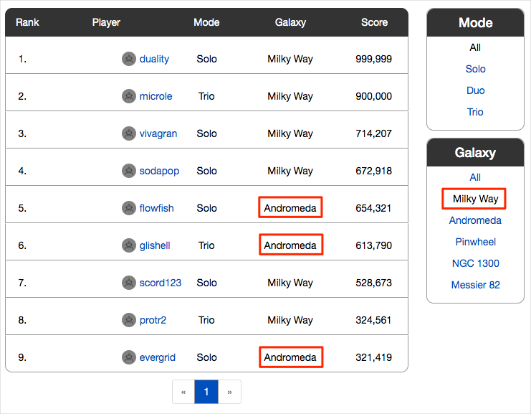

Unit tests are a great way to automatically test for regression bugs.

The application uses a document database to store high scores and player profiles. Right now, it uses local test data. Later, they plan to connect the app to a live database.

A number of unit test frameworks are available for C# applications. We choose NUnit because it's popular with the community.

Here's the unit test you're working with,

[TestCase("Milky Way")]

[TestCase("Andromeda")]

[TestCase("Pinwheel")]

[TestCase("NGC 1300")]

[TestCase("Messier 82")]

public void FetchOnlyRequestedGameRegion(string gameRegion)

{

const int PAGE = 0; // take the first page of results

const int MAX_RESULTS = 10; // sample up to 10 results

// Form the query predicate.

// This expression selects all scores for the provided game region.

Expression<Func<Score, bool>> queryPredicate = score => (score.GameRegion == gameRegion);

// Fetch the scores.

Task<IEnumerable<Score>> scoresTask = _scoreRepository.GetItemsAsync(

queryPredicate, // the predicate defined above

score => 1, // we don't care about the order

PAGE,

MAX_RESULTS

);

IEnumerable<Score> scores = scoresTask.Result;

// Verify that each score's game region matches the provided game region.

Assert.That(scores, Is.All.Matches<Score>(score => score.GameRegion == gameRegion));

}

You can filter the leaderboard by any combination of game type and game map.

This test queries the leaderboard for high scores and verifies that each result matches the provided game map.

In an NUnit test method, TestCase, provides inline data to use to test that method. Here, NUnit calls the FetchOnlyRequestedGameRegion unit test method like this:

FetchOnlyRequestedGameRegion("Milky Way");

FetchOnlyRequestedGameRegion("Andromeda");

FetchOnlyRequestedGameRegion("Pinwheel");

FetchOnlyRequestedGameRegion("NGC 1300");

FetchOnlyRequestedGameRegion("Messier 82");

Notice the call to the Assert.That method at the end of the test. An *assertion* is a condition or statement that you declare to be true. If the condition turns out to be false, that could indicate a bug in your code. NUnit runs each test method using the inline data you specify and records the result as a passing or failing test.

Many unit test frameworks provide verification methods that resemble natural language. These methods help make tests easy to read and help you map the tests to the application's requirements.

Consider the assertion made in this example:

Assert.That(scores, Is.All.Matches<Score>(score => score.GameRegion == gameRegion));

You might read this line as:

*Assert that the game region of each returned score matches the provided game region.*

Here's the process to follow:

1. Fetch a branch from the GitHub repository that contains the unit tests.
2. Run the tests locally to verify that they pass.
3. Add tasks to your pipeline configuration to run the tests and collect the results.
4. Push the branch to your GitHub repository.
5. Watch your Azure Pipelines project automatically build the application and run the tests.

#### Fetch the branch from GitHub

Here you fetch the unit-tests branch from GitHub and check out, or switch to, that branch.

This branch contains the *Space Game* project that you worked with in the previous modules and an Azure Pipelines configuration to start with.

1. In Visual Studio Code, open the integrated terminal.
2. Run the following git commands to fetch a branch named unit-tests from the Microsoft repository, and then switch to that branch.

git fetch upstream unit-tests

git checkout -B unit-tests upstream/unit-tests

The format of this command enables you to get starter code from the Microsoft GitHub repository, known as upstream. Shortly, you'll push this branch to your GitHub repository, known as origin.

1. As an optional step, in Visual Studio Code, open the *azure-pipelines.yml* file and familiarize yourself with the initial configuration. The configuration resembles the basic one you created in the Create a build pipeline with Azure Pipelines module. It builds only the application's Release configuration.

#### Run the tests locally

It's a good idea to run all tests locally before you submit any tests to the pipeline. Here you do that.

1. In Visual Studio Code, open the integrated terminal.
2. Run dotnet build to build each project in the solution.

dotnet build --configuration Release

1. Run the following dotnet test command to run the unit tests:

dotnet test --configuration Release --no-build

The --no-build flag specifies not to build the project before running it. You don't need to build the project, because you built it in the previous step.

You see that all five tests pass.

Starting test execution, please wait...

A total of 1 test files matched the specified pattern.

Passed! - Failed: 0, Passed: 5, Skipped: 0, Total: 5, Duration: 57 ms

In this example, the tests took less than one second to run.

Notice that there were five total tests. Although we define just one test method, FetchOnlyRequestedGameRegion, that test is run five times, once for each game map as specified in the TestCase inline data.

1. Run the tests a second time. This time, provide the --logger option to write the results to a log file.

dotnet test Tailspin.SpaceGame.Web.Tests --configuration Release --no-build --logger trx

You see from the output that a TRX file is created in the **TestResults** directory.

A TRX file is an XML document that contains the results of a test run. It's a popular format for test results because Visual Studio and other tools can help you visualize the results.

Later, you'll see how Azure Pipelines can help you visualize and track your tests' results as they run through the pipeline.

**Note**

TRX files are not meant to be included in source control. A *.gitignore* file enables you specify which temporary and other files you want Git to ignore. The project's *.gitignore* file is already set up to ignore anything in the *TestResults* directory.

1. As an optional step, in Visual Studio Code, open the *DocumentDBRepository_GetItemsAsyncShould.cs* file from the *Tailspin.SpaceGame.Web.Tests* folder, and examine the test code. Even if you're not interested in building .NET apps specifically, you might find the test code useful because it resembles code you might see in other unit test frameworks.

#### Add tasks to your pipeline configuration

Here you configure the build pipeline to run your unit tests and collect the results.

1. In Visual Studio Code, modify *azure-pipelines.yml* like this:

trigger:

- '*'

pool:

vmImage: 'ubuntu-20.04'

demands:

- npm

variables:

buildConfiguration: 'Release'

wwwrootDir: 'Tailspin.SpaceGame.Web/wwwroot'

dotnetSdkVersion: '5.x'

steps:

- task: UseDotNet@2

displayName: 'Use .NET SDK $(dotnetSdkVersion)'

inputs:

version: '$(dotnetSdkVersion)'

- task: Npm@1

displayName: 'Run npm install'

inputs:

verbose: false

- script: './node_modules/.bin/node-sass $(wwwrootDir) --output $(wwwrootDir)'

displayName: 'Compile Sass assets'

- task: gulp@1

displayName: 'Run gulp tasks'

- script: 'echo "$(Build.DefinitionName), $(Build.BuildId), $(Build.BuildNumber)" > buildinfo.txt'

displayName: 'Write build info'

workingDirectory: $(wwwrootDir)

- task: DotNetCoreCLI@2

displayName: 'Restore project dependencies'

inputs:

command: 'restore'

projects: '**/*.csproj'

- task: DotNetCoreCLI@2

displayName: 'Build the project - $(buildConfiguration)'

inputs:

command: 'build'

arguments: '--no-restore --configuration $(buildConfiguration)'

projects: '**/*.csproj'

- task: DotNetCoreCLI@2

displayName: 'Run unit tests - $(buildConfiguration)'

inputs:

command: 'test'

arguments: '--no-build --configuration $(buildConfiguration)'

publishTestResults: true

projects: '**/*.Tests.csproj'

- task: DotNetCoreCLI@2

displayName: 'Publish the project - $(buildConfiguration)'

inputs:

command: 'publish'

projects: '**/*.csproj'

publishWebProjects: false

arguments: '--no-build --configuration $(buildConfiguration) --output $(Build.ArtifactStagingDirectory)/$(buildConfiguration)'

zipAfterPublish: true

- task: PublishBuildArtifacts@1

displayName: 'Publish Artifact: drop'

condition: succeeded()

This version introduces this DotNetCoreCLI@2 build task.

- task: DotNetCoreCLI@2

displayName: 'Run unit tests - $(buildConfiguration)'

inputs:

command: 'test'

arguments: '--no-build --configuration $(buildConfiguration)'

publishTestResults: true

projects: '**/*.Tests.csproj'

This build task runs the dotnet test command.

Notice that this task does not specify the --logger trx argument that you used when you ran the tests manually. The publishTestResults argument adds that for you. This argument tells the pipeline to generate the TRX file to a temporary directory, accessible through the $(Agent.TempDirectory) built-in variable. It also publishes the task results to the pipeline.

The projects argument specifies all C# projects that match *"**/*.Tests.csproj*." The *"**"* part matches all directories, and the *"*.Tests.csproj"* part matches all projects whose file name ends with *".Tests.csproj*." The unit-tests branch contains just one unit test project, *Tailspin.SpaceGame.Web.Tests.csproj*. But by specifying a pattern, you can run additional test projects without the need to modify your build configuration.

#### Push the branch to GitHub

Here you push your changes to GitHub and see the pipeline run. Recall that you're currently on the unit-tests branch.

1. In the integrated terminal, add *azure-pipelines.yml* to the index, commit the changes, and push the branch up to GitHub.

git add azure-pipelines.yml

git commit -m "Run and publish unit tests"

git push origin unit-tests

#### Watch Azure Pipelines run the tests

Here you see the tests run in the pipeline and then visualize the results from Microsoft Azure Test Plans. Azure Test Plans provides all the tools you need to successfully test your applications. You can create and run manual test plans, generate automated tests, and collect feedback from stakeholders.

1. In Azure Pipelines, trace the build through each of the steps.

You see that the **Run unit tests - Release** task runs the unit tests just as you did manually from the command line.

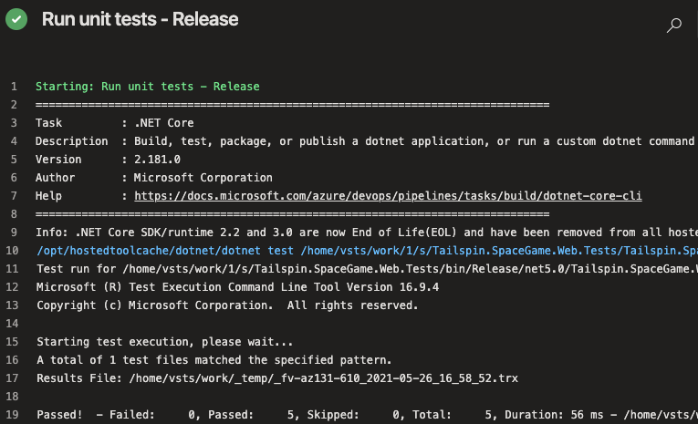

1. Navigate back to the pipeline summary.
2. Move to the **Tests** tab.

You see a summary of the test run. All five tests have passed.

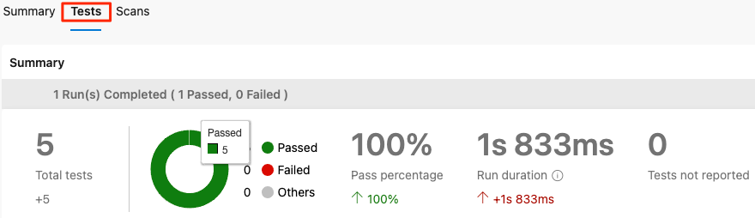

1. In Azure DevOps, select **Test Plans**, and then select **Runs**.

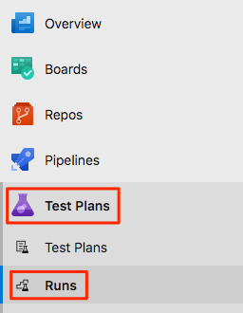

You see the most recent test runs, including the one you just ran.

1. Double-click the most recent test run.

You see a summary of the results.

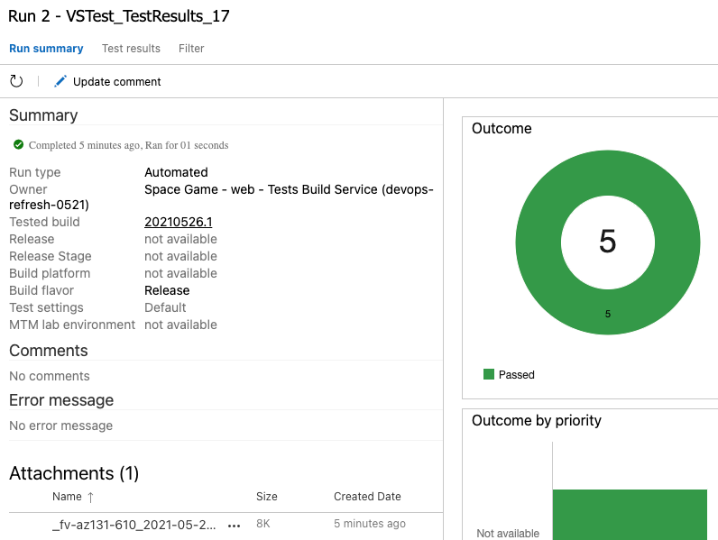

In this example, all five tests have passed. If any tests failed, you could navigate to the build task to get additional details.

You can also download the TRX file so you can examine it through Visual Studio or another visualization tool.

it's a good start and it fixes the immediate problem. Now, the team has a place to add more tests and run them as they improve their process.

### Add a testing widget to your dashboard

In this unit, you add a widget to your dashboard to help visualize your test runs over time.

#### Add the widget to the dashboard

1. In your Azure DevOps project, select **Overview**, and then select **Dashboards**.

**Note**

If you ran the template to create the Azure DevOps project, you won't see the dashboard widgets you set up in previous modules.

1. Select **Add a widget**.
2. In the **Add Widget** pane, search for **Test Results Trend**.
3. Drag **Test Results Trend** to the canvas.
4. Select the gear icon to configure the widget.

a. Under **Build pipeline**, select your pipeline.

b. Keep the other default settings.

1. Select **Save**.
2. Select **Done Editing**.

Although the widget displays only one test run, you now have a way to visualize and track test runs over time. Here's an example that shows a few successful test runs.

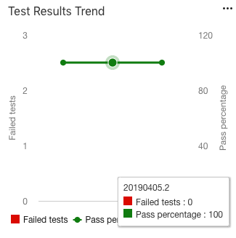

If you begin to see test failures, you can click a point on the graph to navigate directly to that build.

### Perform code coverage testing

Much like the tool you use for unit testing, the tool you use for code coverage depends on the programming language and application framework you use.

When you target .NET applications to run on Linux, [coverlet](https://github.com/tonerdo/coverlet) is a popular option. Coverlet is a cross-platform, code-coverage library for .NET. Before we add code coverage to the pipeline, let's check in with the team.

#### How is code coverage done in .NET?

The way you collect code coverage depends on what programming language and frameworks you're using, as well as what code coverage tools are available.

* Visual Studio on Windows provides a way to perform code coverage.
* However, because the team is building on Linux, they can use [coverlet](https://github.com/tonerdo/coverlet), a cross-platform code coverage library for .NET.

The unit test project requires the [coverlet.msbuild](https://www.nuget.org/packages/coverlet.msbuild" \t "az-portal) NuGet package.

* Code coverage results are written to an XML file so that they can be processed by another tool. Azure Pipelines supports [Cobertura](https://cobertura.github.io/cobertura" \t "az-portal) and [JaCoCo](https://www.eclemma.org/jacoco" \t "az-portal) coverage result formats.

You will try Cobertura.

* To convert Cobertura coverage results to a format that's human-readable, they can use a tool called [ReportGenerator](https://github.com/danielpalme/ReportGenerator" \t "az-portal).
* ReportGenerator provides a number of formats, including HTML. The HTML formats create detailed reports for each class in a .NET project.

Specifically, there's an HTML format called **HtmlInline_AzurePipelines**, which provides a visual appearance that matches Azure Pipelines.

#### How can I manage .NET tools?

A .NET tool such as ReportGenerator is a special NuGet package that contains a console application. You can manage a .NET tool as a global tool or as a local tool.

A global tool is installed in a centralized location and can be called from any directory. One version of a global tool is used for all directories on the machine.

A local tool is a more isolated copy of a .NET tool that's scoped to a specific directory. Scope enables different directories to contain different versions of the same tool.

You use a *manifest file* to manage local tools for a given directory. This file is in JSON format and is typically named *dotnet-tools.json*. A manifest file enables you to describe the specific tool versions that you need to build or run your application.

When you include the manifest file in source control along with your application sources, developers and build systems can run the dotnet tool restore command to install all of the tools listed in the manifest file. When you need a newer version of a local tool, you simply update the version in the manifest file.

To keep things more isolated, in this module you work with local tools. You create a tool manifest that includes the ReportGenerator tool. You also modify your build pipeline to install the ReportGenerator tool to convert code coverage results to a human-readable format.

#### Run code coverage locally

Before write any pipeline code, team decide to try things manually to verify the process. Follow along with their process:

1. In Visual Studio Code, open the integrated terminal.
2. Run the following dotnet new command to create a local tool manifest file.

dotnet new tool-manifest

The command creates a file named *.config/dotnet-tools.json*.

1. Run the following dotnet tool install command to install ReportGenerator:

dotnet tool install dotnet-reportgenerator-globaltool

This command installs the latest version of ReportGenerator and adds an entry to the tool manifest file.

1. Run the following dotnet add package command to add the coverlet.msbuild package to the *Tailspin.SpaceGame.Web.Tests* project:

dotnet add Tailspin.SpaceGame.Web.Tests package coverlet.msbuild

1. Run the following dotnet test command to run your unit tests and collect code coverage:

dotnet test --no-build --configuration Release /p:CollectCoverage=true /p:CoverletOutputFormat=cobertura /p:CoverletOutput=./TestResults/Coverage/

If the command fails, try running it like this:

MSYS2_ARG_CONV_EXCL="*" dotnet test --no-build --configuration Release /p:CollectCoverage=true /p:CoverletOutputFormat=cobertura /p:CoverletOutput=./TestResults/Coverage/

This command resembles the one you ran previously. The /p: flags tell coverlet which code coverage format to use and where to place the results.

1. Run the following dotnet tool run command to use ReportGenerator to convert the Cobertura file to HTML:

dotnet tool run reportgenerator -reports:./Tailspin.SpaceGame.Web.Tests/TestResults/Coverage/coverage.cobertura.xml -targetdir:./CodeCoverage -reporttypes:HtmlInline_AzurePipelines

A number of HTML files appear in the *CodeCoverage* folder at the root of the project.

1. In Visual Studio Code, expand the *CodeCoverage* folder, right-click *index.htm*, and then select **Reveal in Explorer** (**Reveal in Finder** on macOS or **Open Containing Folder** on Linux).
2. In Windows Explorer (Finder on macOS), double-click *index.htm* to open it in a web browser.

You see the coverage report summary.

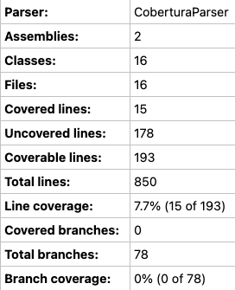

1. Scroll to the bottom of the page to see a coverage breakdown by class type.

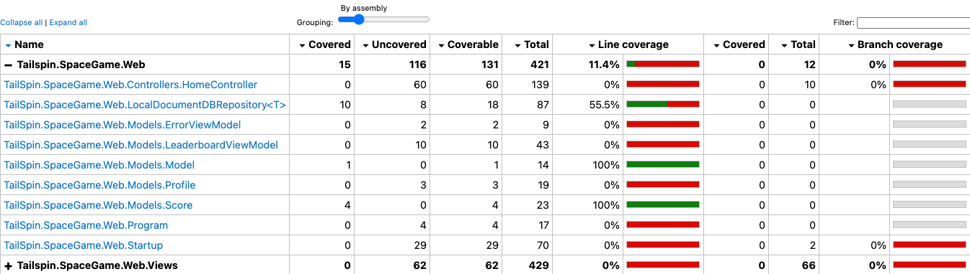

1. Select the link to TailSpin.SpaceGame.Web.LocalDocumentDBRepository<T> to view further details.

Notice that the GetItemsAsync method is covered by unit tests, but the CountItemsAsync method has no coverage.

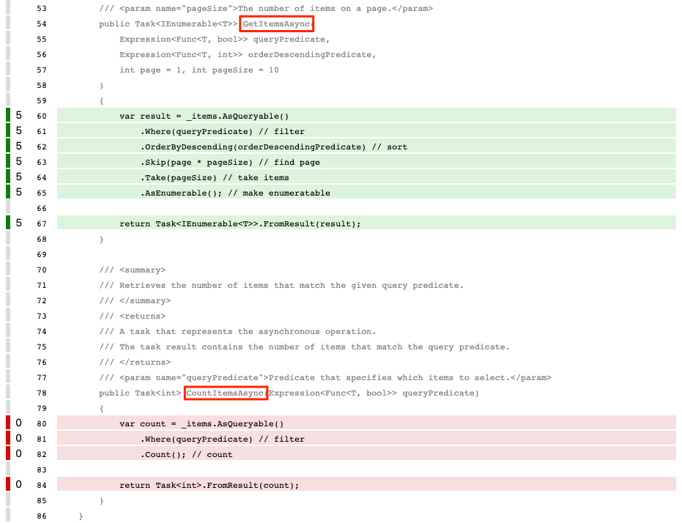

This makes sense, because the FetchOnlyRequestedGameRegion test method calls the GetItemsAsync method but does not call the CountItemsAsync method. (To review the test code, see the *DocumentDBRepository_GetItemsAsyncShould.cs* file.)

#### Create a branch

Now that you can build a code coverage report locally, you're ready to add tasks to your build pipeline, which performs the same tasks.

In this part, you create a branch named code-coverage, based on the unit-tests branch, to hold your work. In practice, you would ordinarily create this branch from the main branch.

1. In Visual Studio Code, open the integrated terminal.
2. In the terminal, run the following git checkout command to create a branch named code-coverage:

git checkout -B code-coverage

#### Add build tasks

In this section, you add tasks that measure code coverage to your build pipeline.

1. In Visual Studio Code, modify *azure-pipelines.yml* like this:

trigger:

- '*'

pool:

vmImage: 'ubuntu-20.04'

demands:

- npm

variables:

buildConfiguration: 'Release'

wwwrootDir: 'Tailspin.SpaceGame.Web/wwwroot'

dotnetSdkVersion: '5.x'

steps:

- task: UseDotNet@2

displayName: 'Use .NET SDK $(dotnetSdkVersion)'

inputs:

version: '$(dotnetSdkVersion)'

- task: Npm@1

displayName: 'Run npm install'

inputs:

verbose: false

- script: './node_modules/.bin/node-sass $(wwwrootDir) --output $(wwwrootDir)'

displayName: 'Compile Sass assets'

- task: gulp@1

displayName: 'Run gulp tasks'

- script: 'echo "$(Build.DefinitionName), $(Build.BuildId), $(Build.BuildNumber)" > buildinfo.txt'

displayName: 'Write build info'

workingDirectory: $(wwwrootDir)

- task: DotNetCoreCLI@2

displayName: 'Restore project dependencies'

inputs:

command: 'restore'

projects: '**/*.csproj'

- task: DotNetCoreCLI@2

displayName: 'Build the project - $(buildConfiguration)'

inputs:

command: 'build'

arguments: '--no-restore --configuration $(buildConfiguration)'

projects: '**/*.csproj'

- task: DotNetCoreCLI@2

displayName: 'Install .NET tools from local manifest'

inputs:

command: custom

custom: tool

arguments: 'restore'

- task: DotNetCoreCLI@2

displayName: 'Run unit tests - $(buildConfiguration)'

inputs:

command: 'test'

arguments: '--no-build --configuration $(buildConfiguration) /p:CollectCoverage=true /p:CoverletOutputFormat=cobertura /p:CoverletOutput=$(Build.SourcesDirectory)/TestResults/Coverage/'

publishTestResults: true

projects: '**/*.Tests.csproj'

- task: DotNetCoreCLI@2

displayName: 'Create code coverage report'

inputs:

command: custom

custom: tool

arguments: 'run reportgenerator -reports:$(Build.SourcesDirectory)/**/coverage.cobertura.xml -targetdir:$(Build.SourcesDirectory)/CodeCoverage -reporttypes:HtmlInline_AzurePipelines'

- task: PublishCodeCoverageResults@1

displayName: 'Publish code coverage report'

inputs:

codeCoverageTool: 'cobertura'

summaryFileLocation: '$(Build.SourcesDirectory)/**/coverage.cobertura.xml'

- task: DotNetCoreCLI@2

displayName: 'Publish the project - $(buildConfiguration)'

inputs:

command: 'publish'

projects: '**/*.csproj'

publishWebProjects: false

arguments: '--no-build --configuration $(buildConfiguration) --output $(Build.ArtifactStagingDirectory)/$(buildConfiguration)'

zipAfterPublish: true

- task: PublishBuildArtifacts@1

displayName: 'Publish Artifact: drop'

condition: succeeded()

This version builds upon your existing configuration. Here's a summary of what's new:

|  |  |  |
| --- | --- | --- |
| **TABLE 1** | | |
| **Azure Pipelines task** | **Display name** | **Description** |
| DotNetCoreCLI@2 | Install .NET tools from local manifest | Installs tools listed in the manifest file, *dotnet-tools.json* |
| DotNetCoreCLI@2 | Run unit tests - $(buildConfiguration) | Runs unit tests and also collects code coverage in Cobertura format |
| DotNetCoreCLI@2 | Create code coverage report | Converts Cobertura output to HTML |
| PublishCodeCoverageResults@1 | Publish code coverage report | Publishes the report to the pipeline |

#### Commit your changes and push the branch to GitHub

Here you push your changes to GitHub and see the pipeline run. Recall that you're currently in the code-coverage branch.

Although not required, here you add and commit each file separately so that each change is associated with a descriptive commit message.

1. In Visual Studio Code, go to the terminal.
2. Add and commit the *Tailspin.SpaceGame.Web.Tests.csproj* file, which now contains a reference to the coverlet.msbuild package:

git add Tailspin.SpaceGame.Web.Tests/Tailspin.SpaceGame.Web.Tests.csproj

git commit -m "Add coverlet.msbuild package"

1. Add and commit the tool manifest file, *dotnet-tools.json*:

git add .config/dotnet-tools.json

git commit -m "Add code coverage"

1. Add and commit *azure-pipelines.yml*, which contains your updated build configuration:

git add azure-pipelines.yml

git commit -m "Add code coverage"

1. Push the code-coverage branch to GitHub.

git push origin code-coverage

#### Watch Azure Pipelines run the tests

Here you see the tests run in the pipeline and then visualize the results from Azure Test Plans.

1. In Azure Pipelines, trace the build through each of the steps.
2. When the build finishes, navigate back to the summary page and select the **Code Coverage** tab.

You view the same results that you did when you ran the tests locally.

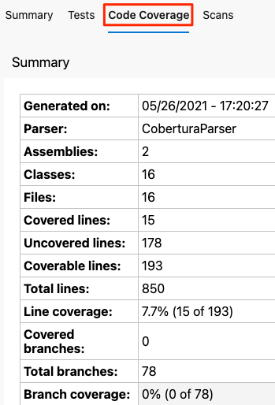

As an optional step, you can explore the results from Azure Pipelines.

#### Add the dashboard widget

In the previous part, you added the **Test Results Trend** widget to your dashboard, which lets others quickly review test result trends over time.

Here you add a second widget that summarizes code coverage.

1. In a new browser tab, go to [marketplace.visualstudio.com](https://marketplace.visualstudio.com/).
2. On the **Azure DevOps** tab, search for **code coverage**.
3. Select **Code Coverage Widgets** (published by Shane Davis).
4. Select **Get it free**.
5. In the drop-down list, select your Azure DevOps organization.
6. Select **Install**.
7. Go back to Azure DevOps.
8. Go to **Overview** > **Dashboards**.
9. Select **Edit**.
10. Search for **Code Coverage**, and then select **Code Coverage**.

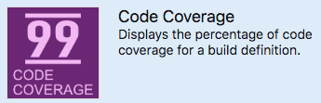

1. Drag **Code Coverage** to the canvas.
2. Select the gear icon to configure the widget.
3. Keep all the default settings, except for:
   * Width: Enter **2**.
   * Build definition: Select your pipeline.
   * Coverage measurement: Enter **Lines**.
4. Select **Save**.
5. Select **Done Editing**.

The widget shows the percentage of code your unit tests cover.

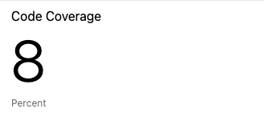

You now have code coverage set up in your pipeline. Although your existing code coverage is low, you have a baseline that you can improve over time.

Later, you can configure coverlet to check to see whether your tests provide a minimum threshold of coverage. Your threshold might be 30 percent, 50 percent, or 80 percent coverage, depending on your requirements. The build will fail if less than this amount is covered by your tests.

#### Remove code coverage files

Recall that when you ran Reportgenerator earlier, a number of HTML files appeared in the *CodeCoverage* folder at the root of the project.

These HTML files are not intended to be included in source control, and you no longer need them. Although the project's *.gitignore* file is already set up to ignore anything in the *CodeCoverage* directory, it's a good idea to delete these files so that they're not added to your Git repository in future modules.

In Visual Studio Code, go to the terminal window and then, in your project's root directory, run this command:

rm -rf CodeCoverage/

### Fix a failed test

At this point, you have a way to run unit tests as changes move through the build pipeline. You also have a way to measure the amount of code that's covered by your tests.

It's always a good idea to run your tests locally before you submit changes to the pipeline. But what happens when someone forgets and submits a change that breaks the build?

In this unit, you help the team fix a broken build that's caused by a failing unit test. Here, you will:

* Get starter code from GitHub.
* Add code coverage tools to your project.
* Push the code up to your repository.
* Watch the pipeline automatically run and the unit tests fail.
* Reproduce the failure locally.
* Analyze and fix the failure.
* Push up a fix and watch the build succeed.

#### Review the new unit test

Here's what the test looks like. You don't need to add any code just yet.

[TestCase(0, ExpectedResult=0)]

[TestCase(1, ExpectedResult=1)]

[TestCase(10, ExpectedResult=10)]

public int ReturnRequestedCount(int count)

{

const int PAGE = 0; // take the first page of results

// Fetch the scores.

Task<IEnumerable<Score>> scoresTask = _scoreRepository.GetItemsAsync(

score => true, // return all scores

score => 1, // we don't care about the order

PAGE,

count // fetch this number of results

);

IEnumerable<Score> scores = scoresTask.Result;

// Verify that we received the specified number of items.

return scores.Count();

}

Recall that in an NUnit test, TestCase provides inline data to use to test that method. NUnit calls the ReturnRequestedCount unit test method like this:

ReturnRequestedCount(0);

ReturnRequestedCount(1);

ReturnRequestedCount(10);

This test also uses the ExpectedResult property to simplify the test code and help make its intention clear. NUnit automatically compares the return value against the value of this property, removing the need to explicitly call the assertion.

#### Fetch the branch from GitHub

As you did earlier, you fetch the failed-test branch from GitHub and check out, or switch to, that branch.

1. In Visual Studio Code, open the integrated terminal.
2. Run the following git fetch and git checkout commands to download a branch named failed-test from the Microsoft repository and switch to that branch:

git fetch upstream failed-test

git checkout -B failed-test upstream/failed-test

We named the branch failed-test for learning purposes. In practice, you would name a branch after its purpose or feature.

1. Run these commands to create a local tool manifest file, install the ReportGenerator tool, and add the coverlet.msbuild package to your tests project:

dotnet new tool-manifest

dotnet tool install dotnet-reportgenerator-globaltool

dotnet add Tailspin.SpaceGame.Web.Tests package coverlet.msbuild

You need this step because the failed-test branch does not contain the work you added to the unit-tests branch.

1. Add your test project file and your tool manifest file to the staging index and commit your changes.

git add Tailspin.SpaceGame.Web.Tests/Tailspin.SpaceGame.Web.Tests.csproj

git add .config/dotnet-tools.json

git commit -m "Configure code coverage tests"

1. Run the following git push command to upload the failed-test branch to your GitHub repository:

git push origin failed-test

#### See the test failure in the pipeline

Let's say that Development lead was in a hurry and pushed up his work without running the tests one final time. Luckily, the pipeline can help you catch issues early when there are unit tests. You can see that here.

1. In Azure Pipelines, trace the build as it runs through the pipeline.
2. Expand the **Run unit tests - Release** task as it runs.

You see that the ReturnRequestedCount test method fails.

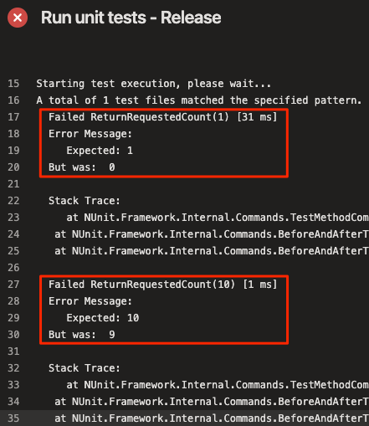

The test passes when the input value is 0, but it fails when the input value is 1 or 10.

The build is published to the pipeline only when the previous task succeeds. Here, the build wasn't published because the unit tests failed. This prevents others from accidentally obtaining a broken build.

In practice, you won't always manually trace the build as it runs. Here are a few ways you might discover the failure:

* **An email notification from Azure DevOps**

You can configure Azure DevOps to send you an email notification when the build is complete. The subject line starts with "[Build failed]" when the build fails.

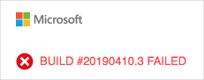

* **Azure Test Plans**

In Azure DevOps, select **Test Plans**, and then select **Runs**. You see the recent test runs, including the one that just ran. Select the latest completed test. You see that two of the eight tests failed.

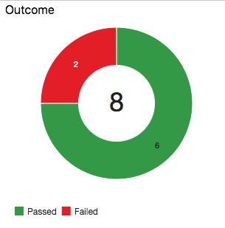

* **The dashboard**

In Azure DevOps, select **Overview**, and then select **Dashboards**. You see the failure appear in the **Test Results Trend** widget. The **Code Coverage** widget is blank, which indicates that code coverage was not run.

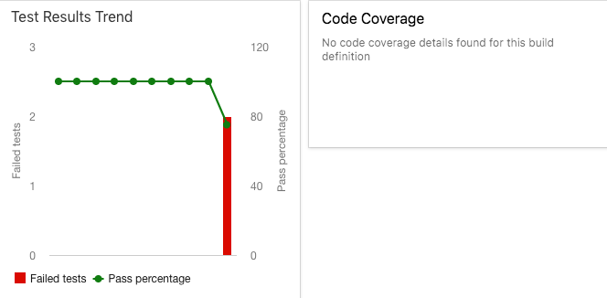

* **The build badge**

Although the failed-test branch doesn't include the build badge in the *README.md* file, here's what you would see on GitHub when the build fails:

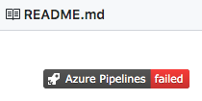

#### Analyze the test failure

When unit tests fail, you ordinarily have two choices, depending on the nature of the failure:

* If the test reveals a defect in the code, you fix the code and rerun the tests.
* If the functionality changes, adjust the test to match the new requirements.

#### Reproduce the failure locally

In this section, you reproduce the failure locally,

1. In Visual Studio Code, open the integrated terminal.
2. In the terminal, run this dotnet build command to build the application:

dotnet build --configuration Release

1. In the terminal, run this dotnet test command to run the unit tests:

dotnet test --no-build --configuration Release

You see the same errors that you saw in the pipeline. Here's part of the output:

Starting test execution, please wait...

A total of 1 test files matched the specified pattern.

Failed ReturnRequestedCount(1) [33 ms]

Error Message:

Expected: 1

But was: 0

Stack Trace:

at NUnit.Framework.Internal.Commands.TestMethodCommand.Execute(TestExecutionContext context)

at NUnit.Framework.Internal.Commands.BeforeAndAfterTestCommand.<>c__DisplayClass1_0.<Execute>b__0()

at NUnit.Framework.Internal.Commands.BeforeAndAfterTestCommand.RunTestMethodInThreadAbortSafeZone(TestExecutionContext context, Action action)

Failed ReturnRequestedCount(10) [1 ms]

Error Message:

Expected: 10

But was: 9

Stack Trace:

at NUnit.Framework.Internal.Commands.TestMethodCommand.Execute(TestExecutionContext context)

at NUnit.Framework.Internal.Commands.BeforeAndAfterTestCommand.<>c__DisplayClass1_0.<Execute>b__0()

at NUnit.Framework.Internal.Commands.BeforeAndAfterTestCommand.RunTestMethodInThreadAbortSafeZone(TestExecutionContext context, Action action)

Failed! - Failed: 2, Passed: 6, Skipped: 0, Total: 8, Duration: 98 ms

**Find the cause of the error**

Each failed test produces a result that's off by one. For example, when 10 is expected, the test returns 9.

By looking at the source code for the method that's being tested, LocalDocumentDBRepository<T>.GetItemsAsync. They see this:

public Task<IEnumerable<T>> GetItemsAsync(

Expression<Func<T, bool>> queryPredicate,

Expression<Func<T, int>> orderDescendingPredicate,

int page = 1, int pageSize = 10

)

{

var result = _items.AsQueryable()

.Where(queryPredicate) // filter

.OrderByDescending(orderDescendingPredicate) // sort

.Skip(page * pageSize) // find page

.Take(pageSize - 1) // take items

.AsEnumerable(); // make enumeratable

return Task<IEnumerable<T>>.FromResult(result);

}

You examine the file on GitHub and notice that it was recently changed.



You suspects that pageSize - 1 is returning one fewer results and that this should be just pageSize.

**Tip**

Discussion and collaboration can also happen on GitHub. You can comment on a pull request or open an issue.

#### Fix the error

In this section, you fix the error by changing the code back to its original state and running the tests to verify the fix.

1. In Visual Studio Code, open *Tailspin.SpaceGame.Web/LocalDocumentDBRepository.cs* from the file explorer.
2. Modify the GetItemsAsync method as shown here:

public Task<IEnumerable<T>> GetItemsAsync(

Expression<Func<T, bool>> queryPredicate,

Expression<Func<T, int>> orderDescendingPredicate,

int page = 1, int pageSize = 10

)

{

var result = _items.AsQueryable()

.Where(queryPredicate) // filter

.OrderByDescending(orderDescendingPredicate) // sort

.Skip(page * pageSize) // find page

.Take(pageSize) // take items

.AsEnumerable(); // make enumeratable

return Task<IEnumerable<T>>.FromResult(result);

}

This version changes pageSize - 1 to pageSize.

1. Save the file.
2. In the integrated terminal, build the application.

dotnet build --configuration Release

You see that the build succeeds.

In practice, you might run the app and briefly try it out. For learning purposes, we'll skip that for now.

1. In the terminal, run the unit tests.

dotnet test --no-build --configuration Release

You see that the tests pass.

Starting test execution, please wait...

A total of 1 test files matched the specified pattern.

Passed! - Failed: 0, Passed: 8, Skipped: 0, Total: 8, Duration: 69 ms

1. In the integrated terminal, add each modified file to the index, commit the changes, and push the branch up to GitHub.

git add .

git commit -m "Return correct number of items"

git push origin failed-test

**Tip**

The dot (.) in this git add example is a wildcard character. It matches all unstaged files in the current directory and all subdirectories.

Before you use this wildcard character, it's a good practice to run git status to ensure that you're staging the files you intend to stage.

1. Return to Azure Pipelines. Watch the change move through the pipeline. The tests pass, and the overall build succeeds.

Optionally, to verify the test results, you can select the **Tests** and **Code Coverage** tabs when the build completes.

You can also check out the dashboard to view the updated results trend.

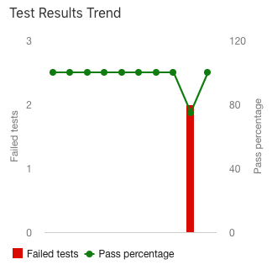

#### Move the work item to Done

In this part, you move the work item that you assigned to yourself earlier in this module, **Create unit tests**, to the **Done** column.

In practice, the definition of "Done" often means that working software is in the hands of your users. In this unit, for learning purposes, you mark this work as complete because you have working unit tests and code coverage tests set up in your build pipeline.

At the end of each sprint, or work iteration, you and your team might hold a retrospective meeting, where you share the work you completed, what went well in the sprint, and what could be improved.

To complete the work item:

1. In Azure DevOps, go to **Boards** and then, in the left pane, select **Boards**.
2. Move the **Create unit tests** work item from the **Doing** column to the **Done** column.

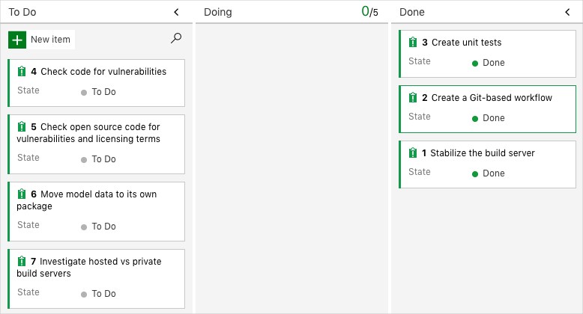

#### Disable the pipeline

Each module in this learning path provides a template that you can run to create a clean environment for the duration of the module.

Running multiple templates gives you multiple Azure Pipelines projects, each pointing to the same GitHub repository. This can trigger multiple pipelines to run each time you push a change to your GitHub repository, which can cause you to run out of free build minutes on our hosted agents. Therefore, it's important that you disable or delete your pipeline before you move on to the next module.

#### Disable the pipeline

This option disables the pipeline so that it doesn't process further build requests. You can reenable the build pipeline later if you want to. Choose this option if you want to keep your Azure DevOps project and your build pipeline for future reference.

To disable the pipeline:

1. In Azure Pipelines, navigate to your pipeline.
2. From the drop-down menu, select **Settings**:



1. Under **Processing of new run requests**, select **Disabled** and then select **Save**.

Your pipeline will no longer process build requests.

## Task 06: Manage build dependencies with Azure Artifacts

Manage your application and the packages it uses across build pipelines.

In this module, you'll create a build pipeline that produces a package that can be used by multiple apps.

It's likely that you've used open source or other third-party components in your software. Using components that are popular in the community and have already been built and tested is often the fastest way to get things done.

You might also have your own app code that you can move into a library or package so that others can use it. This might be an open source project, or software that only your team can access.

There are many ways to build and host your packages. The right solution depends both on the kinds of programming languages and frameworks you use and who you want to access your packages. Here, you'll continue your work with the Tailspin web team by creating a NuGet package for .NET that's hosted on Azure Artifacts.

After completing this module, you'll be able to:

* Create and share packages that can be used by multiple applications
* Create a build pipeline for your package and publish your package to Azure Artifacts
* Connect an application to your package and build the application in Azure Pipelines
* Push changes to your package and update your application to use them

### Plan build dependencies for your pipeline

In this unit, you'll learn about packaging code to make it easier to share. You'll discover why you should make packages, what kinds of packages you can create, where you can host the packages, and how you access them when they are hosted. You'll also learn about package versioning.

Codebases are always growing larger and more complex. It's unusual for a team to write all the code that their app uses. Instead, the team includes existing code written by other developers and there can be many of these packages, or dependencies, in an app. It's important to actively manage these dependencies to be able to maintain them properly and make sure they meet security requirements.

Let's check in and see how the team is doing.

### Set up your Azure DevOps environment

In this unit, you ensure that your Microsoft Azure DevOps organization is set up to complete the rest of this module.

To do this, you:

* Set up an Azure DevOps project for this module.
* On Azure Boards, move the work item for this module to the **Doing** column.
* Make sure your project is set up locally so that you can push changes to the pipeline.

### Get the Azure DevOps project

Here, you make sure that your Azure DevOps organization is set up to complete the rest of this module. You do this by running a template that creates a project for you in Azure DevOps.

The modules in this learning path form a progression, where you follow the Tailspin web team through their DevOps journey. For learning purposes, each module has an associated Azure DevOps project.

#### Run the template

To set up everything for you in your Azure DevOps organization, run a template.

[Click here to Run the template](https://azuredevopsdemogenerator.azurewebsites.net/?x-ms-routing-name=self&name=manage-build-dependencies)

From the Azure DevOps demo generator site, to run the template, perform these steps.

1. Select **Sign In**, and accept the usage terms.
2. From the **Create New Project** page, select your Azure DevOps organization, and enter a project name. For example, enter *Space Game - web - Dependencies*.
3. Select **Fork repository on GitHub**, and then select **Authorize**. If a window appears, authorize access to your GitHub account.

**Important**

You need to select this option for the template to connect to your GitHub repository. Select this option even if you've already forked the *Space Game* website project. The template uses your existing fork.

1. Select **Create Project**.

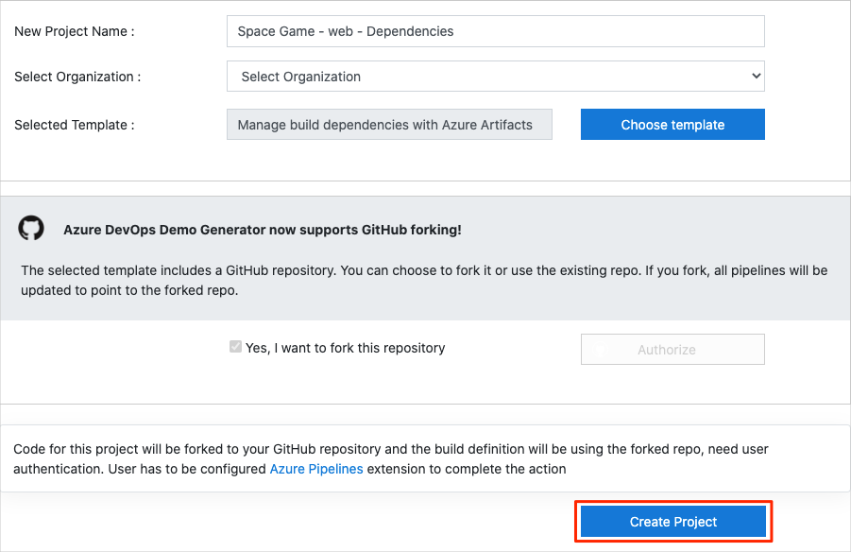

It takes a few moments for the template to run.

1. To go to your project in Azure DevOps, select **Navigate to project**.

#### Move the work item to Doing

In this part, you'll assign a work item to yourself that relates to this module on Azure Boards. You'll also move the work item to the **Doing** state. In practice, you and your team would create work items at the start of each sprint, or work iteration.

Assigning work in this way gives you a checklist to work from. It gives others on your team visibility into what you're working on and how much work is left. It also helps the team enforce work-in-progress limits, so that the team doesn't take on too much work at one time.

Recall that the team settled on these seven top issues:



**Note**

Within an Azure DevOps organization, work items are numbered sequentially. In your project, the number that's assigned to each work item might not match what you see here.

Here, you move the sixth item, **Move model data to its own package** to the **Doing** column, and assign yourself to the work item.

Recall that **Move model data to its own package** relates to moving reusable code to its own NuGet package, so that package can be shared among multiple apps.

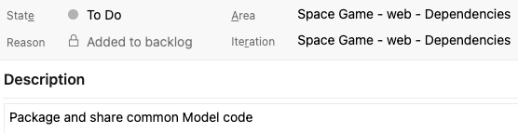

To set up the work item:

1. From Azure DevOps, go to **Boards**, and from the menu, select **Boards**.



1. From the **Move model data to its own package** work item, at the bottom of the card, select the down arrow. Then, assign the work item to yourself.



1. Move the work item from the **To Do** to the **Doing** column.

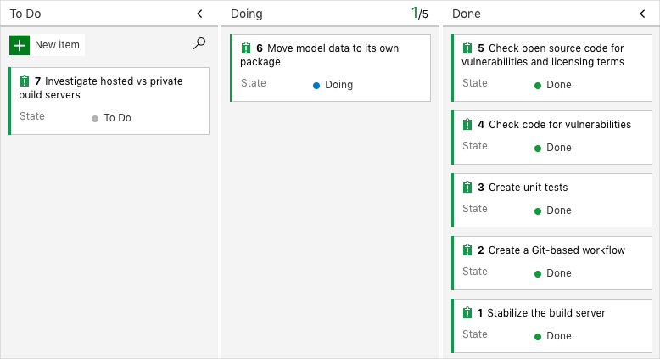

At the end of this module, after you've completed the task, you'll move the card to the **Done** column.

#### Set up the project locally

Here, you load the *Space Game* project in Visual Studio Code, configure Git, clone your repository locally, and set the upstream remote so that you can download starter code.

**Note**

If you're already set up with the **[mslearn-tailspin-spacegame-web](https://github.com/MicrosoftDocs/mslearn-tailspin-spacegame-web" \t "az-portal)** project locally, you can move to the next section.

#### Open the integrated terminal

Visual Studio Code comes with an integrated terminal, so you can edit files and work from the command line all from one place.

1. Start Visual Studio Code.
2. On the **View** menu, select **Terminal**.
3. In the drop-down list, select **bash**. If you're familiar with another Unix shell that you prefer to use, such as Zsh, select that shell instead.



The terminal window lets you choose any shell that's installed on your system, like Bash, Zsh, and PowerShell.

Here you'll use Bash. Git for Windows provides Git Bash, which makes it easy to run Git commands.

**Note**

On Windows, if you don't see **bash** listed as an option, make sure you've installed [**Git**](https://git-scm.com/downloads) and then restart Visual Studio Code.

If you still don't see the **bash** option, see [**Integrated Terminal**](https://code.visualstudio.com/docs/editor/integrated-terminal) to manually configure your terminal settings.

1. Run the cd command to navigate to the directory you want to work from, like your home directory (~). You can choose a different directory if you want.

cd ~

#### Configure Git

If you're new to Git and GitHub, you first need to run a few commands to associate your identity with Git and authenticate with GitHub.

[Set up Git](https://help.github.com/articles/set-up-git) explains the process in greater detail.

At a minimum, you'll need to complete the following steps. Run these commands from the integrated terminal:

1. [Set your username](https://help.github.com/articles/setting-your-username-in-git).
2. [Set your commit email address](https://help.github.com/articles/setting-your-commit-email-address-in-git).
3. [Cache your GitHub password](https://help.github.com/articles/caching-your-github-password-in-git).

**Note**

If you're already using two-factor authentication with GitHub, [**create a personal access token**](https://help.github.com/articles/creating-a-personal-access-token-for-the-command-line) and use your token in place of your password when prompted later.

Treat your access token like you would a password. Keep it in a safe place.

#### Set up your project in Visual Studio Code

In this part, you clone your fork locally so that you can make changes and build out your pipeline configuration.

#### Clone your fork locally

You now have a copy of the *Space Game* web project in your GitHub account. Now you'll download, or *clone*, a copy to your computer so you can work with it.

A clone, just like a fork, is a copy of a repository. When you clone a repository, you can make changes, verify they work as you expect, and then upload those changes back to GitHub. You can also synchronize your local copy with changes other authenticated users have made to GitHub's copy of your repository.

To clone the *Space Game* web project to your computer:

1. Go to your fork of the *Space Game* web project (**mslearn-tailspin-spacegame-web**) on [GitHub](https://github.com/).
2. Select **Code**. Then, from the **HTTPS** tab, select the button next to the URL that's shown to copy the URL to your clipboard.



1. In Visual Studio Code, go to the terminal window.
2. In the terminal, move to the directory you want to work from, like your home directory (~). You can choose a different directory if you want.

cd ~

1. Run the git clone command. Replace the URL that's shown here with the contents of your clipboard:

git clone https://github.com/your-name/mslearn-tailspin-spacegame-web.git

1. Move to the mslearn-tailspin-spacegame-web directory. This is the root directory of your repository.

cd mslearn-tailspin-spacegame-web

**Set the upstream remote**

A *remote* is a Git repository where team members collaborate (like a repository on GitHub). Here you list your remotes and add a remote that points to Microsoft's copy of the repository so that you can get the latest sample code.

1. Run this git remote command to list your remotes:

git remote -v

You see that you have both fetch (download) and push (upload) access to your repository:

origin https://github.com/username/mslearn-tailspin-spacegame-web.git (fetch)

origin https://github.com/username/mslearn-tailspin-spacegame-web.git (push)

*Origin* specifies your repository on GitHub. When you fork code from another repository, it's common to name the original remote (the one you forked from) as *upstream*.

1. Run this git remote add command to create a remote named *upstream* that points to the Microsoft repository:

git remote add upstream https://github.com/MicrosoftDocs/mslearn-tailspin-spacegame-web.git

1. Run git remote a second time to see the changes:

git remote -v

You see that you still have both fetch (download) and push (upload) access to your repository. You also now have fetch access from the Microsoft repository:

origin https://github.com/username/mslearn-tailspin-spacegame-web.git (fetch)

origin https://github.com/username/mslearn-tailspin-spacegame-web.git (push)

upstream https://github.com/MicrosoftDocs/mslearn-tailspin-spacegame-web.git (fetch)

#### Open the project in the file explorer

In Visual Studio Code, your terminal window points to the root directory of the *Space Game* web project. To view its structure and work with files, from the file explorer, you'll now open the project.

1. The easiest way to open the project is to reopen Visual Studio Code in the current directory. To do so, run the following command from the integrated terminal:

code -r .

You see the directory and file tree in the file explorer.

1. Reopen the integrated terminal. The terminal places you at the root of your web project.

If the code command fails, you need to add Visual Studio Code to your system PATH. To do so:

1. In Visual Studio Code, select F1 or select **View** > **Command Palette** to access the command palette.
2. In the command palette, enter *Shell Command: Install 'code' command in PATH*.
3. Repeat the previous procedure to open the project in the file explorer.

You're now set up to work with the *Space Game* source code and your Azure Pipelines configuration from your local development environment.

### Create a package feed in Azure Artifacts

In this unit, you'll set up Azure Artifacts and create a new feed. You'll use this feed later to store your new Models package and to consume the package in your app pipeline.

#### Set up Azure Artifacts

1. From Azure DevOps, go to the **Artifacts** tab, and then select **+ Create feed**.
   1. Name the feed *Tailspin.SpaceGame.Web.Models*.
   2. Under **Visibility**, select **Members of (your organization name)**.
   3. Under **Upstream sources**, unselect **Include packages from common public sources**.

The other choice, to use public sources, is if you want to create an *upstream* from this feed. That is, you can access your packages and packages from public package managers like NuGet or npmjs from this feed.

* 1. Under **Scope**, leave the **Project** option selected.
  2. Select **Create**.

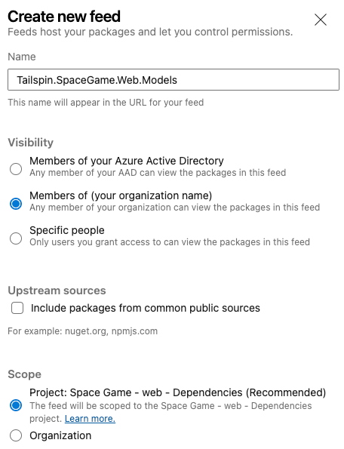

1. Select **Connect to feed**.

This has a list of links, commands, and a credential provider you could use if you wanted to run this locally by using Visual Studio.

**Note**

In practice, you would connect your application to the feed so that you can pull down packages and include them when you build and run your application locally. For brevity, we'll skip this part.

#### Create a pipeline for your package

Here, you'll get the team's new code for the **Tailspin.SpaceGame.Web.Models** project that is now separate from the **Tailspin.SpaceGame.Web** project. You'll create an Azure Pipelines project for the Models project and see the artifact in Azure Artifacts with a version number of 1.0.0 in your feed.

What changes were made to the project?

Recall that the Space Game website is an ASP.NET Core app. It uses the Model-View-Controller (MVC) pattern to separate data from how that data is displayed in the user interface. Developer lead and developer want to move the model classes to a separate library so that multiple projects can use those classes.

To do that, they create a new C# project, called Tailspin.SpaceGame.Web.Models, that contains only the model classes. At the same time, they remove the model classes from their existing project, Tailspin.SpaceGame.Web. They replace the model classes in their existing project with a reference to the Tailspin.SpaceGame.Web.Models project.

To build these projects, Andy and Mara use two pipelines, one for each project. You already have the first project and its associated Azure Pipelines configuration. Here, you'll fork the second project on GitHub, and create an Azure Pipelines configuration to build it. You'll publish the resulting package to Azure Artifacts.

#### Prepare Visual Studio Code

Previously, you set up Visual Studio Code to work with the **Tailspin.SpaceGame.Web** project. Here you open a second instance of Visual Studio Code so you can work with the **Tailspin.SpaceGame.Web.Models** project.

1. Open a second instance of Visual Studio Code.
2. From Visual Studio Code, open the integrated terminal.
3. Navigate to the parent directory from where your **mslearn-tailspin-spacegame-web** project is located. Here's an example that moves to your home directory:

cd ~

#### Get the source code

Get the source code for the **Tailspin.SpaceGame.Web.Models** project from GitHub and set up Visual Studio Code so you can work with the files.

#### Create a fork

The first step is to fork the **mslearn-tailspin-spacegame-web-models** repository so you can work with and modify the source files. Recall that Mara put the **Models** directory in a new project and removed it from the web project.

To fork the **mslearn-tailspin-spacegame-web-models** project into your GitHub account:

1. From a web browser, go to [GitHub](https://github.com/), and sign in.
2. Go to the [mslearn-tailspin-spacegame-web-models](https://github.com/MicrosoftDocs/mslearn-tailspin-spacegame-web-models" \t "az-portal) project.
3. Select **Fork**.
4. To fork the repository into your account, follow the instructions.

#### Clone your fork locally

To clone the **mslearn-tailspin-spacegame-web-models** projects to your computer:

1. On GitHub, go to your fork of the **mslearn-tailspin-spacegame-web-models** project.
2. Select **Code**. Then, from the **HTTPS** tab, select the button next to the URL that's shown to copy the URL to your clipboard.

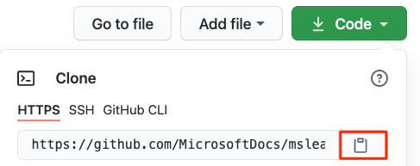

1. From Visual Studio Code, go to the terminal window, and run this git clone command. Replace the URL that's shown with the contents of your clipboard.

git clone https://github.com/your-name/mslearn-tailspin-spacegame-web-models.git

1. Move to the **mslearn-tailspin-spacegame-web-models** directory. This is the root directory of your repository.

cd mslearn-tailspin-spacegame-web-models

#### Open the project and examine the configuration

In Visual Studio Code, your terminal window points to the root directory of the **mslearn-tailspin-spacegame-web-models** project. Open the project from the file explorer so that you can view its structure and work with files.

1. The easiest way to open the project is to reopen Visual Studio Code in the current directory. To do so, run the following command from the integrated terminal:

code -r .

You see the directory and file tree in the file explorer.

1. Reopen the integrated terminal. The terminal places you at the root of your web project.
2. Open the *azure-pipelines.yml* file.

You see the steps where the package is built, the version is set, and the package is added to Azure Artifacts.

This DotNetCoreCLI@2 task builds the project:

- task: DotNetCoreCLI@2

displayName: 'Build the project - $(buildConfiguration)'

inputs:

command: 'build'

arguments: '--no-restore --configuration $(buildConfiguration)'

projects: '**/*.csproj'

This DotNetCoreCLI@2 task packages the project with a version of 1.0.0.

- task: DotNetCoreCLI@2

displayName: 'Pack the project - $(buildConfiguration)'

inputs:

command: 'pack'

projects: '**/*.csproj'

arguments: '--no-build --configuration $(buildConfiguration)'

versioningScheme: byPrereleaseNumber

majorVersion: '1'

minorVersion: '0'

patchVersion: '0'

When developing your package, it's common to use the byPrereleaseNumber versioning scheme. This appends a unique pre-release suffix, such as "-CI-20190621-042647" to the end of the version number. Following this example, the complete version number would be "1.0.0-CI-20190621-042647".

This NuGetCommand@2 task pushes the package to your **Tailspin.SpaceGame.Web.Models** Azure Artifacts feed.

- task: NuGetCommand@2

displayName: 'Publish NuGet package'

inputs:

command: push

feedPublish: '$(System.TeamProject)/Tailspin.SpaceGame.Web.Models'

allowPackageConflicts: true

condition: succeeded()

feedPublish specifies the name of the feed to publish to. The format of the name is <projectName>/<feedName>, where:

* + $(System.TeamProject) is a predefined variable that refers to your project name, for example, "Space Game - web - Dependencies".
  + "Tailspin.SpaceGame.Web.Models" is the feed name that you provided in the previous exercise.

#### Create the pipeline in Azure Pipelines

You learned how to set up Azure Pipelines in an earlier module. If you need a refresher, head over to Create a build pipeline with Azure Pipelines.

Here's how to set up a second pipeline to build the package, and upload that package to Azure Artifacts.

1. From Azure DevOps, go to the **Space Game - web - Dependencies** project.
2. From the menu on the left, select **Pipelines**.
3. Select **+ New Pipeline**.
4. From the **Connect** tab, select **GitHub**.
5. From the **Select** tab, select **mslearn-tailspin-spacegame-web-models**.

If prompted, enter your GitHub credentials. From the page that appears, scroll to the bottom, and select **Approve and install**.

1. From the **Review** tab, you see the new pipeline's *azure-pipelines.yml* file.
2. Select **Run**.
3. Watch the pipeline run.
4. Go to the **Artifacts** tab.
5. From the dropdown at the top, select **Tailspin.SpaceGame.Web.Models**.

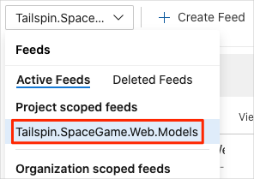

You see the resulting package, **Tailspin.SpaceGame.Web.Models**, in Azure Artifacts.

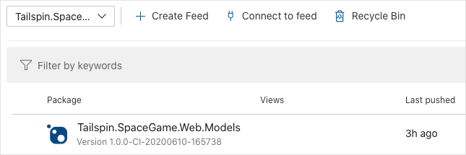

1. Select the package to go to the details page. Then, copy the version number to a location where you can easily access it later.

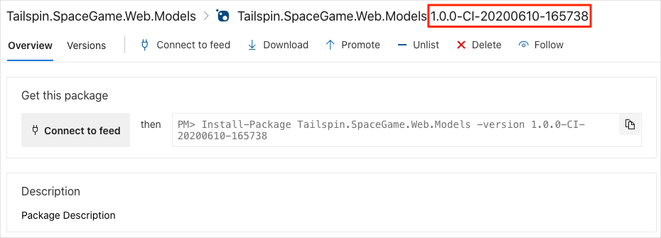

You'll use this version number in the next unit.

### Reference the package from the application

In this unit, you'll get the new **Tailspin.SpaceGame.Web** code that has the model classes removed. Instead of referencing the models directly, the code will reference them from the package you created in the previous unit.

Here is a list of the steps:

* Get the new code from a branch of the original **Tailspin.SpaceGame.Web** repository.
* Reference the new Models package, version 1.0.0.
* To look for this package in your Azure Artifacts feed, change the build pipeline.
* Watch the pipeline successfully build the app.

#### Fetch the branch from GitHub

Fetch the models-package branch from GitHub and check out, or switch to, that branch.

This branch contains the *Space Game* project you worked with in the previous modules, but the **Models** directory has been removed.

1. Switch to your copy of Visual Studio Code that shows the **Tailspin.SpaceGame.Web** project.
2. From the terminal, to fetch a branch named models-package from the Microsoft repository, run the following git commands. Then, switch to that branch.

git fetch upstream models-package

git checkout -B models-package upstream/models-package

The format of these commands enables you to get starter code from the Microsoft repository on GitHub, known as upstream. Shortly, you'll push this branch up to your GitHub repository, known as origin.

1. As an optional step, verify that the **Models** directory no longer exists in the file explorer.

Instead, you see **Controllers**, **Views**, and other directories.

#### Reference the Models package

1. Open the **Tailspin.SpaceGame.Web.csproj** file and add the following ItemGroup:

<ItemGroup>

<PackageReference Include="Tailspin.SpaceGame.Web.Models" Version="1.0.0" />

</ItemGroup>

Be sure to place the ItemGroup inside the Project node. Your file should resemble this:

<Project Sdk="Microsoft.NET.Sdk.Web">

<PropertyGroup>

<TargetFramework>net5.0</TargetFramework>

<ProjectGuid>{A0C4E31E-AC75-4F39-9F59-0AA19D9B8F46}</ProjectGuid>

</PropertyGroup>

<ItemGroup>

<PackageReference Include="Tailspin.SpaceGame.Web.Models" Version="1.0.0" />

</ItemGroup>

<ItemGroup>

<Folder Include="wwwroot\images\avatars\" />

</ItemGroup>

</Project>

1. Modify the version, "1.0.0", to include the pre-release prefix that was generated during the build process. Here's an example:

<PackageReference Include="Tailspin.SpaceGame.Web.Models" Version="1.0.0-CI-20200610-165738" />

This references the **Tailspin.SpaceGame.Web.Models** package that you created in Azure Artifacts. Notice the version number, 1.0.0, plus the pre-release suffix. This matches the initial version that you published to Azure Artifacts in the previous unit.

1. Save the file.

**Note**

When you save the file, Visual Studio Code might ask you to restore dependencies. We're not going to run this locally, so there is no need to restore the dependencies.

#### Modify the pipeline configuration

The models-package branch provides an initial *azure-pipelines.yml* file. Here, you modify the pipeline configuration to pull the **Tailspin.SpaceGame.Web.Models** package from Azure Artifacts.

1. From Visual Studio Code, open *azure-pipelines.yml*.
2. Modify *azure-pipelines.yml* as shown here:

trigger:

- '*'

pool:

vmImage: 'ubuntu-20.04'

demands:

- npm

variables:

buildConfiguration: 'Release'

wwwrootDir: 'Tailspin.SpaceGame.Web/wwwroot'

dotnetSdkVersion: '5.x'

steps:

- task: UseDotNet@2

displayName: 'Use .NET SDK $(dotnetSdkVersion)'

inputs:

version: '$(dotnetSdkVersion)'

- task: NuGetToolInstaller@0

inputs:

versionSpec: '5.9.1'

- task: Npm@1

displayName: 'Run npm install'

inputs:

verbose: false

- script: './node_modules/.bin/node-sass $(wwwrootDir) --output $(wwwrootDir)'

displayName: 'Compile Sass assets'

- task: gulp@1

displayName: 'Run gulp tasks'

- script: 'echo "$(Build.DefinitionName), $(Build.BuildId), $(Build.BuildNumber)" > buildinfo.txt'

displayName: 'Write build info'

workingDirectory: $(wwwrootDir)

- task: NuGetCommand@2

displayName: 'Restore project dependencies'

inputs:

command: 'restore'

restoreSolution: '**/*.sln'

feedsToUse: 'select'

vstsFeed: '$(System.TeamProject)/Tailspin.SpaceGame.Web.Models'

- task: DotNetCoreCLI@2

displayName: 'Build the project - $(buildConfiguration)'

inputs:

command: 'build'

arguments: '--no-restore --configuration $(buildConfiguration)'

projects: '**/*.csproj'

- task: DotNetCoreCLI@2

displayName: 'Publish the project - $(buildConfiguration)'

inputs:

command: 'publish'

projects: '**/*.csproj'

publishWebProjects: false

arguments: '--no-build --configuration $(buildConfiguration) --output $(Build.ArtifactStagingDirectory)/$(buildConfiguration)'

zipAfterPublish: true

- task: PublishBuildArtifacts@1

displayName: 'Publish Artifact: drop'

condition: succeeded()

The highlighted code shows where the pipeline restores dependencies, and looks in your Azure Artifacts feed for the dependencies that might be there.

1. Stage, commit, and push your changes to GitHub.

git add .

git commit -m "Add reference to Models package"

git push origin models-package

1. Go to Azure Pipelines and watch the build run. The build picks up your Models package from Azure Artifacts and builds the project successfully.

### Push a change to your package

At this point, you have two pipelines. One publishes the Models package to Azure Artifacts, and one is for the *Space Game* web app. The build configuration for the web app references the Models package so that it can access the model classes.

Here, you practice the process of updating the Models package and consuming that change from the web app.

To do that, you start by adding a property to one of the model classes and then bump the package version. Then, you submit the change to GitHub, so that the pipeline can build the package and publish it to Azure Artifacts.

You update the web app to reference the newer version number of the Models package so that it can use the added property.

#### Create a branch

Let's start by creating a branch to hold our work. Create a branch named add-game-style, which is based off the main branch.

At this point, you have two copies of Visual Studio Code open, one for the **Tailspin.SpaceGame.Web.Models** project and one for the *Space Game* web app project, **Tailspin.SpaceGame.Web**. Here, you'll work from the copy for the **Tailspin.SpaceGame.Web.Models** project.

1. From Visual Studio Code, open the integrated terminal.
2. From the terminal, to create a branch named add-game-style, run the following git checkout command.

git checkout -B add-game-style

#### Add a property to the Models package

Add a property to one of the model classes, named Score, that provides the game style, or difficulty, the score is associated with.

Here, you'll work from the copy of Visual Studio Code for the **Tailspin.SpaceGame.Web.Models** project.

1. From Visual Studio Code, open *Tailspin.SpaceGame.Web.Models/Models/Score.cs*. Add the following highlighted property to the list of properties already there.

using System.Text.Json.Serialization;

namespace TailSpin.SpaceGame.Web.Models

{

public class Score : Model

{

// The ID of the player profile associated with this score.

[JsonPropertyName("profileId")]

public string ProfileId { get; set; }

// The score value.

[JsonPropertyName("score")]

public int HighScore { get; set; }

// The game mode the score is associated with.

[JsonPropertyName("gameMode")]

public string GameMode { get; set; }

// The game region (map) the score is associated with.

[JsonPropertyName("gameRegion")]

public string GameRegion { get; set; }

// The game style (difficulty) the score is associated with.

[JsonPropertyName("gameStyle")]

public string GameStyle { get; set; }

}

}

**Note**

You're making a change to a file in the project to demonstrate where you bump up the version number. However, we won't update the web app to use the new property.

1. Save the file.
2. To verify your work, build the project.

dotnet build --configuration Release

In practice, you might perform additional verification steps, such as running tests or testing the new package with an app that uses it.

**Build and publish the package**

Now that you've added the new property to the Score class, and verified the project builds successfully, you can update the package's version. You can then push your change to GitHub so that Azure Pipelines can build and publish the updated package.

1. Open *azure-pipelines.yml*, and change the minorVersion from 0 to 1, and save the file.

minorVersion: '1'

Here, we bump the version from 1.0.0 to 1.1.0 to make the change clear. In practice, you would follow the versioning scheme for the kind of package you're working with.

For example, according to Semantic Versioning, bumping the minor version to 1 (1.1.0) tells others that the package is backward compatible with apps that use version 1.0.0 of that package. Those who use the package might then modify their app to make use of new features.

Popular open source projects provide documentation in the form of a *changelog* that explains the changes made in each version, as well as how to migrate from one major version to the next.

1. Stage, commit, and push your changes.

git add .

git commit -m "Add GameStyle property"

git push origin add-game-style

1. From Microsoft Azure Pipelines, go to the **Tailspin.SpaceGame.Web.Models** project, and watch the build run.
2. Open the **Artifacts** tab and note the new version. Don't worry. Your old version is still there for any projects that still reference it.

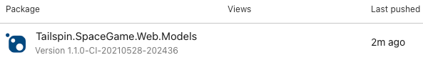

1. As you did previously, write down the new version for the next unit.

#### Reference the new version of the Models package

Now, change the **Tailspin.SpaceGame.Web** project to use the new version of the **Tailspin.SpaceGame.Web.Models** package.

Here, you'll work from the copy of Visual Studio Code for the *Space Game* web app project, **Tailspin.SpaceGame.Web**.

1. From Visual Studio Code, open **Tailspin.SpaceGame.Web.csproj**, and change PackageReference to the version number of the **Tailspin.SpaceGame.Web.Models** package you just created in Azure Artifacts. Then, save the file.

Here's an example.

<PackageReference Include="Tailspin.SpaceGame.Web.Models" Version="1.1.0-CI-20210528-202436" />

If Visual Studio Code asks you to restore packages, you can safely ignore that message. For brevity, we won't build the web app locally.

1. From the terminal, stage, commit, and push the changes.

git add .

git commit -m "Bump Models package to 1.1.0"

git push origin models-package

1. From Azure Pipelines, go to the **mslearn-tailspin-spacegame-web** project, and watch the build run.

You see from the build output that it gets the latest dependency, builds the app, and publishes the artifact for the web app.

#### Move the work item to Done

Move the work item you assigned to yourself earlier in this module, "Move model data to its own package," to the **Done** column.

In practice, the definition of "Done" often means having working software in the hands of your users. Here, for learning purposes, you'll mark this work as complete because you set up a build pipeline that publishes NuGet packages to Azure Artifacts.

At the end of each sprint, or work iteration, you and your team might hold a retrospective meeting. You share the work you completed, what went well in the sprint, and what could be improved.

To complete the work item:

1. From Azure DevOps, go to **Boards**, and from the menu, select **Boards**.
2. Move the **Move model data to its own package** work item from the **Doing** column to the **Done** column.

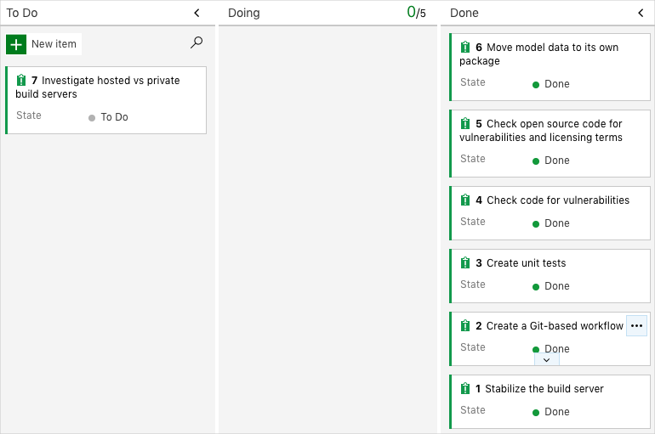

#### Disable the pipeline

Each module in this learning path provides a template you can run to create a clean environment for the duration of the module.

Running multiple templates gives you multiple Azure Pipelines projects, each pointing to the same GitHub repository. This can trigger multiple pipelines to run each time you push a change to your GitHub repository, which can cause you to run out of free build minutes on our hosted agents. Therefore, it's important that you disable or delete your pipeline before moving on to the next module.

#### Disable the pipeline

This option disables the pipeline so that it doesn't process further build requests. You can re-enable the build pipeline later if you want to. Select this option if you want to keep your Azure DevOps project and your build pipeline for future reference.

To disable the pipeline:

1. In Azure Pipelines, navigate to your pipeline.
2. From the dropdown, select **Settings**.



1. Under **Processing of new run requests**, select **Disabled**, and then select **Save**.

Your pipeline will no longer process build requests.

1. Repeat the process for the second pipeline.

# Challenge 03: Deploy applications with Azure DevOps

## Task 01: Create a release pipeline in Azure Pipelines

Set up a continuous delivery (CD) pipeline that automates the process of deploying your application.

In the Build applications with Azure DevOps learning path, you helped the Tailspin Toys team use Microsoft Azure DevOps to plan and build a continuous integration (CI) pipeline for the *Space Game* website.

The Tailspin team's big release is approaching. The team can use Azure DevOps to build and test their code. But how can they quickly deploy the application to an environment that's available to their users?

In this module, you'll continue your journey with the Tailspin team as they set up a continuous delivery (CD) pipeline for the *Space Game* website.

### Set up your environment

The team has been slowly integrating a DevOps strategy into their processes. In this section, you make sure that your environment reflects the team's efforts so far.

To do this, you:

* Add a user to ensure Azure DevOps can connect to your Azure subscription.
* Set up an Azure DevOps project for this module.
* Add the build pipeline.

**Get the Azure DevOps project**

Make sure your Azure DevOps organization is set up to complete the rest of this module. You do this by running a template that creates a project for you in Azure DevOps.

The modules in this learning path form a progression as you follow the Tailspin web team through their DevOps journey. For learning purposes, each module has an associated Azure DevOps project.

**Run the template**

Run a template that sets up everything for you in your Azure DevOps organization.

[Click here to Run the template](https://azuredevopsdemogenerator.azurewebsites.net/?x-ms-routing-name=self&name=create-release-pipeline)

From the Azure DevOps Demo Generator site, follow these steps to run the template:

1. Select **Sign In** and accept the usage terms.
2. From the **Create New Project** page, select your Azure DevOps organization and enter a project name, such as *Space Game - web - Release*.

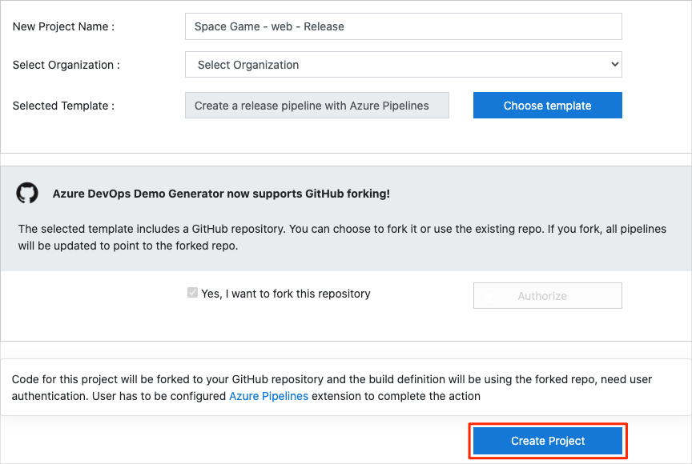

1. Select **Yes, I want to fork this repository** > **Authorize**.

If a window appears, authorize access to your GitHub account.

**Important**

You need to select this option so the template will connect to your GitHub repository. Select it even if you've already forked the *Space Game* website project. The template uses your existing fork.

1. Select **Create Project**.

The template takes a few moments to run.

1. Select **Navigate to project** to go to your project in Azure DevOps.

#### Set up your project in Visual Studio Code

In the Build applications with Azure DevOps learning path, you forked and then cloned a Git repository that contains the source code for the *Space Game* website. Your fork was connected to your projects in Azure DevOps so that the build runs when you push changes to GitHub.

**Important**

In this learning path, we switch to a different Git repository, **[mslearn-tailspin-spacegame-web-deploy](https://github.com/MicrosoftDocs/mslearn-tailspin-spacegame-web-deploy" \t "az-portal)**. When you ran the template to set up your Azure DevOps project, the process forked the repository automatically for you.

In this part, you clone your fork locally so that you can make changes and build out your pipeline configuration.

#### Clone your fork locally

You now have a copy of the *Space Game* web project in your GitHub account. Now you'll download, or *clone*, a copy to your computer so you can work with it.

A clone, just like a fork, is a copy of a repository. When you clone a repository, you can make changes, verify they work as you expect, and then upload those changes back to GitHub. You can also synchronize your local copy with changes that other authenticated users have made to GitHub's copy of your repository.

To clone the *Space Game* web project to your computer:

1. On [GitHub](https://github.com/), go to your fork of the *Space Game* web project (**mslearn-tailspin-spacegame-web-deploy**).
2. Select **Code**. Then, from the **HTTPS** tab, select the button next to the URL that's shown to copy the URL to your clipboard.



1. In Visual Studio Code, go to the terminal window.
2. In the terminal, move to the directory you want to work from, like your home directory (~). You can choose a different directory if you want.

cd ~

1. Run the git clone command. Replace the URL that's shown here with the contents of your clipboard:

git clone https://github.com/your-name/mslearn-tailspin-spacegame-web-deploy.git

1. Move to the *mslearn-tailspin-spacegame-web-deploy* directory. This directory is the root of your repository.

cd mslearn-tailspin-spacegame-web-deploy

#### Set the upstream remote

A *remote* is a Git repository where team members collaborate (like a repository on GitHub). Here you list your remotes and add a remote that points to Microsoft's copy of the repository so that you can get the latest sample code.

1. Run this git remote command to list your remotes:

git remote -v

You see that you have both fetch (download) and push (upload) access to your repository:

origin https://github.com/username/mslearn-tailspin-spacegame-web-deploy.git (fetch)

origin https://github.com/username/mslearn-tailspin-spacegame-web-deploy.git (push)

*Origin* specifies your repository on GitHub. When you fork code from another repository, the original remote (the one you forked from) is commonly named *upstream*.

1. Run this git remote add command to create a remote named *upstream* that points to the Microsoft repository:

git remote add upstream https://github.com/MicrosoftDocs/mslearn-tailspin-spacegame-web-deploy.git

1. Run git remote a second time to see the changes:

git remote -v

You see that you still have both fetch (download) and push (upload) access to your repository. You also now have fetch access from the Microsoft repository:

origin https://github.com/username/mslearn-tailspin-spacegame-web-deploy.git (fetch)

origin https://github.com/username/mslearn-tailspin-spacegame-web-deploy.git (push)

upstream https://github.com/MicrosoftDocs/mslearn-tailspin-spacegame-web-deploy.git (fetch)

**Open the project in the file explorer**

In Visual Studio Code, your terminal window points to the root directory of the *Space Game* web project. To view its structure and work with files, from the file explorer, you'll now open the project.

1. The easiest way to open the project is to reopen Visual Studio Code in the current directory. To do so, run the following command from the integrated terminal:

code -r .

You see the directory and file tree in the file explorer.

1. Reopen the integrated terminal. The terminal places you at the root of your web project.

If the code command fails, you need to add Visual Studio Code to your system PATH. To do so:

1. In Visual Studio Code, select F1 or select **View** > **Command Palette** to access the command palette.
2. In the command palette, enter *Shell Command: Install 'code' command in PATH*.
3. Repeat the previous procedure to open the project in the file explorer.

You're now set up to work with the *Space Game* source code and your Azure Pipelines configuration from your local development environment.

#### Fetch the branch from GitHub

Here you fetch the release-pipeline branch from GitHub and check out, or switch to, that branch.

This branch contains the *Space Game* project that you worked with in the previous modules and an Azure Pipelines configuration to start with.

1. In Visual Studio Code, open the integrated terminal.
2. Run the following git commands to fetch a branch named release-pipeline from the Microsoft repository, and then switch to that branch.

git fetch upstream release-pipeline

git checkout -B release-pipeline upstream/release-pipeline

The format of this command enables you to get starter code from the Microsoft GitHub repository, known as upstream. Shortly, you'll push this branch to your GitHub repository, known as origin.

1. As an optional step, in Visual Studio Code, open the *azure-pipelines.yml* file and familiarize yourself with the initial configuration. The configuration resembles the basic one you created in the Create a build pipeline with Azure Pipelines module. It builds only the application's Release configuration.

**Note**

A more robust configuration might specify the branches that participate in the build process. For example, to help verify code quality, you might run unit tests each time you push up a change on any branch. You might also deploy the application to an environment that performs more exhaustive testing. But you do this deployment only when you have a pull request, when you have a release candidate, or when you merge code to *main*.

#### Run the pipeline

This this point, you have:

* A fork of the **mslearn-tailspin-spacegame-web-deploy** repository in your GitHub account.
* The **mslearn-tailspin-spacegame-web-deploy** repository cloned locally.
* A branch named release-pipeline that contains the web site source code and an initial Azure Pipelines configuration.

Next, you'll manually trigger the pipeline to run. This step ensures that your project is set up to build from your GitHub repository. The initial pipeline configuration builds the application and produces a builds artifact. Shortly, you'll add a stage that deploys the build artifact to Azure App Service.

1. In Azure DevOps, go to your project.
2. Select **Pipelines** from the menu on the side of the page.
3. You see that your pipeline has not yet been run.

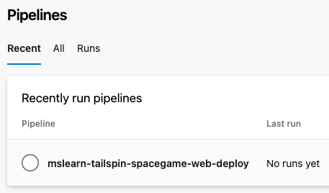

1. Select your pipeline, **mslearn-tailspin-spacegame-web-deploy**.
2. Select **Run pipeline**.

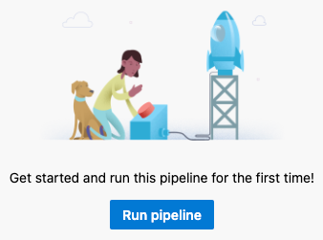

1. From the **Run pipeline** window that appears, set **Branch/tag** to *release-pipeline*. Then select **Run**.
2. In Azure Pipelines, go to the build and trace it as it runs.

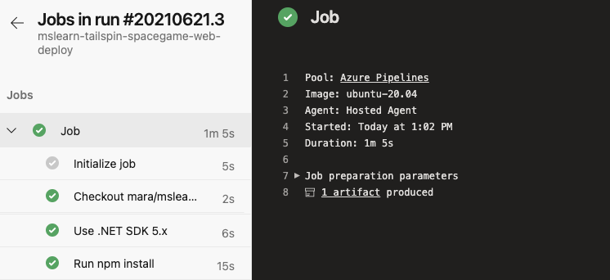

1. After the build finishes, select the back button to return to the summary page.

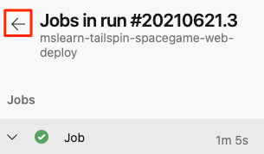

1. On the summary page, select your published artifact.

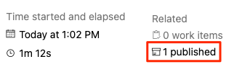

1. From the **Published artifacts** page, expand the **drop** folder.

You see a *.zip* file that contains your built application and its dependencies. This is your build artifact.

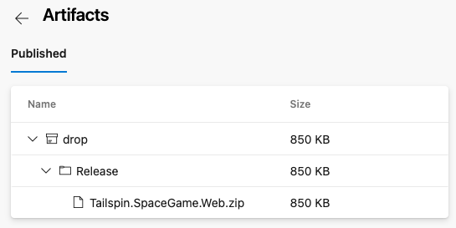

You can manually download and install the build artifact in your own environment, just as Amita did in the previous learning path. In this module, you add a deployment stage that automatically deploys the build artifact to Azure App Service.

You now have a build pipeline for the *Space Game* web project. Next you add the deployment stage to the pipeline.

### Deploy the web application to Azure App Service

Here you create a multistage pipeline that includes a stage named *Build* and a stage named *Deploy*. To create the pipeline, you:

* Create an App Service instance to host the website.
* Use multistage pipelines to define a build stage and a deployment stage.
* Run the pipeline and see the website deployed to App Service.

#### Create the App Service instance

1. Go to the [Azure portal](https://portal.azure.com/) and sign in.
2. On the left, select **App Services**.
3. Select **+ Create**.
4. On the **Web App** page, fill in these fields:

|  |  |
| --- | --- |
| **TABLE 1** | |
| **Field** | **Value** |
| **Subscription** | Your Azure subscription. |
| **Resource Group** | Select **Create new** and then enter *tailspin-space-game-rg* as the resource group name. |
| **Name** | Provide a unique name, such as *tailspin-space-game-web-<****your-employee-id****>*. Your App Service instance requires a unique name because the name becomes part of the domain name. In practice, choose a name that describes your service. Note the name for later. |
| **Publish** | **Code** |
| **Runtime stack** | **.NET 5** |
| **Operating System** | **Linux** |
| **Region** | Select any region, preferably one close to you. |
| **Linux Plan** | Keep the default value. |
| **Sku and size** | Select **Change size** > **Dev/Test** tab > **B1** > **Apply**. |

1. Select **Review + create** > **Create**.

The deployment takes a few moments to finish.

1. After the deployment finishes, select **Go to resource**.

You see details related to your deployment.



1. Select the URL.

From a new browser tab, you see the default home page for your app.

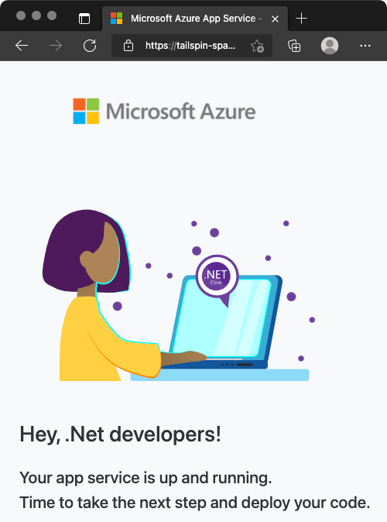

Soon you'll define a pipeline stage that deploys the *Space Game* website to this App Service instance.

Keep this browser tab open for later.

**Note**

For learning purposes, here you use the default network settings. These settings make your site accessible from the internet. In practice, you could configure an Azure virtual network that places your website in a network that's not internet routable but that only you and your team can access. Later, when you're ready, you could reconfigure your network to make the website available to your users.

#### Create a service connection

Here you create a service connection that enables Azure Pipelines to access your Azure subscription. Azure Pipelines uses this service connection to deploy the website to App Service.

**Important**

Make sure that you're signed in to both the Azure portal and Azure DevOps under the same Microsoft account.

1. In Azure DevOps, go to your **Space Game - web - Release** project.
2. From the bottom corner of the page, select **Project settings**.
3. Under **Pipelines**, select **Service connections**.
4. Select **New service connection**, then choose **Azure Resource Manager**, then select **Next**.
5. Near the top of the page, **Service principal (automatic)**. Then select **Next**.
6. Fill in these fields:

|  |  |
| --- | --- |
| **TABLE 2** | |
| **Field** | **Value** |
| Scope level | **Subscription** |
| Subscription | Your Azure subscription |
| Resource Group | **tailspin-space-game-rg** |
| Service connection name | *Resource Manager - Tailspin - Space Game* |

1. During the process, you might be prompted to sign in to your Microsoft account.
2. Ensure that **Grant access permission to all pipelines** is selected.
3. Select **Save**.

Azure DevOps performs a test connection to verify that it can connect to your Azure subscription. If Azure DevOps can't connect, you have the chance to sign in a second time.

#### Add the Build stage to the pipeline

Here you convert your existing build pipeline to use the multistage feature of Azure Pipelines. You update your build configuration to define one stage that performs the build. Then you watch the pipeline run.

Recall that your build pipeline defines the agent pool, variables, and tasks that are required to build your app. As a refresher, here are the first few lines from your current build configuration:

trigger:

- '*'

pool:

vmImage: 'ubuntu-20.04'

demands:

- npm

variables:

buildConfiguration: 'Release'

wwwrootDir: 'Tailspin.SpaceGame.Web/wwwroot'

dotnetSdkVersion: '5.x'

steps:

- task: UseDotNet@2

displayName: 'Use .NET SDK $(dotnetSdkVersion)'

inputs:

version: '$(dotnetSdkVersion)'

...

A *multistage pipeline* enables you to define distinct phases that your change passes through as it's promoted through the pipeline. Each stage defines the agent, variables, and steps required to carry out that phase of the pipeline. In this module, you define one stage to perform the build. You define a second stage to deploy the web application to App Service.

To convert your existing build configuration to a multistage pipeline, you add a stages section to your configuration. You then add one or more stage sections to define each phase of your pipeline. Stages break down into jobs, which are a series of steps that run sequentially as a unit.

Before we add the *Deploy* stage to the pipeline, let's first convert the existing build configuration to a multistage pipeline.

1. From your project in Visual Studio Code, open *azure-pipelines.yml* and replace its contents with this code:

trigger:

- '*'

variables:

buildConfiguration: 'Release'

stages:

- stage: 'Build'

displayName: 'Build the web application'

jobs:

- job: 'Build'

displayName: 'Build job'

pool:

vmImage: 'ubuntu-20.04'

demands:

- npm

variables:

wwwrootDir: 'Tailspin.SpaceGame.Web/wwwroot'

dotnetSdkVersion: '5.x'

steps:

- task: UseDotNet@2

displayName: 'Use .NET SDK $(dotnetSdkVersion)'

inputs:

version: '$(dotnetSdkVersion)'

- task: Npm@1

displayName: 'Run npm install'

inputs:

verbose: false

- script: './node_modules/.bin/node-sass $(wwwrootDir) --output $(wwwrootDir)'

displayName: 'Compile Sass assets'

- task: gulp@1

displayName: 'Run gulp tasks'

- script: 'echo "$(Build.DefinitionName), $(Build.BuildId), $(Build.BuildNumber)" > buildinfo.txt'

displayName: 'Write build info'

workingDirectory: $(wwwrootDir)

- task: DotNetCoreCLI@2

displayName: 'Restore project dependencies'

inputs:

command: 'restore'

projects: '**/*.csproj'

- task: DotNetCoreCLI@2

displayName: 'Build the project - $(buildConfiguration)'

inputs:

command: 'build'

arguments: '--no-restore --configuration $(buildConfiguration)'

projects: '**/*.csproj'

- task: DotNetCoreCLI@2

displayName: 'Publish the project - $(buildConfiguration)'

inputs:

command: 'publish'

projects: '**/*.csproj'

publishWebProjects: false

arguments: '--no-build --configuration $(buildConfiguration) --output $(Build.ArtifactStagingDirectory)/$(buildConfiguration)'

zipAfterPublish: true

- publish: '$(Build.ArtifactStagingDirectory)'

artifact: drop

**Important**

In YAML, white space is important. This change affects all of the white space in your file, so we recommend that you replace the entire file with what you see here. The highlighted sections illustrate the use of stages and jobs.

1. From the integrated terminal, add *azure-pipelines.yml* to the index. Then commit the change and push it up to GitHub.

**Tip**

Save *azure-pipelines.yml* before you run these Git commands.

git add azure-pipelines.yml

git commit -m "Add a build stage to the pipeline"

git push origin release-pipeline

1. In Azure Pipelines, go to the build and trace the build as it runs.
2. After the build finishes, select the back button to return to the summary page.

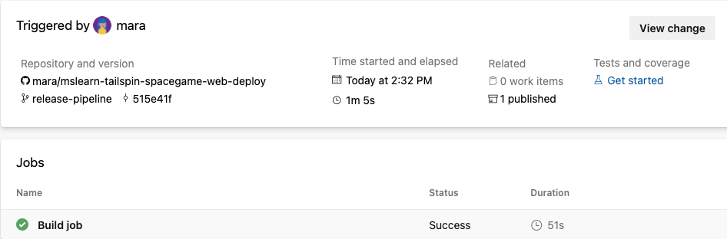

You see that the build finished successfully. Your build pipeline accomplishes the same task as before. It builds the web app and publishes the artifact to the pipeline. But with this new change, you can now add more stages to the pipeline.

### Create the dev environment

Recall that in Azure Pipelines, an *environment* is an abstract representation of your deployment environment. You can also define an environment through Azure Pipelines that includes specific criteria for your release. This criteria can include the pipelines that are authorized to deploy to the environment. You can also specify the human approvals that are needed to promote the release from one stage to the next.

For your POC, you'll deploy to the **dev** environment. For now, your environment will define no specific release criteria. In future modules, you'll specify criteria such as human approvals which are required to sign off on changes before those changes move to the next stage.

To create the **dev** environment:

1. From Azure Pipelines, select **Environments**.

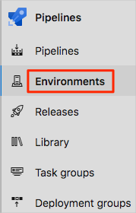

1. Select **Create environment**.
2. Under **Name**, enter *dev*.
3. Leave the remaining fields at their default values.
4. Select **Create**.

#### Store your web app name in a pipeline variable

Here you add a variable to your pipeline to store the name of your web app in App Service.

When you set up App Service earlier, you assigned it a name, such as *tailspin-space-game-web-1234*. The *Deploy* stage you'll define uses this name to identify which App Service instance to deploy to.

Although you could hard-code this name in your pipeline configuration, defining it as a variable makes your configuration more reusable.

A pipeline variable enables you to define a value in Azure Pipelines and read that value from your pipeline configuration. If the name of your App Service instance changes, you can update the variable and trigger your pipeline without modifying your configuration.

To add the variable:

1. In Azure DevOps, under **Pipelines**, select **Library**.

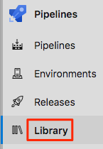

1. Select **+ Variable group**.
2. Under **Properties**, enter *Release* for the variable group name.
3. Under **Variables**, select **+ Add**.
4. For the name of your variable, enter *WebAppName*. For its value, enter your App Service instance's name, such as *tailspin-space-game-web-1234*.
5. Near the top of the page, select **Save** to save your variable to the pipeline.

#### Add the deployment stage to the pipeline

Here you extend your pipeline by adding a deployment stage that uses App Service to deploy the *Space Game* web application. To accomplish this objective, you define a second stage and use the download and AzureWebApp@1 tasks to download the build artifact from the pipeline and perform the deployment.

1. From Visual Studio Code, replace the contents of *azure-pipelines.yml* with this code:

trigger:

- '*'

variables:

buildConfiguration: 'Release'

stages:

- stage: 'Build'

displayName: 'Build the web application'

jobs:

- job: 'Build'

displayName: 'Build job'

pool:

vmImage: 'ubuntu-20.04'

demands:

- npm

variables:

wwwrootDir: 'Tailspin.SpaceGame.Web/wwwroot'

dotnetSdkVersion: '5.x'

steps:

- task: UseDotNet@2

displayName: 'Use .NET SDK $(dotnetSdkVersion)'

inputs:

version: '$(dotnetSdkVersion)'

- task: Npm@1

displayName: 'Run npm install'

inputs:

verbose: false

- script: './node_modules/.bin/node-sass $(wwwrootDir) --output $(wwwrootDir)'

displayName: 'Compile Sass assets'

- task: gulp@1

displayName: 'Run gulp tasks'

- script: 'echo "$(Build.DefinitionName), $(Build.BuildId), $(Build.BuildNumber)" > buildinfo.txt'

displayName: 'Write build info'

workingDirectory: $(wwwrootDir)

- task: DotNetCoreCLI@2

displayName: 'Restore project dependencies'

inputs:

command: 'restore'

projects: '**/*.csproj'

- task: DotNetCoreCLI@2

displayName: 'Build the project - $(buildConfiguration)'

inputs:

command: 'build'

arguments: '--no-restore --configuration $(buildConfiguration)'

projects: '**/*.csproj'

- task: DotNetCoreCLI@2

displayName: 'Publish the project - $(buildConfiguration)'

inputs:

command: 'publish'

projects: '**/*.csproj'

publishWebProjects: false

arguments: '--no-build --configuration $(buildConfiguration) --output $(Build.ArtifactStagingDirectory)/$(buildConfiguration)'

zipAfterPublish: true

- publish: '$(Build.ArtifactStagingDirectory)'

artifact: drop

- stage: 'Deploy'

displayName: 'Deploy the web application'

dependsOn: Build

jobs:

- deployment: Deploy

pool:

vmImage: 'ubuntu-20.04'

environment: dev

variables:

- group: Release

strategy:

runOnce:

deploy:

steps:

- download: current

artifact: drop

- task: AzureWebApp@1

displayName: 'Azure App Service Deploy: website'

inputs:

azureSubscription: 'Resource Manager - Tailspin - Space Game'

appName: '$(WebAppName)'

package: '$(Pipeline.Workspace)/drop/$(buildConfiguration)/*.zip'

Notice the use of the download and AzureWebApp@1 tasks. $(WebAppName) reads the web app name from your pipeline variable.

Also notice the environment field. This specifies that the deployment is associated with the **dev** environment.

1. From the integrated terminal, add *azure-pipelines.yml* to the index. Then commit the change and push it up to GitHub.

git add azure-pipelines.yml

git commit -m "Add a deployment stage to the pipeline"

git push origin release-pipeline

1. In Azure Pipelines, trace the build and deployment through each of the stages.
2. After the pipeline finishes, select the back button to return to the summary page.

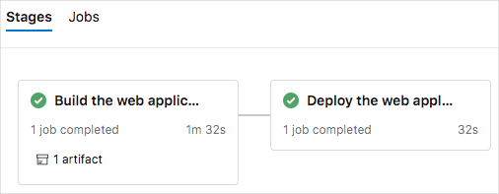

You see that both the build stages and the deployment stages finished successfully.

#### See the deployed website on App Service

When you created your App Service instance, you saw the default website that was created for you. Here you revisit your website to see the results of your deployment.

1. From a web browser, navigate to the URL that's associated with your App Service instance.

If you still have the browser tab open, simply refresh the page. If the browser tab isn't open, you can find the URL on the App Service details page in the Azure portal.



1. See that the *Space Game* website has been successfully deployed to App Service and is running.

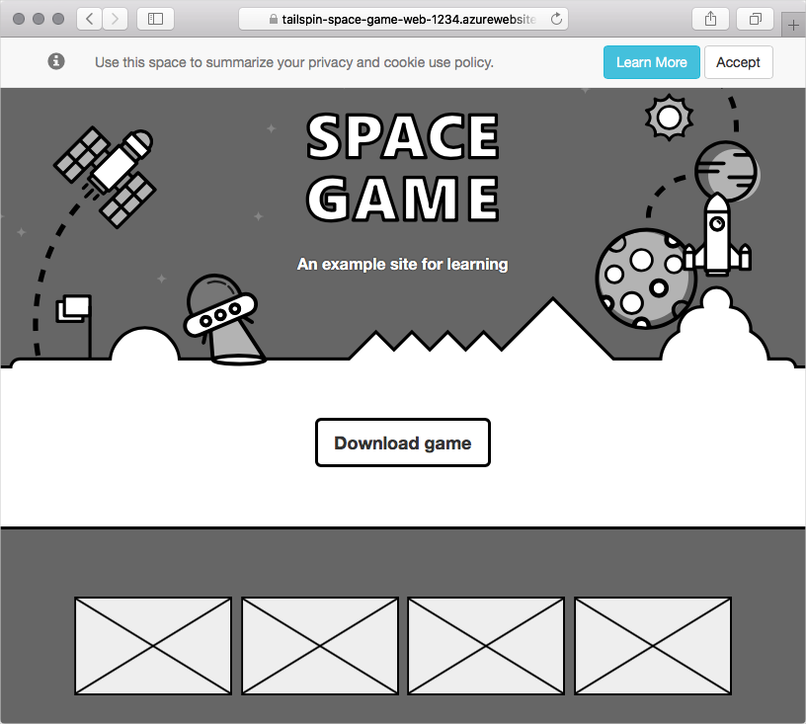

Congratulations! You've successfully deployed the *Space Game* website to App Service by using Azure Pipelines.

### Monitor the health of your pipeline

In this exercise, you examine a few of the analytics features that Azure Pipelines provides.

**Explore your pipeline's analytics**

Let's examine a few of your pipeline's analytics.

1. In Azure Pipelines, navigate to your pipeline.
2. Select the **Analytics** tab.

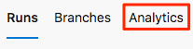

1. Note the pass rates and average duration of your pipeline runs.

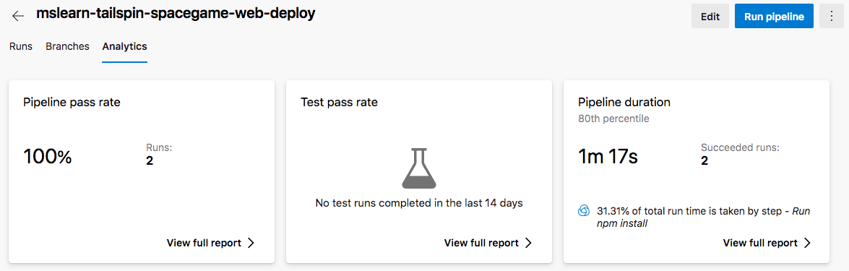

1. Under **Pipeline pass rate**, select **View full report**.

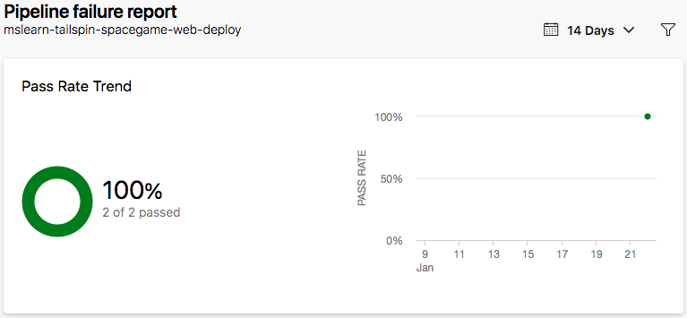

At this point, you have a basic pipeline report that contains data for just a few runs.

### Clean up Azure resources

Here you delete your Azure App Service instance. One way to delete Azure resources, such as an App Service instance, is to delete its parent resource group. Deleting a resource group deletes all resources in that group.

To clean up your resource group:

1. Go to the [Azure portal](https://portal.azure.com/) and sign in.
2. Select **Resource groups** from the menu.
3. Select your resource group, **tailspin-space-game-rg**.
4. Select **Delete resource group**.
5. Enter **tailspin-space-game-rg** into the text box and then select **Delete**.

After the deletion process finishes, you return to the list of resource groups in your Azure subscription.

### Disable the pipeline

Each module in this learning path provides a template you can run to create a clean environment for the module.

When you run multiple templates, you get multiple Azure Pipelines projects, each pointing to the same GitHub repository. This setup can trigger multiple pipelines to run each time you push a change to your GitHub repository, consuming free build minutes on our hosted agents. Therefore, it's important to disable or delete your pipeline before you move to the next module.

#### Disable the pipeline

This option disables the pipeline so that it doesn't process further build requests. You can re-enable the build pipeline later if you want to. Choose this option if you want to keep your DevOps project and your build pipeline for future reference.

To disable the pipeline:

1. In Azure Pipelines, navigate to your pipeline.
2. From the drop-down menu, select **Settings**:



1. Under **Processing of new run requests**, select **Disabled** and then select **Save**.

Your pipeline will no longer process build requests.

## Task 02: Create a multistage pipeline by using Azure Pipelines

In Create a release pipeline with Azure Pipelines, you built a basic release pipeline. That pipeline has a *Build* stage that builds the artifact, and a *Deploy* stage that installs the web app on Azure App Service.

Of course, an actual release pipeline has more stages. Each stage has its own set of tasks that can potentially take an artifact all the way to production.

In this module, you'll join the Tailspin Toys web team as they design a realistic release pipeline that contains multiple stages. You'll also learn different ways to control how an artifact is promoted from one stage to the next.

A good release-management workflow enables you to release more frequently and more consistently. In practice, you'll want to define a process that maps to your team's needs. Here you'll create a basic workflow. That means first designing the environments. The environments define the runtimes of each stage in the pipeline. You'll then deploy the *Space Game* web app to these stages: *Dev*, *Test*, and *Staging*. Each stage deploys the app to its own App Service instance.

### Set up your Azure DevOps environment

In this section, you make sure that your Azure DevOps organization is set up to complete the rest of this module. You also create the Azure App Service environments that you'll deploy to.

To accomplish these goals, you:

* Add a user to ensure Azure DevOps can connect to your Azure subscription.
* Set up an Azure DevOps project for this module.
* On Azure Boards, move the work item for this module to the **Doing** column.
* Make sure your project is set up locally so that you can push changes to the pipeline.
* Create the Azure App Service environments by using the Azure CLI in Azure Cloud Shell.
* Create pipeline variables that define the names of your App Service environments.
* Create a service connection that enables Azure Pipelines to securely access your Azure subscription.

### Run the template

Run a template that sets up your Azure DevOps organization:

[Click here to Run the template](https://azuredevopsdemogenerator.azurewebsites.net/?x-ms-routing-name=self&name=create-multi-stage-pipeline)

From the Azure DevOps Demo Generator site, to run the template, follow these steps.

1. Select **Sign In**, and accept the usage terms.
2. On the **Create New Project** page, select your Azure DevOps organization. Enter a project name, such as *Space Game - web - Multistage*.

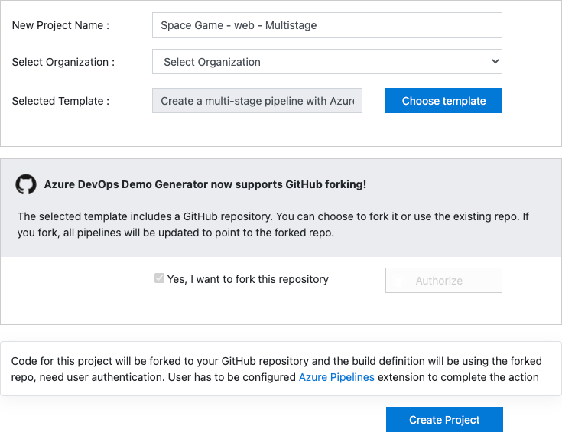

1. Select **Yes, I want to fork this repository** > **Authorize**.

If a window appears, authorize access to your GitHub account.

**Important**

You need to select this option so the template will connect to your GitHub repository. Select it even if you've already forked the *Space Game* website project. The template uses your existing fork.

1. Select **Create Project**.

The template takes a few moments to run.

1. To go to your project in Azure DevOps, select **Navigate to project**.

#### Move the work item to Doing

Here, you assign a work item to yourself on Azure Boards. You also move the work item to the **Doing** state. In practice, you and your team would create work items at the start of each *sprint*, or work iteration.

This work assignment gives you a checklist to work from. It gives other team members visibility into what you're working on and how much work is left. The work item also helps enforce work-in-progress (WIP) limits, so that the team doesn't take on too much work at one time.

Recall that the team settled on the following top issues for the current sprint.

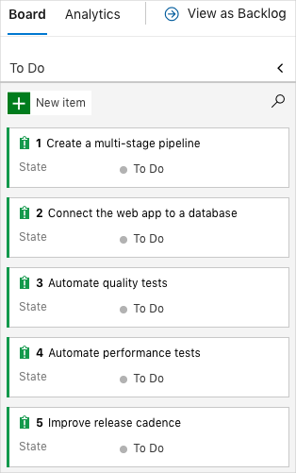

**Note**

Within an Azure DevOps organization, work items are numbered sequentially. In your project, the number for each work item might not match what you see here.

Here you move the first item, **Create a multistage pipeline**, to the **Doing** column. Then you assign yourself to the work item. **Create a multistage pipeline** relates to defining each stage of deploying the *Space Game* website.

To set up the work item:

1. From Azure DevOps, navigate to **Boards**. Then, from the menu, select **Boards**.



1. In the **Create a multistage pipeline** work item, at the bottom of the card, select the down arrow. Then, assign the work item to yourself.



1. Move the work item from the **To Do** column to the **Doing** column.

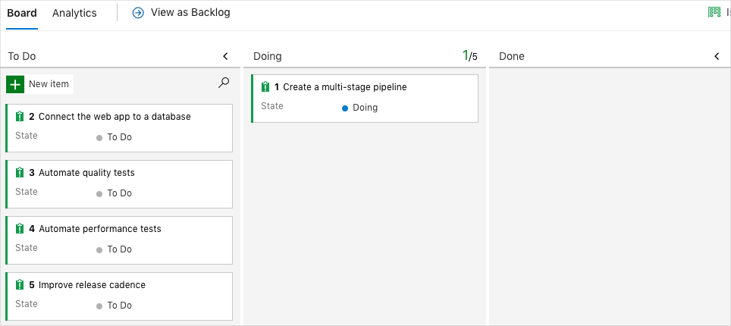

At the end of this module, you'll move the card to the **Done** column, after you complete the task.

#### Set up the project locally

Here you load the *Space Game* project in Visual Studio Code, configure Git, clone your repository locally, and set the upstream remote so that you can download starter code.

**Note**

If you're already set up with the **[mslearn-tailspin-spacegame-web-deploy](https://github.com/MicrosoftDocs/mslearn-tailspin-spacegame-web-deploy" \t "az-portal)** project locally, you can move to the next section.

#### Open the integrated terminal

Visual Studio Code comes with an integrated terminal. Here you can both edit files and work from the command line.

1. Start Visual Studio Code.
2. On the **View** menu, select **Terminal**.
3. In the drop-down list, select **bash**. If you're familiar with another Unix shell that you prefer to use, such as Zsh, select that shell instead.



In the terminal window, you can choose any shell that's installed on your system. For example, you can choose Bash, Zsh, or PowerShell.

Here you'll use Bash. Git for Windows provides Git Bash, which makes it easy to run Git commands.

**Note**

On Windows, if you don't see **bash** listed as an option, make sure you've installed [**Git**](https://git-scm.com/downloads) and then restart Visual Studio Code.

If you still don't see the **bash** option, see [**Integrated Terminal**](https://code.visualstudio.com/docs/editor/integrated-terminal) to manually configure your terminal settings.

1. Run the cd command to navigate to the directory where you want to work. Choose your home directory (~) or a different directory if you want.

cd ~

#### Configure Git

If you're new to Git and GitHub, first run a few commands to associate your identity with Git and authenticate with GitHub. For more information, see [Set up Git](https://help.github.com/articles/set-up-git).

At a minimum, you need to complete the following steps. Run the commands from the integrated terminal.

1. [Set your username](https://help.github.com/articles/setting-your-username-in-git).
2. [Set your commit email address](https://help.github.com/articles/setting-your-commit-email-address-in-git).
3. [Cache your GitHub password](https://help.github.com/articles/caching-your-github-password-in-git).

**Note**

If you already use two-factor authentication with GitHub, [**create a personal access token**](https://help.github.com/articles/creating-a-personal-access-token-for-the-command-line). When you're prompted, use your token in place of your password.

Treat your access token like a password. Keep it in a safe place.

#### Set up your project in Visual Studio Code

In the [Build applications with Azure DevOps](https://docs.microsoft.com/en-us/learn/paths/build-applications-with-azure-devops/) learning path, you forked and then cloned a Git repository. The repository contains the source code for the *Space Game* website. Your fork was connected to your projects in Azure DevOps so that the build runs when you push changes to GitHub.

**Important**

In this learning path, we switch to a different Git repository, **[mslearn-tailspin-spacegame-web-deploy](https://github.com/MicrosoftDocs/mslearn-tailspin-spacegame-web-deploy" \t "az-portal)**. When you ran the template to set up your Azure DevOps project, the process forked the repository automatically for you.

In this part, you clone your fork locally so that you can change and build out your pipeline configuration.

#### Clone your fork locally

You now have a copy of the *Space Game* web project in your GitHub account. Now you'll download, or *clone*, a copy to your computer so you can work with it.

A clone, just like a fork, is a copy of a repository. When you clone a repository, you can make changes, verify that they work as you expect, and then upload those changes to GitHub. You can also synchronize your local copy with changes that other authenticated users have made to the GitHub copy of your repository.

To clone the *Space Game* web project to your computer:

1. Go to your fork of the *Space Game* web project (**mslearn-tailspin-spacegame-web-deploy**) on [GitHub](https://github.com/).
2. Select **Code**. Then, from the **HTTPS** tab, select the button next to the URL that's shown to copy the URL to your clipboard.



1. In Visual Studio Code, go to the terminal window.
2. In the terminal, move to the directory where you want to work. Choose your home directory (~) or a different directory if you want.

cd ~

1. Run the git clone command. Replace the URL that's shown here with the contents of your clipboard:

git clone https://github.com/your-name/mslearn-tailspin-spacegame-web-deploy.git

1. Move to the mslearn-tailspin-spacegame-web-deploy directory. This is the root directory of your repository.

cd mslearn-tailspin-spacegame-web-deploy

#### Set the upstream remote

A *remote* is a Git repository where team members collaborate (like a repository on GitHub). Here you list your remotes and add a remote that points to Microsoft's copy of the repository so that you can get the latest sample code.

1. Run this git remote command to list your remotes:

git remote -v

You see that you have both fetch (download) and push (upload) access to your repository:

origin https://github.com/username/mslearn-tailspin-spacegame-web-deploy.git (fetch)

origin https://github.com/username/mslearn-tailspin-spacegame-web-deploy.git (push)

*Origin* specifies your repository on GitHub. When you fork code from another repository, the original remote (the one you forked from) is often named *upstream*.

1. Run this git remote add command to create a remote named *upstream* that points to the Microsoft repository:

git remote add upstream https://github.com/MicrosoftDocs/mslearn-tailspin-spacegame-web-deploy.git

1. Run git remote again to see the changes:

git remote -v

You see that you still have both fetch (download) access and push (upload) access to your repository. You also now have fetch access to the Microsoft repository:

origin https://github.com/username/mslearn-tailspin-spacegame-web-deploy.git (fetch)

origin https://github.com/username/mslearn-tailspin-spacegame-web-deploy.git (push)

upstream https://github.com/MicrosoftDocs/mslearn-tailspin-spacegame-web-deploy.git (fetch)

#### Open the project in the file explorer

In Visual Studio Code, your terminal window points to the root directory of the *Space Game* web project. To view its structure and work with files, from the file explorer, you'll now open the project.

1. The easiest way to open the project is to reopen Visual Studio Code in the current directory. To do so, run the following command from the integrated terminal:

code -r .

You see the directory and file tree in the file explorer.

1. Reopen the integrated terminal. The terminal places you at the root of your web project.

If the code command fails, you need to add Visual Studio Code to your system PATH. To do so:

1. In Visual Studio Code, select F1 or select **View** > **Command Palette** to access the command palette.
2. In the command palette, enter *Shell Command: Install 'code' command in PATH*.
3. Repeat the previous procedure to open the project in the file explorer.

You're now set up to work with the *Space Game* source code and your Azure Pipelines configuration from your local development environment.

#### Create the Azure App Service environments

Here, you create the environments that define the pipeline stages. You create one App Service instance for each stage: *Dev*, *Test*, and *Staging*.

In Create a release pipeline with Azure Pipelines, you brought up App Service through the Azure portal. Although the portal is a great way to explore what's available on Azure or to do basic tasks, bringing up components such as App Service can be tedious.

In this module, you use the Azure CLI to bring up three App Service instances. You can access the Azure CLI from a terminal or through Visual Studio Code. Here, you access the Azure CLI from Azure Cloud Shell. This browser-based shell experience is hosted in the cloud. In Cloud Shell, the Azure CLI is configured for use with your Azure subscription.

#### Bring up Cloud Shell through the Azure portal

1. Go to the [Azure portal](https://portal.azure.com/), and sign in.
2. From the menu, select **Cloud Shell**. When prompted, select the **Bash** experience.



**Note**

Cloud Shell requires an Azure storage resource to persist any files that you create in the Cloud Shell. When you first open the Cloud Shell, you're prompted to create a resource group, storage account, and Azure Files share. This setup is automatically used for all future Cloud Shell sessions.

#### Select an Azure region

A *region* is one or more Azure datacenters within a geographic location. East US, West US, and North Europe are examples of regions. Every Azure resource, including an App Service instance, is assigned a region.

To make commands easier to run, start by selecting a default region. After you specify the default region, later commands use that region unless you specify a different region.

1. From the Cloud Shell, to list the regions that are available from your Azure subscription, run the following az account list-locations command.

az account list-locations \

--query "[].{Name: name, DisplayName: displayName}" \

--output table

1. From the Name column in the output, select a region that's close to you. For example, choose eastasia or westus2.
2. Run az configure to set your default region. Replace <REGION> with the name of the region you selected.

az configure --defaults location=<REGION>

This example sets westus2 as the default region:

az configure --defaults location=westus2

#### Create the App Service instances

Here, you create the App Service instances for the three stages you'll deploy to: *Dev*, *Test*, and *Staging*. Here's a brief overview of the process you'll follow:

1. Generate a random number that makes your web app's domain name unique.

This step is for learning purposes. In practice, you would choose a domain name that matches the name of your app or service.

1. Create a resource group that contains all of your App Service instances.

For learning purposes, here you create one resource group that contains all of your App Service instances. In practice, you might create a separate resource group for each App Service instance so that you can better control the life cycle of each instance.

1. Create an App Service plan.

An App Service plan defines the CPU, memory, and storage resources for your web app. Here, you use the **B1 Basic** plan. This plan is intended for apps that have low traffic requirements. The **Standard** and **Premium** plans are for production workloads. These plans run on dedicated virtual machine instances.

1. For each of the *Dev*, *Test*, and *Staging* environments, create an App Service instance.
2. Get the host name for each environment.
3. Verify that each environment is running, and that the home page is accessible.

**Note**

For learning purposes, here, you use the default network settings. These settings make your site accessible from the internet. In practice, you could configure an Azure virtual network that places your website in a network that's not internet routable, and that only you and your team can access. Later, you could reconfigure your network to make the website available to your users.

To create your App Service instances, follow these steps:

1. From the Cloud Shell, generate a random number that makes your web app's domain name unique.

webappsuffix=$RANDOM

1. To create a resource group that's named *tailspin-space-game-rg*, run the following az group create command.

az group create --name tailspin-space-game-rg

1. To create an App Service plan that's named *tailspin-space-game-asp*, run the following az appservice plan create command.

az appservice plan create \

--name tailspin-space-game-asp \

--resource-group tailspin-space-game-rg \

--sku B1 \

--is-linux

The --sku argument specifies the B1 plan. This plan runs on the Basic tier. The --is-linux argument specifies to use Linux workers.

**Important**

If the B1 SKU isn't available in your Azure subscription, [**select a different plan**](https://azure.microsoft.com/pricing/details/app-service/linux/), such as S1 (Standard).

1. To create the three App Service instances, one for each environment (*Dev*, *Test*, and *Staging*), run the following az webapp create commands.

az webapp create \

--name tailspin-space-game-web-dev-$webappsuffix \

--resource-group tailspin-space-game-rg \

--plan tailspin-space-game-asp \

--runtime "DOTNET|5.0"

az webapp create \

--name tailspin-space-game-web-test-$webappsuffix \

--resource-group tailspin-space-game-rg \

--plan tailspin-space-game-asp \

--runtime "DOTNET|5.0"

az webapp create \

--name tailspin-space-game-web-staging-$webappsuffix \

--resource-group tailspin-space-game-rg \

--plan tailspin-space-game-asp \

--runtime "DOTNET|5.0"

For learning purposes, here, you apply the same App Service plan, B1 Basic, to each App Service instance. In practice, you would assign a plan that matches your expected workload.

For example, for the environments that map to the *Dev* and *Test* stages, B1 Basic might be appropriate because you want only your team to access the environments.

For the *Staging* environment, you would select a plan that matches your production environment. That plan would likely provide greater CPU, memory, and storage resources. Under the plan, you can run performance tests, like load tests, in an environment that resembles your production environment. You can run the tests without affecting live traffic to your site.

1. To list the host name and state of each App Service instance, run the following az webapp list command.

az webapp list \

--resource-group tailspin-space-game-rg \

--query "[].{hostName: defaultHostName, state: state}" \

--output table

Note the host name for each running service. You'll need the host names later when you verify your work. Here's an example:

HostName State

------------------------------------------------------- -------

tailspin-space-game-web-dev-21017.azurewebsites.net Running

tailspin-space-game-web-test-21017.azurewebsites.net Running

tailspin-space-game-web-staging-21017.azurewebsites.net Running

1. As an optional step, go to one or more of the host names. Verify that they're running, and that the default home page appears.

Here's what you see:



#### Create pipeline variables in Azure Pipelines

To add the variables:

1. In Azure DevOps, go to your **Space Game - web - Multistage** project.
2. Under **Pipelines**, select **Library**.

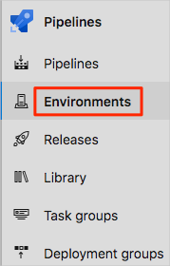

1. Select **+ Variable group**.
2. Under **Properties**, enter **Release** for the variable group name.
3. Under **Variables**, select **+ Add**.
4. For the name of your variable, enter *WebAppNameDev*. For the value, enter the name of the App Service instance that corresponds to your *Dev* environment, such as *tailspin-space-game-web-dev-1234*.
5. Repeat the previous two steps twice more to create variables for your *Test* and *Staging* environments. Here are examples:

|  |  |
| --- | --- |
| **TABLE 1** | |
| **Variable name** | **Example value** |
| *WebAppNameTest* | *tailspin-space-game-web-test-1234* |
| *WebAppNameStaging* | *tailspin-space-game-web-staging-1234* |

1. Be sure to replace each example value with the App Service instance that corresponds to your environment.

**Important**

Set the name of the App Service instance, not its host name. In this example, you would enter *tailspin-space-game-web-dev-1234* and not *tailspin-space-game-web-dev-1234.azurewebsites.net*.

1. Near the top of the page, to save your variable to the pipeline, select **Save**.

Your variable group resembles this one:

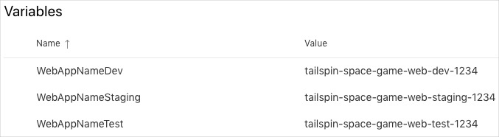

#### Create the dev and test environments

In Create a release pipeline with Azure Pipelines, you created an environment for the **dev** environment. Here, you'll repeat the process for both the **dev** and **test** environments. Later, you'll set up the **staging** environment, which includes additional criteria.

To create the **dev** and **test** environments:

1. From Azure Pipelines, select **Environments**.



1. To create the **dev** environment:
   1. Select **Create environment**.
   2. Under **Name**, enter *dev*.
   3. Leave the remaining fields at their default values.
   4. Select **Create**.
2. To create the **test** environment:
   1. Return to the **Environments** page.
   2. Select **New environment**.
   3. Under **Name**, enter *test*.
   4. Select **Create**.

#### Create a service connection

Here, you create a service connection that enables Azure Pipelines to access your Azure subscription. Azure Pipelines uses this service connection to deploy the website to App Service. You created a similar service connection in the previous module.

**Important**

Make sure that you're signed in to both the Azure portal and Azure DevOps under the same Microsoft account.

1. In Azure DevOps, go to your **Space Game - web - Multistage** project.
2. From the bottom corner of the page, select **Project settings**.
3. Under **Pipelines**, select **Service connections**.
4. Select **New service connection**, then select **Azure Resource Manager**, and then select **Next**.
5. Near the top of the page, **Service principal (automatic)**. Then, select **Next**.
6. Fill in these fields:

|  |  |
| --- | --- |
| **TABLE 2** | |
| **Field** | **Value** |
| Scope level | **Subscription** |
| Subscription | Your Azure subscription |
| Resource Group | **tailspin-space-game-rg** |
| Service connection name | *Resource Manager - Tailspin - Space Game* |

1. During the process, you might be prompted to sign in to your Microsoft account.
2. Ensure you have selected **Grant access permission to all pipelines**.
3. Select **Save**.

To verify that it can connect to your Azure subscription, Azure DevOps performs a test connection. If Azure DevOps can't connect, you have the chance to sign in a second time.

### Promote to the Dev stage

The team has a plan and is ready to begin implementing their release pipeline. You've set up your Azure DevOps project, and your Azure App Service instances are ready to receive build artifacts.

At this point, remember that the team's pipeline has only two stages. The first stage produces the build artifact. The second stage deploys the *Space Game* web app to App Service. Here, you follow along with Andy and Mara as they modify the pipeline. They'll deploy to the App Service environment that corresponds to the *Dev* stage.

The *Dev* stage resembles the deployment stage that you made in the Create a release pipeline in Azure Pipelines module. There, you used a CI trigger to start the build process. Here you do the same.

#### Fetch the branch from GitHub

Here, you fetch the release branch from GitHub. You also check out, or switch to, the branch.

This branch serves as your *release* branch. It contains the *Space Game* project that you used in previous modules. It also contains an Azure Pipelines configuration to start with.

To fetch and switch to the branch:

1. In Visual Studio Code, open the integrated terminal.
2. To fetch a branch named release from the Microsoft repository, and to switch to that branch, run the following git commands.

git fetch upstream release

git checkout -B release upstream/release

The format of these commands enables you to get starter code from the Microsoft GitHub repository, known as upstream. Shortly, you'll push this branch up to your GitHub repository, known as origin.

1. As an optional step, from Visual Studio Code, open *azure-pipelines.yml*. Familiarize yourself with the initial configuration.

The configuration resembles the basic one that you created in the Create a release pipeline with Azure Pipelines module. It builds only the app's release configuration. For learning purposes, this configuration doesn't run the quality or security checks that you set up in previous modules.

**Note**

A more robust configuration might specify the branches that participate in the build process. For example, to help verify code quality, you might run unit tests each time you push up a change on any branch. You might also deploy the application to an environment that performs more exhaustive testing. But you do this deployment only when you have a pull request, when you have a release candidate, or when you merge code to *main*.

#### Promote changes to the Dev stage

Here, you modify your pipeline configuration to promote the build to the *Dev* stage.

1. In Visual Studio Code, modify *azure-pipelines.yml*.

trigger:

- '*'

variables:

buildConfiguration: 'Release'

releaseBranchName: 'release'

stages:

- stage: 'Build'

displayName: 'Build the web application'

jobs:

- job: 'Build'

displayName: 'Build job'

pool:

vmImage: 'ubuntu-20.04'

demands:

- npm

variables:

wwwrootDir: 'Tailspin.SpaceGame.Web/wwwroot'

dotnetSdkVersion: '5.x'

steps:

- task: UseDotNet@2

displayName: 'Use .NET SDK $(dotnetSdkVersion)'

inputs:

version: '$(dotnetSdkVersion)'

- task: Npm@1

displayName: 'Run npm install'

inputs:

verbose: false

- script: './node_modules/.bin/node-sass $(wwwrootDir) --output $(wwwrootDir)'

displayName: 'Compile Sass assets'

- task: gulp@1

displayName: 'Run gulp tasks'

- script: 'echo "$(Build.DefinitionName), $(Build.BuildId), $(Build.BuildNumber)" > buildinfo.txt'

displayName: 'Write build info'

workingDirectory: $(wwwrootDir)

- task: DotNetCoreCLI@2

displayName: 'Restore project dependencies'

inputs:

command: 'restore'

projects: '**/*.csproj'

- task: DotNetCoreCLI@2

displayName: 'Build the project - $(buildConfiguration)'

inputs:

command: 'build'

arguments: '--no-restore --configuration $(buildConfiguration)'

projects: '**/*.csproj'

- task: DotNetCoreCLI@2

displayName: 'Publish the project - $(buildConfiguration)'

inputs:

command: 'publish'

projects: '**/*.csproj'

publishWebProjects: false

arguments: '--no-build --configuration $(buildConfiguration) --output $(Build.ArtifactStagingDirectory)/$(buildConfiguration)'

zipAfterPublish: true

- publish: '$(Build.ArtifactStagingDirectory)'

artifact: drop

- stage: 'Dev'

displayName: 'Deploy to the dev environment'

dependsOn: Build

condition: |

and

(

succeeded(),

eq(variables['Build.SourceBranchName'], variables['releaseBranchName'])

)

jobs:

- deployment: Deploy

pool:

vmImage: 'ubuntu-20.04'

environment: dev

variables:

- group: Release

strategy:

runOnce:

deploy:

steps:

- download: current

artifact: drop

- task: AzureWebApp@1

displayName: 'Azure App Service Deploy: website'

inputs:

azureSubscription: 'Resource Manager - Tailspin - Space Game'

appName: '$(WebAppNameDev)'

package: '$(Pipeline.Workspace)/drop/$(buildConfiguration)/*.zip'

This configuration resembles the one that you built in the previous module. There, you and the team built a proof of concept for continuous deployment. But note these differences, which are highlighted in the preceding code example:

* + This configuration defines variables at the top of the file. The variables are used throughout the pipeline. They define which configuration to build (Release). They also define the name of your release branch (release).
  + The **Deploy** stage from the proof of concept is now named **Dev**.
  + The **Dev** stage uses a condition that directs the system to run the stage only when the previous stage succeeds and the current branch is release. This setup ensures that release features are deployed only to the *Dev* environment.
  + The deployment step uses the WebAppNameDev variable to deploy to the App Service instance that's associated with the *Dev* environment.

**Note**

In practice, you might deploy from some other branch, such as main. You can include logic that allows changes to be promoted to the *Dev* stage from multiple branches, such as release and main.

1. From the integrated terminal, add *azure-pipelines.yml* to the index. Commit the change, and push it up to GitHub.

**Tip**

Before you run these Git commands, save *azure-pipelines.yml*.

git add azure-pipelines.yml

git commit -m "Deploy to the Dev stage"

git push origin release

1. In Azure Pipelines, go to the build. As it runs, trace the build.
2. After the build finishes, to return to the summary page, select the back button.

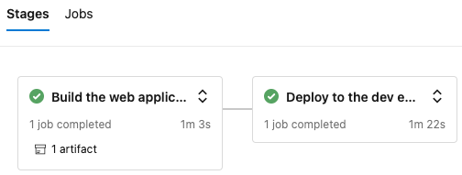

You see that the deployment finished successfully.

1. From a web browser, navigate to the URL that's associated with the App Service instance for your *Dev* environment.

If you still have the browser tab open, refresh the page. If you don't remember the URL, find it in the Azure portal, on the **App Service details** page.

You see that the *Space Game* website is deployed to App Service, and is running.

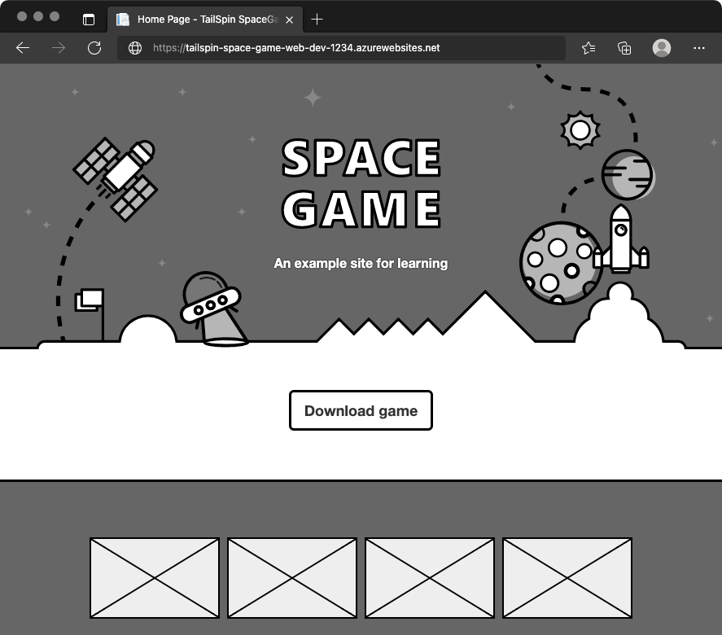

1. As an optional step, in Azure Pipelines, select **Environments**. Then, select the **dev** environment.

Azure Pipelines records your deployment history. In the history, you can trace the environment's changes back to code commits and work items.

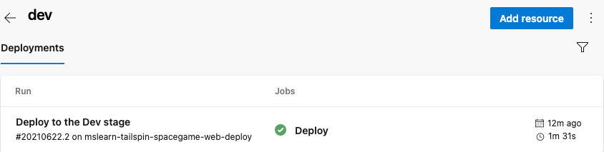

### Promote to the Test stage

Your release pipeline still has two stages, but they're now different than before. The stages are *Build* and *Dev*. Every change you push to GitHub triggers the *Build* stage to run. The *Dev* stage runs only when the change is in the *release* branch. Here, you add the *Test* stage to the pipeline.

Recall that promoting the build from the *Dev* stage to the *Test* stage at 3 A.M. each morning, the team decided to use a scheduled trigger. To set up the scheduled trigger:

* Define the schedule in your build configuration.
* Define the *Test* stage, which includes a condition that runs the stage only if the build reason is marked as Schedule.

For learning purposes, here, you define the schedule but allow the build to go directly from *Dev* to *Test*. This setup avoids the need to wait for the schedule to be triggered. After you complete this module, try experimenting with different cron expressions to run the *Test* stage only at the scheduled time.

#### Promote changes to the Test stage

Here, you modify your pipeline configuration to deploy the build to the *Test* stage.

1. In Visual Studio Code, modify *azure-pipelines.yml* like this:

trigger:

- '*'

variables:

buildConfiguration: 'Release'

releaseBranchName: 'release'

schedules:

- cron: '0 3 * * *'

displayName: 'Deploy every day at 3 A.M.'

branches:

include:

- release

always: false

stages:

- stage: 'Build'

displayName: 'Build the web application'

jobs:

- job: 'Build'

displayName: 'Build job'

pool:

vmImage: 'ubuntu-20.04'

demands:

- npm

variables:

wwwrootDir: 'Tailspin.SpaceGame.Web/wwwroot'

dotnetSdkVersion: '5.x'

steps:

- task: UseDotNet@2

displayName: 'Use .NET SDK $(dotnetSdkVersion)'

inputs:

version: '$(dotnetSdkVersion)'

- task: Npm@1

displayName: 'Run npm install'

inputs:

verbose: false

- script: './node_modules/.bin/node-sass $(wwwrootDir) --output $(wwwrootDir)'

displayName: 'Compile Sass assets'

- task: gulp@1

displayName: 'Run gulp tasks'

- script: 'echo "$(Build.DefinitionName), $(Build.BuildId), $(Build.BuildNumber)" > buildinfo.txt'

displayName: 'Write build info'

workingDirectory: $(wwwrootDir)

- task: DotNetCoreCLI@2

displayName: 'Restore project dependencies'

inputs:

command: 'restore'

projects: '**/*.csproj'

- task: DotNetCoreCLI@2

displayName: 'Build the project - $(buildConfiguration)'

inputs:

command: 'build'

arguments: '--no-restore --configuration $(buildConfiguration)'

projects: '**/*.csproj'

- task: DotNetCoreCLI@2

displayName: 'Publish the project - $(buildConfiguration)'

inputs:

command: 'publish'

projects: '**/*.csproj'

publishWebProjects: false

arguments: '--no-build --configuration $(buildConfiguration) --output $(Build.ArtifactStagingDirectory)/$(buildConfiguration)'

zipAfterPublish: true

- publish: '$(Build.ArtifactStagingDirectory)'

artifact: drop

- stage: 'Dev'

displayName: 'Deploy to the dev environment'

dependsOn: Build

condition: |

and

(

succeeded(),

eq(variables['Build.SourceBranchName'], variables['releaseBranchName'])

)

jobs:

- deployment: Deploy

pool:

vmImage: 'ubuntu-20.04'

environment: dev

variables:

- group: Release

strategy:

runOnce:

deploy:

steps:

- download: current

artifact: drop

- task: AzureWebApp@1

displayName: 'Azure App Service Deploy: website'

inputs:

azureSubscription: 'Resource Manager - Tailspin - Space Game'

appName: '$(WebAppNameDev)'

package: '$(Pipeline.Workspace)/drop/$(buildConfiguration)/*.zip'

- stage: 'Test'

displayName: 'Deploy to the test environment'

dependsOn: Dev

#condition: eq(variables['Build.Reason'], 'Schedule')

jobs:

- deployment: Deploy

pool:

vmImage: 'ubuntu-20.04'

environment: test

variables:

- group: 'Release'

strategy:

runOnce:

deploy:

steps:

- download: current

artifact: drop

- task: AzureWebApp@1

displayName: 'Azure App Service Deploy: website'

inputs:

azureSubscription: 'Resource Manager - Tailspin - Space Game'

appName: '$(WebAppNameTest)'

package: '$(Pipeline.Workspace)/drop/$(buildConfiguration)/*.zip'

The schedules section defines one cron expression. You can define more than one expression in your configuration. The expression triggers the pipeline to run against the release branch at 3 A.M. each day. The always flag is set to false so that the pipeline runs only when the release branch contains changes from the prior run.

The Test stage defines a condition that runs the stage only when the build reason equals Schedule. (The built-in variable Build.Reason defines the build reason.) If this condition is false, the stage is skipped, but the prior stages continue to run.

**Note**

This condition is shown for learning purposes. It's commented to enable the change to go from *Dev* to *Test* without waiting for the schedule to be triggered.

1. From the integrated terminal, to the index, add *azure-pipelines.yml*. Then, commit the change, and push it up to GitHub.

**Tip**

Before you run these Git commands, save *azure-pipelines.yml*.

git add azure-pipelines.yml

git commit -m "Deploy to the Test stage"

git push origin release

1. In Azure Pipelines, go to the build. Trace the build as it runs.
2. After the build finishes, to return to the summary page, select the back button.

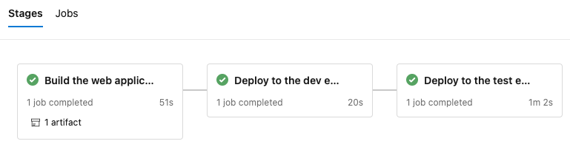

You see that the deployment finished successfully.

1. From a web browser, navigate to the URL that's associated with the App Service instance for your *Test* environment.

If you still have the browser tab open, refresh the page. If you don't remember the URL, find it in the Azure portal, on the **App Service details** page.

You see that the *Space Game* website is deployed to App Service, and it's running.

### Promote to Staging

Your release pipeline now has three stages: *Build*, *Dev*, and *Test*. You and the Tailspin team have one more stage to implement: *Staging*.

In this part, you'll:

* Create the **staging** environment in Azure Pipelines, and assign yourself as an approver.
* Define the *Staging* stage, which runs only after an approver verifies the results of the *Test* stage.

#### Create the staging environment

Here, you create an environment in Azure Pipelines for *Staging*. For learning purposes, you assign yourself as the approver. In practice, you would assign the users who are required to sign off on changes before those changes move to the next stage. For the Tailspin team, Amita approves changes so that they can be promoted from *Test* to *Staging*.

Earlier in this module, you specified environment settings for both *Dev* and *Test* stages. Here's an example for the *Dev* stage.

- stage: 'Deploy'

displayName: 'Deploy the web application'

dependsOn: Build

jobs:

- deployment: Deploy

pool:

vmImage: 'ubuntu-20.04'

environment: dev

variables:

- group: Release

You can define an environment through Azure Pipelines that includes specific criteria for your release. This criteria can include the pipelines that are authorized to deploy to the environment. You can also specify the human approvals that are needed to promote the release from one stage to the next. Here, you specify those approvals.

To create the **staging** environment:

1. From Azure Pipelines, select **Environments**.



1. Select **New environment**.
2. Under **Name**, enter *staging*.
3. Leave the remaining fields at their default values.
4. Select **Create**.
5. On the **staging** environment page, open the dropdown, and then select **Approvals and checks**.

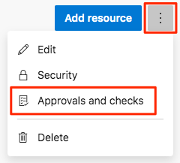

1. Select **Approvals**.
2. Under **Approvers**, select **Add users and groups**, and then select your account.
3. Under **Instructions to approvers**, enter *Approve this change when it's ready for staging*.
4. Select **Create**.

#### Promote changes to Staging

Here you modify your pipeline configuration to deploy the build to the *Staging* stage.

1. In Visual Studio Code, modify *azure-pipelines.yml* like this:

trigger:

- '*'

variables:

buildConfiguration: 'Release'

releaseBranchName: 'release'

schedules:

- cron: '0 3 * * *'

displayName: 'Deploy every day at 3 A.M.'

branches:

include:

- release

always: false

stages:

- stage: 'Build'

displayName: 'Build the web application'

jobs:

- job: 'Build'

displayName: 'Build job'

pool:

vmImage: 'ubuntu-20.04'

demands:

- npm

variables:

wwwrootDir: 'Tailspin.SpaceGame.Web/wwwroot'

dotnetSdkVersion: '5.x'

steps:

- task: UseDotNet@2

displayName: 'Use .NET SDK $(dotnetSdkVersion)'

inputs:

version: '$(dotnetSdkVersion)'

- task: Npm@1

displayName: 'Run npm install'

inputs:

verbose: false

- script: './node_modules/.bin/node-sass $(wwwrootDir) --output $(wwwrootDir)'

displayName: 'Compile Sass assets'

- task: gulp@1

displayName: 'Run gulp tasks'

- script: 'echo "$(Build.DefinitionName), $(Build.BuildId), $(Build.BuildNumber)" > buildinfo.txt'

displayName: 'Write build info'

workingDirectory: $(wwwrootDir)

- task: DotNetCoreCLI@2

displayName: 'Restore project dependencies'

inputs:

command: 'restore'

projects: '**/*.csproj'

- task: DotNetCoreCLI@2

displayName: 'Build the project - $(buildConfiguration)'

inputs:

command: 'build'

arguments: '--no-restore --configuration $(buildConfiguration)'

projects: '**/*.csproj'

- task: DotNetCoreCLI@2

displayName: 'Publish the project - $(buildConfiguration)'

inputs:

command: 'publish'

projects: '**/*.csproj'

publishWebProjects: false

arguments: '--no-build --configuration $(buildConfiguration) --output $(Build.ArtifactStagingDirectory)/$(buildConfiguration)'

zipAfterPublish: true

- publish: '$(Build.ArtifactStagingDirectory)'

artifact: drop

- stage: 'Dev'

displayName: 'Deploy to the dev environment'

dependsOn: Build

condition: |

and

(

succeeded(),

eq(variables['Build.SourceBranchName'], variables['releaseBranchName'])

)

jobs:

- deployment: Deploy

pool:

vmImage: 'ubuntu-20.04'

environment: dev

variables:

- group: Release

strategy:

runOnce:

deploy:

steps:

- download: current

artifact: drop

- task: AzureWebApp@1

displayName: 'Azure App Service Deploy: website'

inputs:

azureSubscription: 'Resource Manager - Tailspin - Space Game'

appName: '$(WebAppNameDev)'

package: '$(Pipeline.Workspace)/drop/$(buildConfiguration)/*.zip'

- stage: 'Test'

displayName: 'Deploy to the test environment'

dependsOn: Dev

#condition: eq(variables['Build.Reason'], 'Schedule')

jobs:

- deployment: Deploy

pool:

vmImage: 'ubuntu-20.04'

environment: test

variables:

- group: 'Release'

strategy:

runOnce:

deploy:

steps:

- download: current

artifact: drop

- task: AzureWebApp@1

displayName: 'Azure App Service Deploy: website'

inputs:

azureSubscription: 'Resource Manager - Tailspin - Space Game'

appName: '$(WebAppNameTest)'

package: '$(Pipeline.Workspace)/drop/$(buildConfiguration)/*.zip'

- stage: 'Staging'

displayName: 'Deploy to the staging environment'

dependsOn: Test

jobs:

- deployment: Deploy

pool:

vmImage: 'ubuntu-20.04'

environment: staging

variables:

- group: 'Release'

strategy:

runOnce:

deploy:

steps:

- download: current

artifact: drop

- task: AzureWebApp@1

displayName: 'Azure App Service Deploy: website'

inputs:

azureSubscription: 'Resource Manager - Tailspin - Space Game'

appName: '$(WebAppNameStaging)'

package: '$(Pipeline.Workspace)/drop/$(buildConfiguration)/*.zip'

This code adds the *Staging* stage. The stage deploys to the **staging** environment, which includes a release approval.

**Tip**

You probably noticed that all three of your deployment stages follow similar steps. You can use *templates* to define common build tasks one time and reuse them multiple times. You already used this technique in the **Create a build pipeline with Azure Pipelines** module. For learning purposes, we repeat the steps in each stage.

1. From the integrated terminal, add *azure-pipelines.yml* to the index. Next, commit the change and push it up to GitHub.

**Tip**

Before you run these Git commands, save *azure-pipelines.yml*.

git add azure-pipelines.yml

git commit -m "Deploy to Staging"

git push origin release

1. In Azure Pipelines, go to the build. Trace the build as it runs.

When the build reaches *Staging*, you see that the pipeline waits for all checks to pass. In this case, there's one check - the manual release approval.

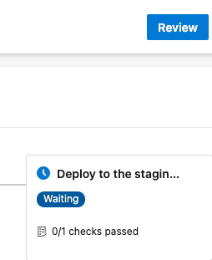

You can configure Azure DevOps to send you an email notification when the build requires approval. Here's an example:

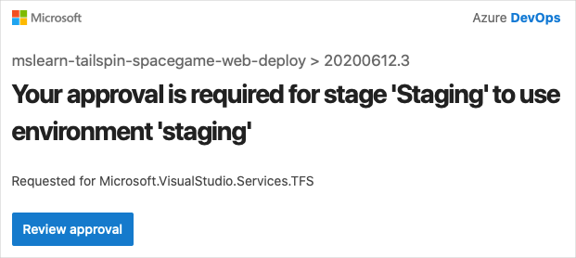

1. Select **Review** > **Approve**.

In practice, to verify that they meet your requirements, you would inspect the changes.

1. After the build finishes, open a web browser. Navigate to the URL that's associated with the App Service instance for your **staging** environment.

If you still have the browser tab open, refresh the page. If you don't remember the URL, find it in the Azure portal, on the **App Service details** page.

You see that the *Space Game* website is deployed to App Service and is running.

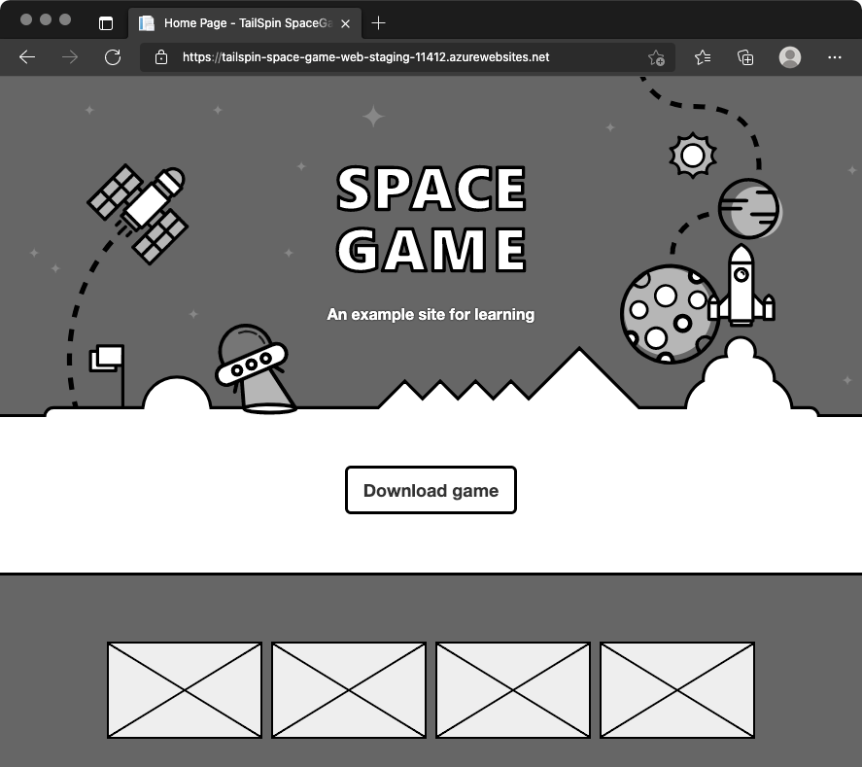

1. As an optional step, in Azure Pipelines, select **Environments**. Next, select the **staging** environment.

Azure Pipelines records your deployment history, which enables you to trace changes in the environment back to code commits and work items.

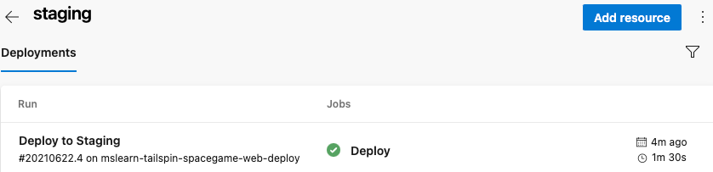

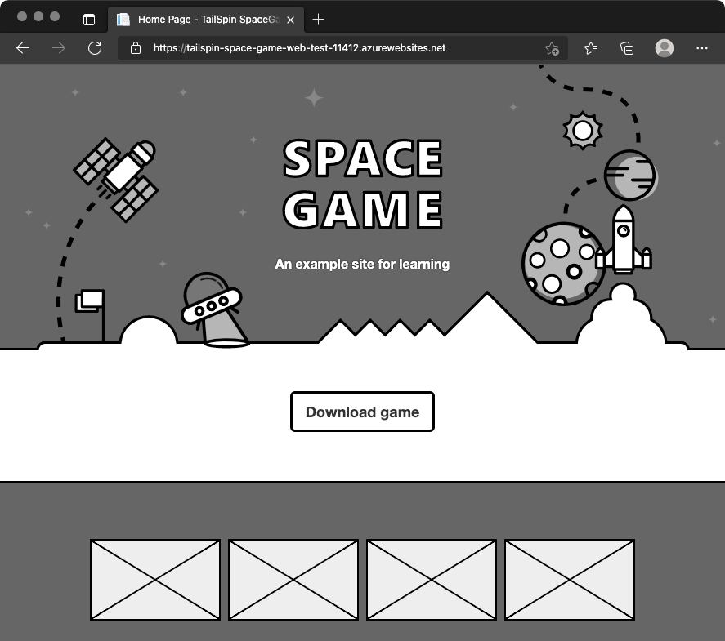

1. As an optional step, in Azure Pipelines, select **Environments**. Then, select the **test** environment.

Azure Pipelines records your deployment history. In the history, you can trace changes in the environment back to code commits and work items.

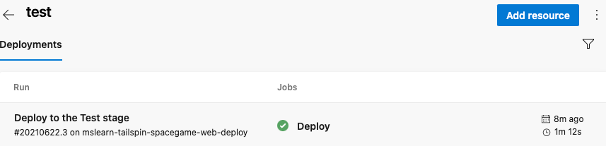

### Clean up Azure resources

Here, you delete your Azure App Service instances. The easiest way to delete the instances is to delete their parent resource group. When you delete a resource group, you delete all resources in that group.

In the Create a release pipeline with Azure Pipelines module, you managed Azure resources through the Azure portal. Here you tear down your deployment by using the Azure CLI through Azure Cloud Shell. The steps are similar to the steps that you used when you created the resources.

To clean up your resource group:

1. Go to the [Azure portal](https://portal.azure.com/), and sign in.
2. From the menu bar, select Cloud Shell. When prompted, select the **Bash** experience.



1. To delete the resource group that you used, tailspin-space-game-rg, run the following az group delete command.

az group delete --name tailspin-space-game-rg

When prompted, to confirm the operation, enter y.

1. As an optional step, after the previous command finishes, run the following az group list command.

az group list --output table

You see that the resource group tailspin-space-game-rg no longer exists.

#### Move the work item to Done

Here, you move the work item that you assigned to yourself earlier in this module. You move **Create a multistage pipeline** to the **Done** column.

In practice, "Done" often means putting working software into the hands of your users. For learning purposes, here, you mark this work as done because you fulfilled the goal for the Tailspin team. They wanted to define a complete multistage pipeline to deliver new features.

At the end of each *sprint*, or work iteration, you and your team can hold a retrospective meeting. In the meeting, share the work you completed, what went well, and what you can improve.

To complete the work item:

1. From Azure DevOps, navigate to **Boards**, and from the menu, select **Boards**.
2. From the **Doing** column to the **Done** column, move the **Create a multistage pipeline** work item.

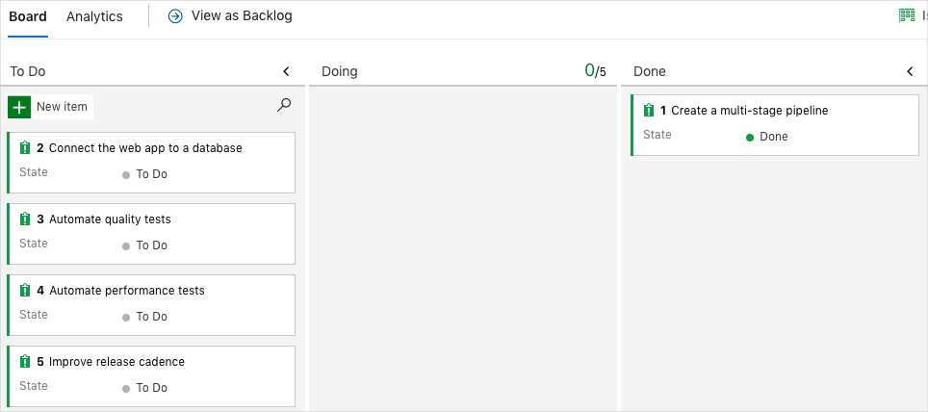

### Disable the pipeline

Each module in this learning path provides a template. You can run the template to create a clean environment for the module.

Running multiple templates gives you multiple Azure Pipelines projects. Each project points to the same GitHub repository. This setup can trigger multiple pipelines to run each time you push a change to your GitHub repository. The pipeline runs use up free build minutes on our hosted agents. To avoid losing those free build minutes, disable or delete your pipeline before you move to the next module.

#### Disable the pipeline

Disable the pipeline so that it doesn't process build requests. You can re-enable the build pipeline later if you want to. Select this option if you want to keep your DevOps project and your build pipeline for future reference.

To disable the pipeline:

1. In Azure Pipelines, navigate to your pipeline.
2. From the dropdown, select **Settings**.



1. Under **Processing of new run requests**, select **Disabled**, and then select **Save**.

Your pipeline will no longer process build requests.

## Task 03: Run functional tests in Azure Pipelines

Run Selenium UI tests, a form of functional testing, in Azure Pipelines.

In this module, you'll add functional tests to the pipeline. These tests verify an application's behavior.

In the Create a multistage pipeline by using Azure Pipelines module, you helped the Tailspin Toys web team design and build a multistage release pipeline. The team uses the pipeline to move changes through a series of stages. Changes move through the *Dev* stage, the *Test* stage, and finally the *Staging* stage, which resembles a production environment.

The stages that you and the team defined provide the overall shape of the pipeline. But you can add more to each stage.

In the Run quality tests in your build pipeline using Azure Pipelines module, you incorporated unit and code coverage tests into the build process. These tests help avoid regression bugs and ensure that the code meets the company's standards for quality and style. But what kinds of tests can you run after a service is operational and deployed to an environment?

### Set up your Azure DevOps environment

In this section, you make sure that your Azure DevOps organization is set up to complete the rest of this module. You also create the Azure App Service environments that you'll deploy to.

To accomplish these tasks, you:

* Add a user to ensure that Azure DevOps can connect to your Azure subscription.
* Set up an Azure DevOps project for this module.
* Move the work item for this module on Azure Boards to the **Doing** column.
* Create the Azure App Service environments by using the Azure CLI in Azure Cloud Shell.
* Create pipeline variables that define the names of your App Service environments.
* Create a service connection that enables Azure Pipelines to securely access your Azure subscription

#### Run the template

Run a template that sets up everything in your Azure DevOps organization.

[Click here to Run the template](https://azuredevopsdemogenerator.azurewebsites.net/?x-ms-routing-name=self&name=run-functional-tests)

From the Azure DevOps Demo Generator site, follow these steps to run the template:

1. Select **Sign In** and accept the usage terms.
2. On the **Create New Project** page, select your Azure DevOps organization. Then enter a project name, such as *Space Game - web - Functional tests*.

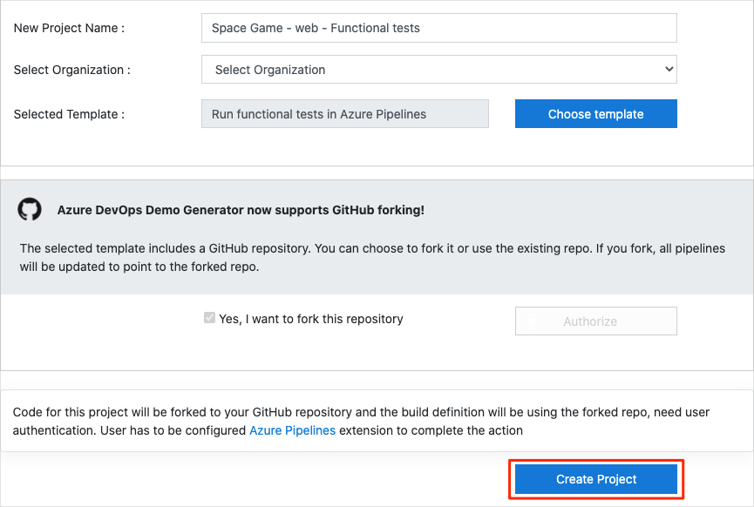

1. Select **Yes, I want to fork this repository**. Then select **Authorize**.
2. Select **Create Project**.

The template takes a few moments to run.

1. Select **Navigate to project** to go to your project in Azure DevOps.

#### Move the work item to Doing

In this part, in Azure Boards you assign yourself a work item that relates to this module. You also move the work item to the **Doing** state. In practice, your team would create work items at the start of each sprint, or work iteration.

Assigning work in this way gives you a checklist to work from. It gives your team visibility into what you're working on and how much work is left. It also helps the team enforce limits on work in progress (WIP) to avoid taking on too much work at one time.

Recall that the team settled on these top issues for the current sprint:



**Note**

Within an Azure DevOps organization, work items are numbered sequentially. In your project, the number for each work item might not match what you see here.

Here you move the third item, **Automate quality tests**, to the **Doing** column. Then you assign yourself to the work item. **Automate quality tests** relates to automating UI tests for the *Space Game* website.

To set up the work item:

1. From Azure DevOps, go to **Boards**, and then select **Boards** from the menu.



1. On the **Automate quality tests** work item, select the down arrow at the bottom of the card. Then assign the work item to yourself.



1. Move the work item from the **To Do** column to the **Doing** column.

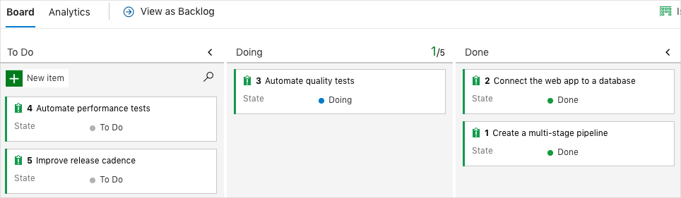

At the end of this module, after you complete the task, you move the card to the **Done** column.

#### Set up the project locally

Here you load the *Space Game* project in Visual Studio Code, configure Git, clone your repository locally, and set the upstream remote so that you can download starter code.

**Note**

If you're already set up with the **[mslearn-tailspin-spacegame-web-deploy](https://github.com/MicrosoftDocs/mslearn-tailspin-spacegame-web-deploy" \t "az-portal)** project locally, you can move to the next section.

#### Open the integrated terminal

Visual Studio Code comes with an integrated terminal. Here you can both edit files and work from the command line.

1. Start Visual Studio Code.
2. On the **View** menu, select **Terminal**.
3. In the drop-down list, select **bash**. If you're familiar with another Unix shell that you prefer to use, such as Zsh, select that shell instead.



In the terminal window, you can choose any shell that's installed on your system. For example, you can choose Bash, Zsh, or PowerShell.

Here you'll use Bash. Git for Windows provides Git Bash, which makes it easy to run Git commands.

**Note**

On Windows, if you don't see **bash** listed as an option, make sure you've installed [**Git**](https://git-scm.com/downloads) and then restart Visual Studio Code.

If you still don't see the **bash** option, see [**Integrated Terminal**](https://code.visualstudio.com/docs/editor/integrated-terminal) to manually configure your terminal settings.

1. Run the cd command to navigate to the directory where you want to work. Choose your home directory (~) or a different directory if you want.

cd ~

**Configure Git**

If you're new to Git and GitHub, first run a few commands to associate your identity with Git and authenticate with GitHub. For more information, see [Set up Git](https://help.github.com/articles/set-up-git).

At a minimum, you need to complete the following steps. Run the commands from the integrated terminal.

1. [Set your username](https://help.github.com/articles/setting-your-username-in-git).
2. [Set your commit email address](https://help.github.com/articles/setting-your-commit-email-address-in-git).
3. [Cache your GitHub password](https://help.github.com/articles/caching-your-github-password-in-git).

**Note**

If you already use two-factor authentication with GitHub, [**create a personal access token**](https://help.github.com/articles/creating-a-personal-access-token-for-the-command-line). When you're prompted, use your token in place of your password.

Treat your access token like a password. Keep it in a safe place.

#### Set up your project in Visual Studio Code

In the Build applications with Azure DevOps learning path, you forked and then cloned a Git repository. The repository contains the source code for the *Space Game* website. Your fork was connected to your projects in Azure DevOps so that the build runs when you push changes to GitHub.

**Important**

In this learning path, we switch to a different Git repository, **[mslearn-tailspin-spacegame-web-deploy](https://github.com/MicrosoftDocs/mslearn-tailspin-spacegame-web-deploy" \t "az-portal)**. When you ran the template to set up your Azure DevOps project, the process forked the repository automatically for you.

In this part, you clone your fork locally so that you can change and build out your pipeline configuration.

#### Clone your fork locally

You now have a copy of the *Space Game* web project in your GitHub account. Now you'll download, or *clone*, a copy to your computer so you can work with it.

A clone, just like a fork, is a copy of a repository. When you clone a repository, you can make changes, verify that they work as you expect, and then upload those changes to GitHub. You can also synchronize your local copy with changes that other authenticated users have made to the GitHub copy of your repository.

To clone the *Space Game* web project to your computer:

1. Go to your fork of the *Space Game* web project (**mslearn-tailspin-spacegame-web-deploy**) on [GitHub](https://github.com/).
2. Select **Code**. Then, from the **HTTPS** tab, select the button next to the URL that's shown to copy the URL to your clipboard.



1. In Visual Studio Code, go to the terminal window.
2. In the terminal, move to the directory where you want to work. Choose your home directory (~) or a different directory if you want.

cd ~

1. Run the git clone command. Replace the URL that's shown here with the contents of your clipboard:

git clone https://github.com/your-name/mslearn-tailspin-spacegame-web-deploy.git

1. Move to the mslearn-tailspin-spacegame-web-deploy directory. This is the root directory of your repository.

cd mslearn-tailspin-spacegame-web-deploy

#### Set the upstream remote

A *remote* is a Git repository where team members collaborate (like a repository on GitHub). Here you list your remotes and add a remote that points to Microsoft's copy of the repository so that you can get the latest sample code.

1. Run this git remote command to list your remotes:

git remote -v

You see that you have both fetch (download) and push (upload) access to your repository:

origin https://github.com/username/mslearn-tailspin-spacegame-web-deploy.git (fetch)

origin https://github.com/username/mslearn-tailspin-spacegame-web-deploy.git (push)

*Origin* specifies your repository on GitHub. When you fork code from another repository, the original remote (the one you forked from) is often named *upstream*.

1. Run this git remote add command to create a remote named *upstream* that points to the Microsoft repository:

git remote add upstream https://github.com/MicrosoftDocs/mslearn-tailspin-spacegame-web-deploy.git

1. Run git remote again to see the changes:

git remote -v

You see that you still have both fetch (download) access and push (upload) access to your repository. You also now have fetch access to the Microsoft repository:

origin https://github.com/username/mslearn-tailspin-spacegame-web-deploy.git (fetch)

origin https://github.com/username/mslearn-tailspin-spacegame-web-deploy.git (push)

upstream https://github.com/MicrosoftDocs/mslearn-tailspin-spacegame-web-deploy.git (fetch)

#### Open the project in the file explorer

In Visual Studio Code, your terminal window points to the root directory of the *Space Game* web project. To view its structure and work with files, from the file explorer, you'll now open the project.

1. The easiest way to open the project is to reopen Visual Studio Code in the current directory. To do so, run the following command from the integrated terminal:

code -r .

You see the directory and file tree in the file explorer.

1. Reopen the integrated terminal. The terminal places you at the root of your web project.

If the code command fails, you need to add Visual Studio Code to your system PATH. To do so:

1. In Visual Studio Code, select F1 or select **View** > **Command Palette** to access the command palette.
2. In the command palette, enter *Shell Command: Install 'code' command in PATH*.
3. Repeat the previous procedure to open the project in the file explorer.

You're now set up to work with the *Space Game* source code and your Azure Pipelines configuration from your local development environment.

#### Create the Azure App Service environments

Here you create the environments that define the pipeline stages. You create one App Service instance that corresponds to each stage: *Dev*, *Test*, and *Staging*.

In the Create a multistage pipeline by using Azure Pipelines module, you used the Azure CLI to create your App Service instances. Here you'll do the same.

**Important**

You need your own Azure subscription to complete the exercises in this module.

#### Bring up Cloud Shell through the Azure portal

1. Go to the [Azure portal](https://portal.azure.com/) and sign in.
2. From the menu bar, select **Cloud Shell**. When you're prompted, select the **Bash** experience.

#### Select an Azure region

Here you specify the default *region*, or geographic location, where your Azure resources are to be created.

1. From Cloud Shell, run the following az account list-locations command to list the regions that are available from your Azure subscription.

az account list-locations \

--query "[].{Name: name, DisplayName: displayName}" \

--output table

1. From the **Name** column in the output, choose a region that's close to you. For example, choose **eastasia** or **westus2**.
2. Run az configure to set your default region. Replace **<REGION>** with the name of the region you chose.

az configure --defaults location=<REGION>

Here's an example that sets **westus2** as the default region:

az configure --defaults location=westus2

#### Create the App Service instances

Here you create the App Service instances for the three stages you'll deploy to: *Dev*, *Test*, and *Staging*.

**Note**

For learning purposes, here you use the default network settings. These settings make your site accessible from the internet. In practice, you could configure an Azure virtual network that places your website in a network that's not internet routable and that's accessible only to you and your team. Later, when you're ready, you could reconfigure your network to make the website available to your users.

1. From Cloud Shell, generate a random number that makes your web app's domain name unique.

webappsuffix=$RANDOM

1. Run the following az group create command to create a resource group that's named **tailspin-space-game-rg**.

az group create --name tailspin-space-game-rg

1. Run the following az appservice plan create command to create an App Service plan that's named **tailspin-space-game-asp**.

az appservice plan create \

--name tailspin-space-game-asp \

--resource-group tailspin-space-game-rg \

--sku B1 \

--is-linux

The --sku argument specifies the **B1** plan, which runs on the **Basic** tier. The --is-linux argument specifies to use Linux workers.

**Important**

If the **B1** SKU isn't part of your Azure subscription, [**choose a different plan**](https://azure.microsoft.com/pricing/details/app-service/linux/), such as **S1** (**Standard**).

1. Run the following az webapp create commands to create the three App Service instances, one for each of the *Dev*, *Test*, and *Staging* environments.

az webapp create \

--name tailspin-space-game-web-dev-$webappsuffix \

--resource-group tailspin-space-game-rg \

--plan tailspin-space-game-asp \

--runtime "DOTNET|5.0"

az webapp create \

--name tailspin-space-game-web-test-$webappsuffix \

--resource-group tailspin-space-game-rg \

--plan tailspin-space-game-asp \

--runtime "DOTNET|5.0"

az webapp create \

--name tailspin-space-game-web-staging-$webappsuffix \

--resource-group tailspin-space-game-rg \

--plan tailspin-space-game-asp \

--runtime "DOTNET|5.0"

For learning purposes, here you apply the same App Service plan, **B1 Basic**, to each App Service instance. In practice, you would assign a plan that matches your expected workload.

1. Run the following az webapp list command to list the host name and state of each App Service instance.

az webapp list \

--resource-group tailspin-space-game-rg \

--query "[].{hostName: defaultHostName, state: state}" \

--output table

Note the host name for each running service. You'll need these host names later when you verify your work. Here's an example:

HostName State

------------------------------------------------------- -------

tailspin-space-game-web-dev-21017.azurewebsites.net Running

tailspin-space-game-web-test-21017.azurewebsites.net Running

tailspin-space-game-web-staging-21017.azurewebsites.net Running

1. As an optional step, go to one or more of the names to verify that they are running and that the default home page appears.

You see this page:

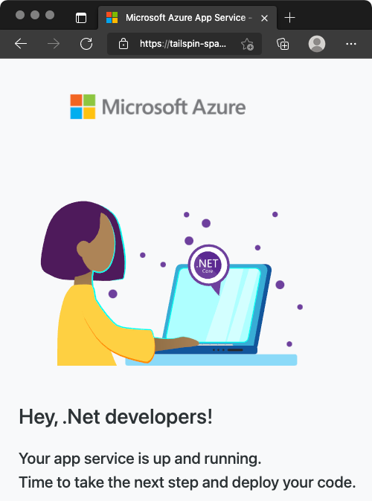

#### Create pipeline variables in Azure Pipelines

In the Create a multistage pipeline by using Azure Pipelines, you added one variable for each of the App Service instances, which correspond to the *Dev*, *Test*, and *Staging* stages in your pipeline. Here you do the same.

Each stage in your pipeline configuration uses these variables to identify which App Service instance to deploy to.

To add the variables:

1. In Azure DevOps, go to your **Space Game - web - Functional tests** project.
2. Under **Pipelines**, select **Library**.

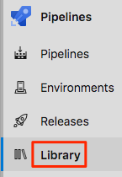

1. Select **+ Variable group**.
2. Under **Properties**, for the variable group name, enter *Release*.
3. Under **Variables**, select **+ Add**.
4. For the name of your variable, enter *WebAppNameDev*. For its value, enter the name of the App Service instance that corresponds to your *Dev* environment, such as *tailspin-space-game-web-dev-1234*.
5. Repeat steps 5 and 6 twice more to create variables for your *Test* and *Staging* environments, as shown in this table:

|  |  |
| --- | --- |
| **TABLE 1** | |
| **Variable name** | **Example value** |
| *WebAppNameTest* | *tailspin-space-game-web-test-1234* |
| *WebAppNameStaging* | *tailspin-space-game-web-staging-1234* |

1. Be sure to replace each example value with the App Service instance that corresponds to your environment.

**Important**

Set the name of the App Service instance, not its host name. In this example, you would enter *tailspin-space-game-web-dev-1234* and not *tailspin-space-game-web-dev-1234.azurewebsites.net*.

1. Near the top of the page, select **Save** to save your variable to the pipeline.

Your variable group resembles this one:



#### Create the dev, test, and staging environments

In Create a multistage pipeline by using Azure Pipelines, you created environments for the **dev**, **test**, and **staging** environments. Here, you repeat the process. This time, however, you omit additional criteria such as the requirement for human approval to promote changes from one stage to the next.

To create the **dev**, **test**, and **staging** environments:

1. From Azure Pipelines, select **Environments**.



1. To create the **dev** environment:
   1. Select **Create environment**.
   2. Under **Name**, enter *dev*.
   3. Leave the remaining fields at their default values.
   4. Select **Create**.
2. To create the **test** environment:
   1. Return to the **Environments** page.
   2. Select **New environment**.
   3. Under **Name**, enter *test*.
   4. Select **Create**.
3. To create the **staging** environment:
   1. Return to the **Environments** page.
   2. Select **New environment**.
   3. Under **Name**, enter *staging*.
   4. Select **Create**.

#### Create a service connection

Here you create a service connection that enables Azure Pipelines to access your Azure subscription. Azure Pipelines uses this service connection to deploy the website to App Service. You created a similar service connection in the previous module.

**Important**

Make sure that you're signed in to both the Azure portal and Azure DevOps under the same Microsoft account.

1. In Azure DevOps, go to your **Space Game - web - Functional tests** project.
2. From the bottom corner of the page, select **Project settings**.
3. Under **Pipelines**, select **Service connections**.
4. Select **New service connection**, then choose **Azure Resource Manager**, then select **Next**.
5. Near the top of the page, **Service principal (automatic)**. Then select **Next**.
6. Fill in these fields:

|  |  |
| --- | --- |
| **TABLE 2** | |
| **Field** | **Value** |
| Scope level | **Subscription** |
| Subscription | Your Azure subscription |
| Resource Group | **tailspin-space-game-rg** |
| Service connection name | *Resource Manager - Tailspin - Space Game* |

1. During the process, you might be prompted to sign in to your Microsoft account.
2. Ensure that **Grant access permission to all pipelines** is selected.
3. Select **Save**.

Azure DevOps performs a test connection to verify that it can connect to your Azure subscription. If Azure DevOps can't connect, you have the chance to sign in a second time.

#### Fetch the branch from GitHub

In this section, you fetch the selenium branch from GitHub. You check out, or switch to, that branch. The contents of the branch will help you follow along with the tests that Andy and Amita write.

This branch contains the *Space Game* project that you worked with in previous modules. It also contains an Azure Pipelines configuration to start with.

1. In Visual Studio Code, open the integrated terminal.
2. To download a branch named selenium from the Microsoft repository, switch to that branch, and run the following git fetch and git checkout commands:

git fetch upstream selenium

git checkout -B selenium upstream/selenium

Recall that *upstream* refers to the Microsoft GitHub repository. Your project's Git configuration understands the upstream remote because you set up that relationship. You set it up when you forked the project from the Microsoft repository and cloned it locally.

Shortly, you'll push this branch up to your GitHub repository, known as origin.

1. Optionally, in Visual Studio Code, open the *azure-pipelines.yml* file. Familiarize yourself with the initial configuration.

The configuration resembles the ones that you created in the previous modules in this learning path. It builds only the application's Release configuration. For brevity, it also omits the triggers, manual approvals, and tests that you set up in previous modules.

**Note**

A more robust configuration might specify the branches that participate in the build process. For example, to help verify code quality, you might run unit tests each time you push up a change on any branch. You might also deploy the application to an environment that performs more exhaustive testing. But you do this deployment only when you have a pull request, when you have a release candidate, or when you merge code to *main*.

### Run the UI tests locally and in the pipeline

Writing automated tests is an iterative process, just like writing any other type of code. For your own apps, you'll likely need to try a few approaches, refer to reference documentation and example code, and fix build errors.

#### Install the Selenium driver for Microsoft Edge

Follow this part if you want to see the tests run locally on Edge.

The NuGet package for Chrome and Firefox installs driver software under the *bin* directory, alongside the compiled test code. For Edge, you need to manually install the driver. To do so:

1. Install [Microsoft Edge](https://www.microsoft.com/edge).
2. Open Edge and navigate to edge://settings/help. Note the version number. Here's an example:

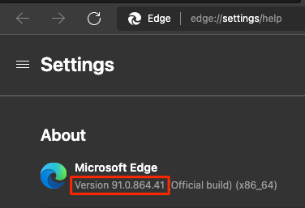

1. Navigate to the [Microsoft Edge Driver downloads](https://developer.microsoft.com/microsoft-edge/tools/webdriver/#downloads?azure-portal=true) page and download the driver that matches the Edge version number. Here's an example:

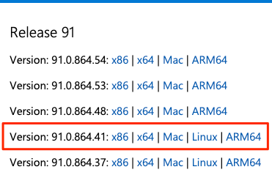

1. Extract the *.zip* file to the *bin/Release/net5.0* directory under your project's *Tailspin.SpaceGame.Web.UITests* directory. Create these directories if they don't exist.

#### Export environment variables

#### Later in this module, you'll run Selenium tests on Windows Server 2019. The [documentation](https://github.com/actions/virtual-environments/blob/main/images/win/Windows2019-Readme.md) lists the software that's preinstalled for you.

The section **Selenium Web Drivers** lists the Selenium driver versions that are available for Chrome, Firefox, and Edge. Here's an example:

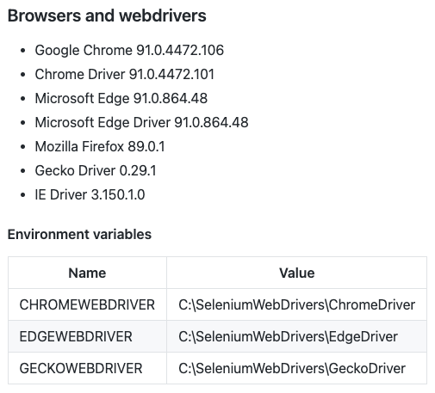

For each driver, you see the environment variable that maps to the location of that driver. For example, ChromeWebDriver maps to the location of the Chrome driver.

The unit tests code is already set up to read these environment variables. These variables tell Selenium where to find the driver executable files. To run the unit tests locally, you need to export these same environment variables.

From Visual Studio Code, go to the terminal. Then run these commands. Replace the path shown with the full path to your **mslearn-tailspin-spacegame-web-deploy** project:

driverDir="C:\Users\user\mslearn-tailspin-spacegame-web-deploy\Tailspin.SpaceGame.Web.UITests\bin\Release\net5.0"

export ChromeWebDriver=$driverDir

export EdgeWebDriver=$driverDir

export GeckoWebDriver=$driverDir

#### Run the UI tests locally

The Setup method in *HomePageTest.cs* navigates to the *Space Game* home page after it sets the driver member variable.

Although you could hard-code the site URL, here we read the URL from an environment variable named SITE_URL. This way, you can run the tests multiple times against different URLs.

// Navigate to the site.

// The site name is stored in the SITE_URL environment variable to make

// the tests more flexible.

string url = Environment.GetEnvironmentVariable("SITE_URL");

driver.Navigate().GoToUrl(url + "/");

Because you haven't yet deployed the *Space Game* website to your App Service environment, you'll use the site that Microsoft hosts to run the tests locally.

To run the tests locally:

1. In Visual Studio Code, open the integrated terminal.
2. From the terminal, ensure that you're in your project's root directory. Here's an example:

cd ~/mslearn-tailspin-spacegame-web-deploy

1. Export the SITE_URL environment variable.

export SITE_URL="http://tailspin-spacegame-web.azurewebsites.net"

This variable points to the *Space Game* website that Microsoft hosts.

1. Run the UI tests.

dotnet test --configuration Release Tailspin.SpaceGame.Web.UITests

This code runs the tests that are located in the *Tailspin.SpaceGame.Web.UITests* project.

As the tests run, one or more browsers appear. Selenium controls each browser and follows the test steps that you defined.

**Note**

Don't worry if all three browsers don't appear. For example, you won't see the tests run on Chrome if you don't have Chrome installed or have an incompatible version. Seeing just one browser will help give you confidence that your tests are working. In practice, in your local development environment, you might want to set up all browsers that you want to test against. This setup will allow you to verify that your tests behave as expected in each configuration before you run your tests in the pipeline.

1. From the terminal, trace the output of each test. Also note the test-run summary at the end.

This example shows that out of nine tests, all nine tests succeeded and zero tests were skipped:

Passed! - Failed: 0, Passed: 9, Skipped: 0, Total: 9, Duration: 5 s

#### Add the SITE_URL variable to Azure Pipelines

Earlier, you set the SITE_URL environment variable locally so that your tests know where to point each browser. You can add this variable to Azure Pipelines. The process is similar to how you added variables for your App Service instances. When the agent runs, this variable is automatically exported to the agent as an environment variable.

Let's add the pipeline variable now, before you update your pipeline configuration. To do so:

1. In Azure DevOps, go to your **Space Game - web - Functional tests** project.
2. Under **Pipelines**, select **Library**.
3. Select the **Release** variable group.
4. Under **Variables**, select **+ Add**.
5. For the name of your variable, enter *SITE_URL*. As its value, enter the URL of the App Service instance that corresponds to your **test** environment, such as **http://tailspin-space-game-web-test-10529.azurewebsites.net**.
6. Near the top of the page, select **Save** to save your variable to the pipeline.

Your variable group resembles this one:

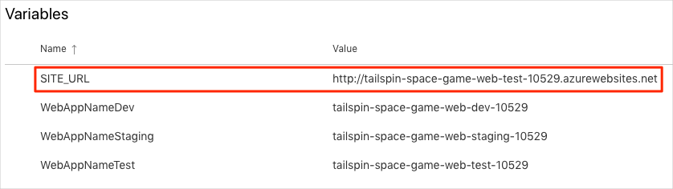

#### Modify the pipeline configuration

In this section, you modify the pipeline configuration to run your Selenium UI tests during the *Test* stage.

1. In Visual Studio Code, open the *azure-pipelines.yml* file. Then modify the file like this:

**Tip**

This file contains a few changes, so we recommend that you replace the entire file with what you see here.

trigger:

- '*'

variables:

buildConfiguration: 'Release'

dotnetSdkVersion: '5.x'

stages:

- stage: 'Build'

displayName: 'Build the web application'

jobs:

- job: 'Build'

displayName: 'Build job'

pool:

vmImage: 'ubuntu-20.04'

demands:

- npm

variables:

wwwrootDir: 'Tailspin.SpaceGame.Web/wwwroot'

dotnetSdkVersion: '5.x'

steps:

- task: UseDotNet@2

displayName: 'Use .NET SDK $(dotnetSdkVersion)'

inputs:

version: '$(dotnetSdkVersion)'

- task: Npm@1

displayName: 'Run npm install'

inputs:

verbose: false

- script: './node_modules/.bin/node-sass $(wwwrootDir) --output $(wwwrootDir)'

displayName: 'Compile Sass assets'

- task: gulp@1

displayName: 'Run gulp tasks'

- script: 'echo "$(Build.DefinitionName), $(Build.BuildId), $(Build.BuildNumber)" > buildinfo.txt'

displayName: 'Write build info'

workingDirectory: $(wwwrootDir)

- task: DotNetCoreCLI@2

displayName: 'Restore project dependencies'

inputs:

command: 'restore'

projects: '**/*.csproj'

- task: DotNetCoreCLI@2

displayName: 'Build the project - $(buildConfiguration)'

inputs:

command: 'build'

arguments: '--no-restore --configuration $(buildConfiguration)'

projects: '**/*.csproj'

- task: DotNetCoreCLI@2

displayName: 'Publish the project - $(buildConfiguration)'

inputs:

command: 'publish'

projects: '$(System.DefaultWorkingDirectory)/**/Tailspin.SpaceGame.Web.csproj'

publishWebProjects: false

arguments: '--no-build --configuration $(buildConfiguration) --output $(Build.ArtifactStagingDirectory)/$(buildConfiguration)'

zipAfterPublish: true

- publish: '$(Build.ArtifactStagingDirectory)'

artifact: drop

- stage: 'Dev'

displayName: 'Deploy to the dev environment'

dependsOn: Build

jobs:

- deployment: Deploy

pool:

vmImage: 'ubuntu-20.04'

environment: dev

variables:

- group: Release

strategy:

runOnce:

deploy:

steps:

- download: current

artifact: drop

- task: AzureWebApp@1

displayName: 'Azure App Service Deploy: website'

inputs:

azureSubscription: 'Resource Manager - Tailspin - Space Game'

appName: '$(WebAppNameDev)'

package: '$(Pipeline.Workspace)/drop/$(buildConfiguration)/*.zip'

- stage: 'Test'

displayName: 'Deploy to the test environment'

dependsOn: Dev

jobs:

- deployment: Deploy

pool:

vmImage: 'ubuntu-20.04'

environment: test

variables:

- group: 'Release'

strategy:

runOnce:

deploy:

steps:

- download: current

artifact: drop

- task: AzureWebApp@1

displayName: 'Azure App Service Deploy: website'

inputs:

azureSubscription: 'Resource Manager - Tailspin - Space Game'

appName: '$(WebAppNameTest)'

package: '$(Pipeline.Workspace)/drop/$(buildConfiguration)/*.zip'

- job: RunUITests

dependsOn: Deploy

displayName: 'Run UI tests'

pool:

vmImage: 'windows-2019'

variables:

- group: 'Release'

steps:

- task: UseDotNet@2

displayName: 'Use .NET SDK $(dotnetSdkVersion)'

inputs:

version: '$(dotnetSdkVersion)'

- task: DotNetCoreCLI@2

displayName: 'Build the project - $(buildConfiguration)'

inputs:

command: 'build'

arguments: '--configuration $(buildConfiguration)'

projects: '$(System.DefaultWorkingDirectory)/**/*UITests.csproj'

- task: DotNetCoreCLI@2

displayName: 'Run unit tests - $(buildConfiguration)'

inputs:

command: 'test'

arguments: '--no-build --configuration $(buildConfiguration)'

publishTestResults: true

projects: '$(System.DefaultWorkingDirectory)/**/*UITests.csproj'

- stage: 'Staging'

displayName: 'Deploy to the staging environment'

dependsOn: Test

jobs:

- deployment: Deploy

pool:

vmImage: 'ubuntu-20.04'

environment: staging

variables:

- group: 'Release'

strategy:

runOnce:

deploy:

steps:

- download: current

artifact: drop

- task: AzureWebApp@1

displayName: 'Azure App Service Deploy: website'

inputs:

azureSubscription: 'Resource Manager - Tailspin - Space Game'

appName: '$(WebAppNameStaging)'

package: '$(Pipeline.Workspace)/drop/$(buildConfiguration)/*.zip'

The file includes these three changes:

* The dotnetSdkVersion variable is moved to the top of the file so that multiple stages can access it. Here the *Build* stage and *Test* stage require this version of .NET Core.
* The *Build* stage publishes only the *Space Game* website package as the build artifact. Previously, you published the artifacts like this:

- task: DotNetCoreCLI@2

displayName: 'Publish the project - $(buildConfiguration)'

inputs:

command: 'publish'

projects: '**/*.csproj'

publishWebProjects: false

arguments: '--no-build --configuration $(buildConfiguration) --output $(Build.ArtifactStagingDirectory)/$(buildConfiguration)'

zipAfterPublish: true

This task generates two build artifacts: the *Space Game* website package and the compiled UI tests. We build the UI tests during the *Build* stage to ensure that they'll compile during the *Test* stage. But we don't need to publish the compiled test code. We build it again during the *Test* stage when the tests run.

* The *Test* stage includes a second job that builds and runs the tests. This job resembles the one that you used in the [Run quality tests in your build pipeline by using Azure Pipelines](https://docs.microsoft.com/en-us/learn/modules/run-quality-tests-build-pipeline/4-add-unit-tests) module. In that module, you ran NUnit tests that verified the leaderboard's filtering functionality.

Recall that a *deployment job* is a special type of job that plays an important role in your deployment stages. The second job is a normal job that runs the Selenium tests on a Windows Server 2019 agent. Although we use a Linux agent to build the application, here we use a Windows agent to run the UI tests. We use a Windows agent because Amita runs manual tests on Windows, and that's what most customers use.

The RunUITests job depends on the Deploy job to ensure that the jobs run in the correct order. You'll deploy the website to App Service before you run the UI tests. If you don't specify this dependency, jobs within the stage can run in any order or run in parallel.

* In the integrated terminal, add *azure-pipelines.yml* to the index, commit the changes, and push the branch up to GitHub.

git add azure-pipelines.yml

git commit -m "Run Selenium UI tests"

git push origin selenium

#### Watch Azure Pipelines run the tests

Here you watch the pipeline run. The pipeline runs the Selenium UI tests during the *Test* stage.

1. In Azure Pipelines, go to the build and trace it as it runs.

During the build, you see the automated tests run after the website is deployed.

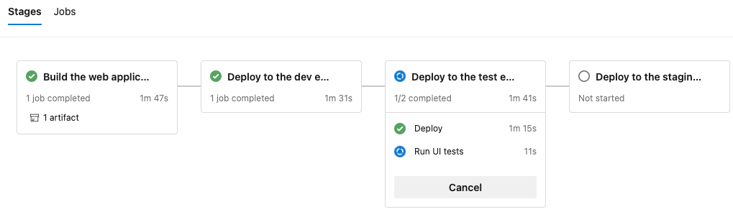

1. After the build finishes, go to the summary page.

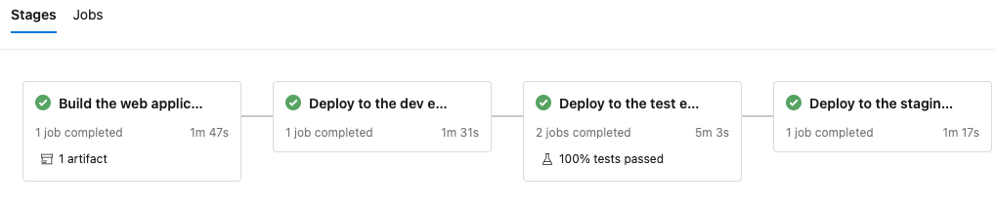

You see that the deployment and the UI tests finished successfully.

1. Near the top of the page, note the summary.

You see that the build artifact for the *Space Game* website is published just like always. Also note the **Tests and coverage** section, which shows that the Selenium tests have passed.

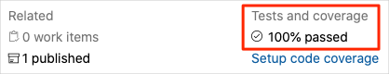

1. Select the test summary to see the full report.

The report shows that all nine tests have passed. These tests include three tests across three browsers.

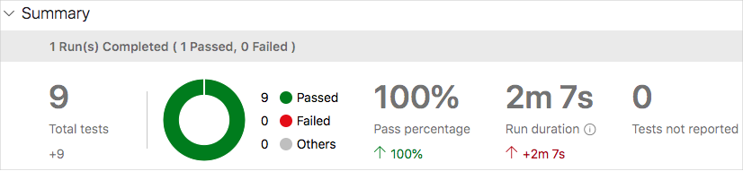

If any test fails, you see detailed results of the failure. From there, you can investigate the source of the failure, fix it locally, and then push up the necessary changes to make the tests pass in the pipeline.

#### Clean up Azure resources

Here you delete your Azure App Service instances. The easiest way to delete the instances is to delete their parent resource group. Deleting a resource group deletes all resources in that group.

To clean up your resource group:

1. Go to the [Azure portal](https://portal.azure.com/) and sign in.
2. From the menu, select **Cloud Shell**. When you're prompted, select the **Bash** experience.



1. Run the following az group delete command. The command deletes the resource group that you used in this module, **tailspin-space-game-rg**.

az group delete --name tailspin-space-game-rg

When you're prompted, enter *y* to confirm the operation.

1. As an optional step, run the following az group list command after the previous command finishes.

az group list --output table

You see that the resource group **tailspin-space-game-rg** no longer exists.

### Move the work item to Done

Here you'll finish the work item that you assigned to yourself earlier in this module. You'll move **Automate quality tests** to the **Done** column.

In practice, *done* often means putting working software into the hands of your users. For learning purposes, here you'll mark this work as complete because you set up working UI tests in your pipeline.

At the end of each *sprint*, or work iteration, your team might want to hold a retrospective meeting. In the meeting, you share the work you completed, what went well in the sprint, and what you could improve.

To complete the work item:

1. In Azure DevOps, go to **Boards**, and then select **Boards** from the menu.
2. Move the **Automate quality tests** work item from the **Doing** column to the **Done** column.

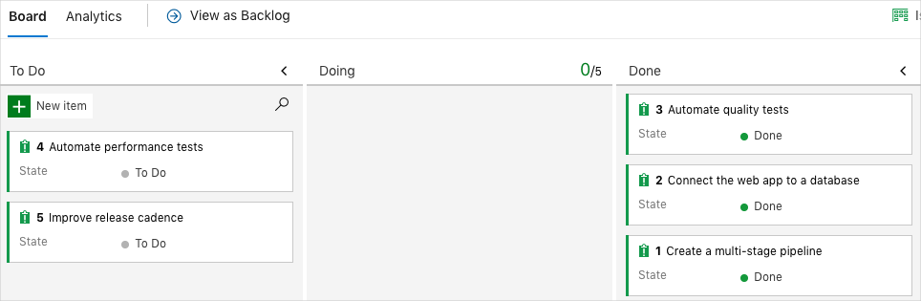

### Disable the pipeline

Each module in this learning path provides a template. You can run the template to create a clean environment for the duration of the module.

Running multiple templates gives you multiple Azure Pipelines projects, each pointing to the same GitHub repository. This setup can trigger multiple pipelines to run each time you push a change to your GitHub repository. These runs can consume free build minutes on our hosted agents. So it's important to disable or delete your pipeline before you continue to the next module.

#### Disable the pipeline

This option disables the pipeline so that it doesn't process further build requests. You can reenable the build pipeline later if you want to. Choose this option if you want to keep your DevOps project and your build pipeline for future reference.

To disable the pipeline:

1. In Azure Pipelines, navigate to your pipeline.
2. From the drop-down menu, select **Settings**:



1. Under **Processing of new run requests**, select **Disabled** and then select **Save**.

Your pipeline will no longer process build requests.

## Task 04: Run nonfunctional tests in Azure Pipelines

Run automated load tests by using Apache JMeter, a form of nonfunctional testing, in Azure Pipelines.

In this module, you'll add nonfunctional tests to the pipeline. These tests check characteristics like performance and reliability.

In Run functional tests in Azure Pipelines, you and the Tailspin Toys web team added UI tests to the pipeline. UI tests are a form of functional testing. Functional tests verify the functionality, or behavior, of software. In other words, functional tests verify that each function of the software does what it should.

But what about the nonfunctional aspects of an application, such as performance and reliability? After your service is operational and deployed to an environment, how can you determine the application's performance under both realistic and heavy loads? Does your application expose any loopholes or weaknesses that might cause an information breach?

In this module, you'll explore the types of nonfunctional tests you can run. You'll run load tests in your pipeline by using Apache JMeter.

### Set up your Azure DevOps environment

In this section, you make sure that your Azure DevOps organization is set up to complete the rest of this module. You also create the Azure App Service environments that you'll deploy to.

To set up your system, you:

* Add a user to ensure that Azure DevOps can connect to your Azure subscription.
* Set up an Azure DevOps project for this module.
* On Azure Boards, move the work item for this module to the **Doing** column.
* Create the Azure App Service environments by using the Azure CLI in Azure Cloud Shell.
* Create pipeline variables that define the names of your App Service environments.
* Create a service connection that enables Azure Pipelines to securely access your Azure subscription.

#### Run the template

Run a template that sets up your Azure DevOps organization.

[Click here to Run the template](https://azuredevopsdemogenerator.azurewebsites.net/?x-ms-routing-name=self&name=run-non-functional-tests)

On the Azure DevOps Demo Generator site, follow these steps to run the template.

1. Select **Sign In** and accept the usage terms.
2. On the **Create New Project** page, select your Azure DevOps organization. Then enter a project name, such as *Space Game - web - Nonfunctional tests*.

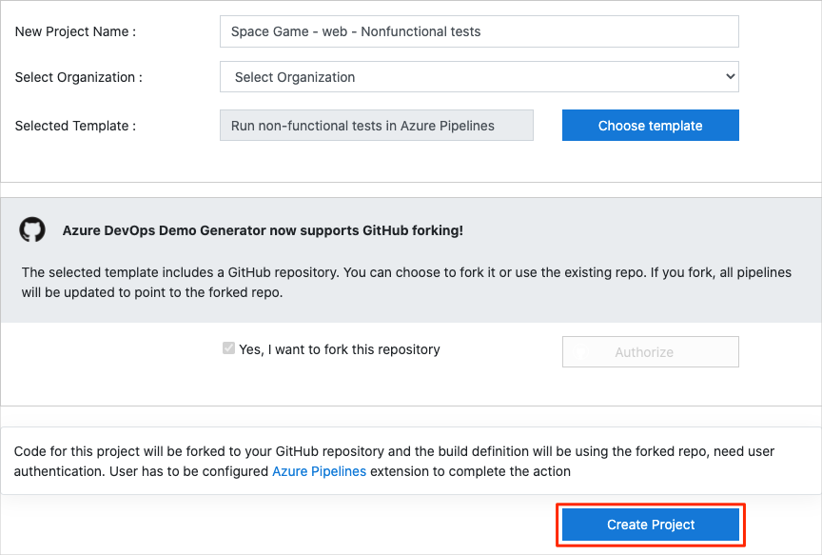

1. Select **Yes, I want to fork this repository**. Then select **Authorize**.
2. Select **Create Project**.

The template takes a few moments to run.

1. Select **Navigate to project** to go to your project in Azure DevOps.

#### Move the work item to Doing

In this part, on Azure Boards you assign yourself a work item that relates to this module. You also move the work item to the **Doing** state. In practice, your team would create work items at the start of each *sprint*, or work iteration.

Assigning work in this way gives you a checklist to work from. It gives your team visibility into what you're working on and how much work is left. It also helps the team enforce limits on work in progress (WIP) so that the team doesn't take on too much work at one time.

Recall that the team settled on these top issues for the current sprint:



**Note**

Within an Azure DevOps organization, work items are numbered sequentially. In your project, the number for each work item might not match what you see here.

Here you move the fourth item, **Automate performance tests**, to the **Doing** column. Then you assign yourself to the work item. **Automate performance tests** relates to automating load testing, a form of performance testing, for the *Space Game* website.

To set up the work item:

1. In Azure DevOps, navigate to **Boards**. Then select **Boards** from the menu.



1. In the **Automate performance tests** work item, select the down arrow at the bottom of the card. Then assign the work item to yourself.



1. Move the work item from the **To Do** column to the **Doing** column.

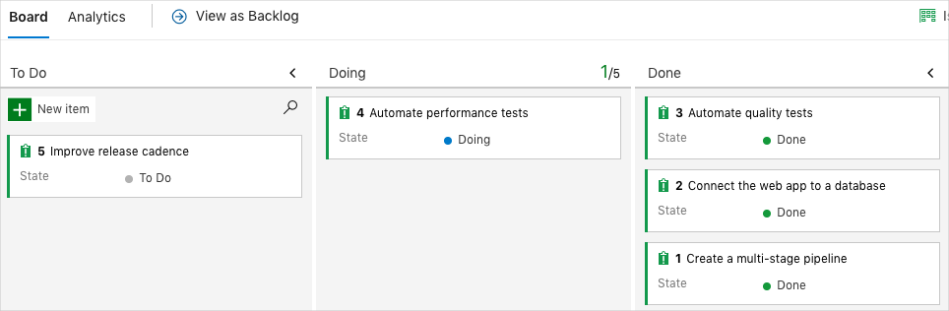

At the end of this module, you move the card to the **Done** column after you complete the task.

#### Set up the project locally

Here you load the *Space Game* project in Visual Studio Code, configure Git, clone your repository locally, and set the upstream remote so that you can download starter code.

**Note**

If you're already set up with the **[mslearn-tailspin-spacegame-web-deploy](https://github.com/MicrosoftDocs/mslearn-tailspin-spacegame-web-deploy" \t "az-portal)** project locally, you can move to the next section.

#### Open the integrated terminal

Visual Studio Code comes with an integrated terminal. Here you can both edit files and work from the command line.

1. Start Visual Studio Code.
2. On the **View** menu, select **Terminal**.
3. In the drop-down list, select **bash**. If you're familiar with another Unix shell that you prefer to use, such as Zsh, select that shell instead.



In the terminal window, you can choose any shell that's installed on your system. For example, you can choose Bash, Zsh, or PowerShell.

Here you'll use Bash. Git for Windows provides Git Bash, which makes it easy to run Git commands.

**Note**

On Windows, if you don't see **bash** listed as an option, make sure you've installed [**Git**](https://git-scm.com/downloads) and then restart Visual Studio Code.

If you still don't see the **bash** option, see [**Integrated Terminal**](https://code.visualstudio.com/docs/editor/integrated-terminal) to manually configure your terminal settings.

1. Run the cd command to navigate to the directory where you want to work. Choose your home directory (~) or a different directory if you want.

cd ~

#### Configure Git

If you're new to Git and GitHub, first run a few commands to associate your identity with Git and authenticate with GitHub. For more information, see [Set up Git](https://help.github.com/articles/set-up-git).

At a minimum, you need to complete the following steps. Run the commands from the integrated terminal.

1. [Set your username](https://help.github.com/articles/setting-your-username-in-git).
2. [Set your commit email address](https://help.github.com/articles/setting-your-commit-email-address-in-git).
3. [Cache your GitHub password](https://help.github.com/articles/caching-your-github-password-in-git).

**Note**

If you already use two-factor authentication with GitHub, [**create a personal access token**](https://help.github.com/articles/creating-a-personal-access-token-for-the-command-line). When you're prompted, use your token in place of your password.

Treat your access token like a password. Keep it in a safe place.

#### Set up your project in Visual Studio Code

In the Build applications with Azure DevOps learning path, you forked and then cloned a Git repository. The repository contains the source code for the *Space Game* website. Your fork was connected to your projects in Azure DevOps so that the build runs when you push changes to GitHub.

**Important**

In this learning path, we switch to a different Git repository, **[mslearn-tailspin-spacegame-web-deploy](https://github.com/MicrosoftDocs/mslearn-tailspin-spacegame-web-deploy" \t "az-portal)**. When you ran the template to set up your Azure DevOps project, the process forked the repository automatically for you.

In this part, you clone your fork locally so that you can change and build out your pipeline configuration.

#### Clone your fork locally

You now have a copy of the *Space Game* web project in your GitHub account. Now you'll download, or *clone*, a copy to your computer so you can work with it.

A clone, just like a fork, is a copy of a repository. When you clone a repository, you can make changes, verify that they work as you expect, and then upload those changes to GitHub. You can also synchronize your local copy with changes that other authenticated users have made to the GitHub copy of your repository.

To clone the *Space Game* web project to your computer:

1. Go to your fork of the *Space Game* web project (**mslearn-tailspin-spacegame-web-deploy**) on [GitHub](https://github.com/).
2. Select **Code**. Then, from the **HTTPS** tab, select the button next to the URL that's shown to copy the URL to your clipboard.



1. In Visual Studio Code, go to the terminal window.
2. In the terminal, move to the directory where you want to work. Choose your home directory (~) or a different directory if you want.

cd ~

1. Run the git clone command. Replace the URL that's shown here with the contents of your clipboard:

git clone https://github.com/your-name/mslearn-tailspin-spacegame-web-deploy.git

1. Move to the mslearn-tailspin-spacegame-web-deploy directory. This is the root directory of your repository.

cd mslearn-tailspin-spacegame-web-deploy

#### Set the upstream remote

A *remote* is a Git repository where team members collaborate (like a repository on GitHub). Here you list your remotes and add a remote that points to Microsoft's copy of the repository so that you can get the latest sample code.

1. Run this git remote command to list your remotes:

git remote -v

You see that you have both fetch (download) and push (upload) access to your repository:

origin https://github.com/username/mslearn-tailspin-spacegame-web-deploy.git (fetch)

origin https://github.com/username/mslearn-tailspin-spacegame-web-deploy.git (push)

*Origin* specifies your repository on GitHub. When you fork code from another repository, the original remote (the one you forked from) is often named *upstream*.

1. Run this git remote add command to create a remote named *upstream* that points to the Microsoft repository:

git remote add upstream https://github.com/MicrosoftDocs/mslearn-tailspin-spacegame-web-deploy.git

1. Run git remote again to see the changes:

git remote -v

You see that you still have both fetch (download) access and push (upload) access to your repository. You also now have fetch access to the Microsoft repository:

origin https://github.com/username/mslearn-tailspin-spacegame-web-deploy.git (fetch)

origin https://github.com/username/mslearn-tailspin-spacegame-web-deploy.git (push)

upstream https://github.com/MicrosoftDocs/mslearn-tailspin-spacegame-web-deploy.git (fetch)

#### Open the project in the file explorer

In Visual Studio Code, your terminal window points to the root directory of the *Space Game* web project. To view its structure and work with files, from the file explorer, you'll now open the project.

1. The easiest way to open the project is to reopen Visual Studio Code in the current directory. To do so, run the following command from the integrated terminal:

code -r .

You see the directory and file tree in the file explorer.

1. Reopen the integrated terminal. The terminal places you at the root of your web project.

If the code command fails, you need to add Visual Studio Code to your system PATH. To do so:

1. In Visual Studio Code, select F1 or select **View** > **Command Palette** to access the command palette.
2. In the command palette, enter *Shell Command: Install 'code' command in PATH*.
3. Repeat the previous procedure to open the project in the file explorer.

You're now set up to work with the *Space Game* source code and your Azure Pipelines configuration from your local development environment.

#### Create the Azure App Service environments

Here you create the environments that define the pipeline stages. You create one App Service instance that corresponds to each stage: *Dev*, *Test*, and *Staging*.

In previous modules, you used the Azure CLI to create your App Service instances. Here you'll do the same.

**Important**

Remember that you need your own Azure subscription to complete the exercises in this module.

**Bring up Cloud Shell through the Azure portal**

1. Go to the [Azure portal](https://portal.azure.com/) and sign in.
2. On the menu bar, select **Cloud Shell**. When you're prompted, select the **Bash** experience.

**Select an Azure region**

Here you specify the default *region*, or geographic location, where your Azure resources are to be created.

1. In Cloud Shell, run the following az account list-locations command to list the regions that are available from your Azure subscription.

az account list-locations \

--query "[].{Name: name, DisplayName: displayName}" \

--output table

1. From the **Name** column in the output, choose a region that's close to you. For example, choose **eastasia** or **westus2**.
2. Run az configure to set your default region. Replace **<REGION>** with the name of the region that you chose.

az configure --defaults location=<REGION>

Here's an example that sets **westus2** as the default region.

az configure --defaults location=westus2

**Create the App Service instances**

Here you create the App Service instances for the three stages that you'll deploy to: *Dev*, *Test*, and *Staging*.

**Note**

For learning purposes, you use the default network settings. These settings make your site accessible from the internet. In practice, you could configure an Azure virtual network that places your website in a network that's not routable from the internet and that's accessible to only your team. Later, when you're ready, you could reconfigure your network to make the website available to your users.

1. In Cloud Shell, generate a random number that makes your web app's domain name unique.

webappsuffix=$RANDOM

1. Run the following az group create command to create a resource group that's named **tailspin-space-game-rg**.

az group create --name tailspin-space-game-rg

1. Run the following az appservice plan create command to create an App Service plan that's named **tailspin-space-game-asp**.

az appservice plan create \

--name tailspin-space-game-asp \

--resource-group tailspin-space-game-rg \

--sku B1 \

--is-linux

The --sku argument specifies the **B1** plan, which runs on the **Basic** tier. The --is-linux argument specifies to use Linux workers.

**Important**

If the **B1** SKU isn't available as part of your Azure subscription, [**choose a different plan**](https://azure.microsoft.com/pricing/details/app-service/linux/), such as **S1** (**Standard**).

1. Run the following az webapp create commands to create the three App Service instances, one for each of the *Dev*, *Test*, and *Staging* environments.

az webapp create \

--name tailspin-space-game-web-dev-$webappsuffix \

--resource-group tailspin-space-game-rg \

--plan tailspin-space-game-asp \

--runtime "DOTNET|5.0"

az webapp create \

--name tailspin-space-game-web-test-$webappsuffix \

--resource-group tailspin-space-game-rg \

--plan tailspin-space-game-asp \

--runtime "DOTNET|5.0"

az webapp create \

--name tailspin-space-game-web-staging-$webappsuffix \

--resource-group tailspin-space-game-rg \

--plan tailspin-space-game-asp \

--runtime "DOTNET|5.0"

For learning purposes, here you apply the same App Service plan, **B1 Basic**, to each App Service instance. In practice, you would assign a plan that matches your expected workload.

1. Run the following az webapp list command to list the host name and state of each App Service instance.

az webapp list \

--resource-group tailspin-space-game-rg \

--query "[].{hostName: defaultHostName, state: state}" \

--output table

Note the host name for each running service. You'll need these host names later when you verify your work. Here's an example:

HostName State

------------------------------------------------------- -------

tailspin-space-game-web-dev-21017.azurewebsites.net Running

tailspin-space-game-web-test-21017.azurewebsites.net Running

tailspin-space-game-web-staging-21017.azurewebsites.net Running

1. As an optional step, go to one or more of the listed names to verify that they're running and that the default home page appears.

You see this page:



#### Create pipeline variables in Azure Pipelines

In Run functional tests in Azure Pipelines, you added one variable for each of the App Service instances. The instances correspond to the *Dev*, *Test*, and *Staging* stages in your pipeline. Here you follow the same pattern.

Each stage in your pipeline configuration uses the variables to identify which App Service instance to deploy to.

To add the variables:

1. In Azure DevOps, go to your **Space Game - web - Nonfunctional tests** project.
2. Under **Pipelines**, select **Library**.



1. Select **+ Variable group**.
2. For the variable group name, under **Properties**, enter *Release*.
3. Under **Variables**, select **+ Add**.
4. For the name of your variable, enter *WebAppNameDev*. For its value, enter the name of the App Service instance that corresponds to your *Dev* environment, such as *tailspin-space-game-web-dev-1234*.
5. Repeat steps 5 and 6 twice more to create variables for your *Test* and *Staging* environments, as shown in this table:

|  |  |
| --- | --- |
| **TABLE 1** | |
| **Variable name** | **Example value** |
| *WebAppNameTest* | *tailspin-space-game-web-test-1234* |
| *WebAppNameStaging* | *tailspin-space-game-web-staging-1234* |

1. Be sure to replace each example value with the App Service instance that corresponds to your environment.
2. **Important**
3. Make sure that you set the name of the App Service instance, not its host name. In this example, you would enter *tailspin-space-game-web-dev-1234* and not *tailspin-space-game-web-dev-1234.azurewebsites.net*.
4. To save your variable to the pipeline, near the top of the page, select **Save**.

Your variable group resembles this one:



#### Create the dev, test, and staging environments

In Run functional tests in Azure Pipelines, you created environments for the **dev**, **test**, and **staging** environments. Here, you repeat the process.

To create the **dev**, **test**, and **staging** environments:

1. From Azure Pipelines, select **Environments**.



1. To create the **dev** environment:
   1. Select **Create environment**.
   2. Under **Name**, enter *dev*.
   3. Leave the remaining fields at their default values.
   4. Select **Create**.
2. To create the **test** environment:
   1. Return to the **Environments** page.
   2. Select **New environment**.
   3. Under **Name**, enter *test*.
   4. Select **Create**.
3. To create the **staging** environment:
   1. Return to the **Environments** page.
   2. Select **New environment**.
   3. Under **Name**, enter *staging*.
   4. Select **Create**.

#### Create a service connection

Here you create a service connection that enables Azure Pipelines to access your Azure subscription. Azure Pipelines uses this service connection to deploy the website to App Service. You created a similar service connection in the previous module.

**Important**

Make sure that you're signed in to both the Azure portal and Azure DevOps under the same Microsoft account.

1. In Azure DevOps, go to your **Space Game - web - Nonfunctional tests** project.
2. From the bottom corner of the page, select **Project settings**.
3. Under **Pipelines**, select **Service connections**.
4. Select **New service connection**, then choose **Azure Resource Manager**, then select **Next**.
5. Near the top of the page, **Service principal (automatic)**. Then select **Next**.
6. Fill in these fields:

|  |  |
| --- | --- |
| **TABLE 2** | |
| **Field** | **Value** |
| Scope level | **Subscription** |
| Subscription | Your Azure subscription |
| Resource Group | **tailspin-space-game-rg** |
| Service connection name | *Resource Manager - Tailspin - Space Game* |

1. During the process, you might be prompted to sign in to your Microsoft account.
2. Ensure that **Grant access permission to all pipelines** is selected.
3. Select **Save**.

Azure DevOps performs a test connection to verify that it can connect to your Azure subscription. If Azure DevOps can't connect, you have the chance to sign in a second time.

### Run load tests in Azure Pipelines

In this section, you run the test plan that Mara and Tim created in the release pipeline. The test plan uses Apache JMeter to run load tests.

Here's how you run the tests:

* Fetch and check out a Git branch that implements the tests.
* Modify your pipeline to install JMeter, run the test plan, transform the results to JUnit, and publish the results to Azure Pipelines.
* Push your branch to GitHub, watch the tests run in Azure Pipelines, and then examine the results.

#### Fetch the branch from GitHub

In this section, you fetch the jmeter branch from GitHub and check out, or switch to, that branch.

This branch contains the *Space Game* project that you worked with in previous modules. It also contains an Azure Pipelines configuration to start with.

1. In Visual Studio Code, open the integrated terminal.
2. To download a branch named jmeter from the Microsoft repository and switch to that branch, run the following git fetch and git checkout commands:

git fetch upstream jmeter

git checkout -B jmeter upstream/jmeter

Recall that *upstream* refers to the Microsoft GitHub repository. Your project's Git configuration understands the upstream remote because you set up that relationship when you forked the project from the Microsoft repository and cloned it locally.

Shortly, you'll push this branch up to your GitHub repository, known as origin.

1. Optionally, in Visual Studio Code, open the *azure-pipelines.yml* file. Review the initial configuration.

The configuration resembles the ones that you created in previous modules in this learning path. It builds only the application's **Release** configuration. For brevity, it omits the triggers, manual approvals, and tests that you set up in previous modules.

**Note**

A more robust configuration might specify the branches that participate in the build process. For example, to help verify code quality, you might run unit tests each time you push up a change on any branch. You might also deploy the application to an environment that performs more exhaustive testing. But you do this deployment only when you have a pull request, when you have a release candidate, or when you merge code to *main*.

1. Optionally, in Visual Studio Code, you can check out the JMeter test plan file, *LoadTest.jmx*, and the XLST transform, *JMeter2JUnit.xsl*. The XLST file transforms the JMeter output to JUnit so that Azure Pipelines can visualize the results.

#### Add variables to Azure Pipelines

Tim's original test plan provides a hard-coded value for the host name of the *Space Game* website that runs in the **staging** environment.

To make the test plan more flexible, your version uses a JMeter property. Think of a property as a variable that you can set from the command line.

Here's how the hostname variable is defined in JMeter:

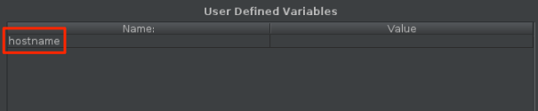

Here's how the hostname variable uses the [__P](https://jmeter.apache.org/usermanual/functions.html#__P) function to read the hostname variable.

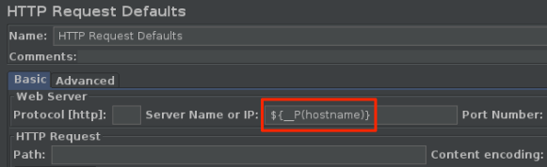

The corresponding test plan file, *LoadTest.jmx*, specifies this variable and uses it to set the host name.

When you run JMeter from the command line, you use the -J argument to set the hostname property. Here's an example:

apache-jmeter-5.4.1/bin/./jmeter -n -t LoadTest.jmx -o Results.xml -Jhostname=tailspin-space-game-web-staging-1234.azurewebsites.net

Here you set the STAGING_HOSTNAME variable in Azure Pipelines. This variable points to your site's host name that runs on App Service in your **staging** environment. You also set the jmeterVersion to specify the version of JMeter to install.

When the agent runs, these variables are automatically exported to the agent as environment variables. So your pipeline configuration can run JMeter this way:

apache-jmeter-5.4.1/bin/./jmeter -n -t LoadTest.jmx -o Results.xml -Jhostname=$(STAGING_HOSTNAME)

Let's add the pipeline variables now, before you update your pipeline configuration. To do so:

1. In Azure DevOps, go to your **Space Game - web - Nonfunctional tests** project.
2. Under **Pipelines**, select **Library**.
3. Select the **Release** variable group.
4. Under **Variables**, select **+ Add**.
5. For the name of your variable, enter *STAGING_HOSTNAME*. For its value, enter the URL of the App Service instance that corresponds to your **staging** environment, such as *tailspin-space-game-web-staging-1234.azurewebsites.net*.

**Important**

Don't include the http:// or https:// protocol prefix in your value. JMeter provides the protocol when the tests run.

1. Add a second variable named *jmeterVersion*. For its value, specify *5.4.1*.

**Note**

This is the version of JMeter that we last used to test this module. To get the latest version, see [**Download Apache JMeter**](https://jmeter.apache.org/download_jmeter.cgi).

1. To save your variable to the pipeline, near the top of the page, select **Save**.

Your variable group resembles this one:

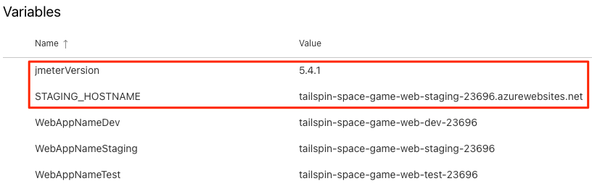

#### Modify the pipeline configuration

In this section, you modify the pipeline to run your load tests during the *Staging* stage.

1. In Visual Studio Code, open the *azure-pipelines.yml* file. Then modify the file:

**Tip**

You can replace the entire file or just update the part that's highlighted.

trigger:

- '*'

variables:

buildConfiguration: 'Release'

stages:

- stage: 'Build'

displayName: 'Build the web application'

jobs:

- job: 'Build'

displayName: 'Build job'

pool:

vmImage: 'ubuntu-20.04'

demands:

- npm

variables:

wwwrootDir: 'Tailspin.SpaceGame.Web/wwwroot'

dotnetSdkVersion: '5.x'

steps:

- task: UseDotNet@2

displayName: 'Use .NET SDK $(dotnetSdkVersion)'

inputs:

version: '$(dotnetSdkVersion)'

- task: Npm@1

displayName: 'Run npm install'

inputs:

verbose: false

- script: './node_modules/.bin/node-sass $(wwwrootDir) --output $(wwwrootDir)'

displayName: 'Compile Sass assets'

- task: gulp@1

displayName: 'Run gulp tasks'

- script: 'echo "$(Build.DefinitionName), $(Build.BuildId), $(Build.BuildNumber)" > buildinfo.txt'

displayName: 'Write build info'

workingDirectory: $(wwwrootDir)

- task: DotNetCoreCLI@2

displayName: 'Restore project dependencies'

inputs:

command: 'restore'

projects: '**/*.csproj'

- task: DotNetCoreCLI@2

displayName: 'Build the project - $(buildConfiguration)'

inputs:

command: 'build'

arguments: '--no-restore --configuration $(buildConfiguration)'

projects: '**/*.csproj'

- task: DotNetCoreCLI@2

displayName: 'Publish the project - $(buildConfiguration)'

inputs:

command: 'publish'

projects: '**/*.csproj'

publishWebProjects: false

arguments: '--no-build --configuration $(buildConfiguration) --output $(Build.ArtifactStagingDirectory)/$(buildConfiguration)'

zipAfterPublish: true

- publish: '$(Build.ArtifactStagingDirectory)'

artifact: drop

- stage: 'Dev'

displayName: 'Deploy to the dev environment'

dependsOn: Build

jobs:

- deployment: Deploy

pool:

vmImage: 'ubuntu-20.04'

environment: dev

variables:

- group: Release

strategy:

runOnce:

deploy:

steps:

- download: current

artifact: drop

- task: AzureWebApp@1

displayName: 'Azure App Service Deploy: website'

inputs:

azureSubscription: 'Resource Manager - Tailspin - Space Game'

appName: '$(WebAppNameDev)'

package: '$(Pipeline.Workspace)/drop/$(buildConfiguration)/*.zip'

- stage: 'Test'

displayName: 'Deploy to the test environment'

dependsOn: Dev

jobs:

- deployment: Deploy

pool:

vmImage: 'ubuntu-20.04'

environment: test

variables:

- group: 'Release'

strategy:

runOnce:

deploy:

steps:

- download: current

artifact: drop

- task: AzureWebApp@1

displayName: 'Azure App Service Deploy: website'

inputs:

azureSubscription: 'Resource Manager - Tailspin - Space Game'

appName: '$(WebAppNameTest)'

package: '$(Pipeline.Workspace)/drop/$(buildConfiguration)/*.zip'

- stage: 'Staging'

displayName: 'Deploy to the staging environment'

dependsOn: Test

jobs:

- deployment: Deploy

pool:

vmImage: 'ubuntu-20.04'

environment: staging

variables:

- group: 'Release'

strategy:

runOnce:

deploy:

steps:

- download: current

artifact: drop

- task: AzureWebApp@1

displayName: 'Azure App Service Deploy: website'

inputs:

azureSubscription: 'Resource Manager - Tailspin - Space Game'

appName: '$(WebAppNameStaging)'

package: '$(Pipeline.Workspace)/drop/$(buildConfiguration)/*.zip'

- job: RunLoadTests

dependsOn: Deploy

displayName: 'Run load tests'

pool:

vmImage: 'ubuntu-20.04'

variables:

- group: Release

steps:

- script: |

wget -c ftp.ps.pl/pub/apache/jmeter/binaries/apache-jmeter-$(jmeterVersion).tgz

tar -xzf apache-jmeter-$(jmeterVersion).tgz

displayName: 'Install Apache JMeter'

- script: apache-jmeter-$(jmeterVersion)/bin/./jmeter -n -t LoadTest.jmx -o Results.xml -Jhostname=$(STAGING_HOSTNAME)

displayName: 'Run Load tests'

- script: |

sudo apt-get update

sudo apt-get install xsltproc

xsltproc JMeter2JUnit.xsl Results.xml > JUnit.xml

displayName: 'Transform JMeter output to JUnit'

- task: PublishTestResults@2

inputs:

testResultsFormat: JUnit

testResultsFiles: JUnit.xml

Here's a summary of the changes:

* + The RunLoadTests job does load testing from a Linux agent.
  + The RunLoadTests job depends on the Deploy job to ensure that the jobs are run in the correct order. You need to deploy the website to App Service before you can run the load tests. If you don't specify this dependency, jobs within the stage can run in any order or run in parallel.
  + The first script task downloads and installs JMeter. The jmeterVersion pipeline variable specifies the version of JMeter to install.
  + The second script task runs JMeter. The -J argument sets the hostname property in JMeter by reading the STAGING_HOSTNAME variable from the pipeline.
  + The third script task installs **xsltproc**, an XSLT processor, and transforms the JMeter output to JUnit.
  + The PublishTestResults@2 task publishes the resulting JUnit report, *JUnit.xml*, to the pipeline. Azure Pipelines can help you visualize the test results.

1. In the integrated terminal, add *azure-pipelines.yml* to the index, commit the changes, and push the branch up to GitHub.

git add azure-pipelines.yml

git commit -m "Run load tests with Apache JMeter"

git push origin jmeter

#### Watch Azure Pipelines run the tests

Here you watch the pipeline run. You see the load tests run during *Staging*.

1. In Azure Pipelines, go to the build and trace it as it runs.

During *Staging*, you see the load tests run after the website is deployed.

1. After the build finishes, go to the summary page.

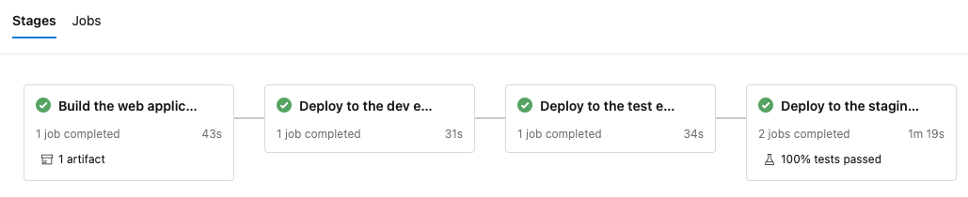

You see that the deployment and the load tests finished successfully.

1. Near the top of the page, note the summary.

You see that the build artifact for the *Space Game* website is published just like always. Also note the **Tests and coverage** section, which shows that the load tests have passed.



1. Select the test summary to see the full report.

The report shows that both tests have passed.

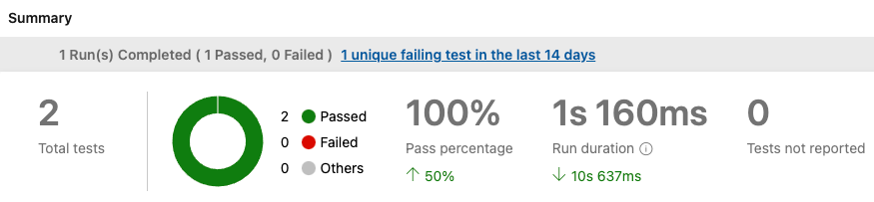

If any test were to fail, you would see detailed results of the failure. From those results, you could investigate the source of the failure.

Recall that the XSLT file produces a JUnit file, *JUnit.xml*. The JUnit file answers these two questions:

* + Is the average request time less than one second?
  + Do fewer than 10 percent of requests take more than one second to complete?

The report proves that these requirements are met. To see more details, select the **Outcome** arrow in the report. Then make sure that only **Passed** is selected.

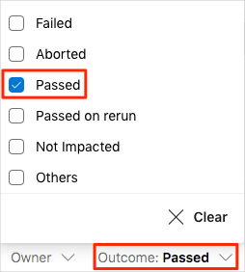

You see that the **Average Response Time** and **Max Response Time** test cases both succeeded.

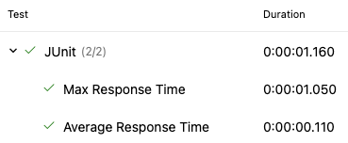

### Clean up Azure resources

Here you delete your Azure App Service instances. The easiest way to do that is to delete their parent resource group. Deleting a resource group deletes all resources in that group.

To clean up your resource group:

1. Go to the [Azure portal](https://portal.azure.com/) and sign in.
2. On the menu bar, select **Cloud Shell**. When you're prompted, select the **Bash** experience.



1. Run the following az group delete command to delete the resource group that you used in this module, **tailspin-space-game-rg**.

az group delete --name tailspin-space-game-rg

When you're prompted, enter *y* to confirm the operation.

1. As an optional step, after the previous command finishes, run the following az group list command.

az group list --output table

You see that the resource group **tailspin-space-game-rg** no longer exists.

**Move the work item to Done**

Here you move the work item that you assigned to yourself, **Automate performance tests**, to the **Done** column.

In practice, *done* often means putting working software into the hands of your users. For learning purposes, here you'll mark this work as complete because you have working load tests set up in your pipeline.

At the end of each sprint, or work iteration, you and your team might hold a retrospective meeting. In the meeting, you share the work you completed, what went well in the sprint, and what could be improved.

To complete the work item:

1. In Azure DevOps, navigate to **Boards** and then select **Boards** from the menu.
2. Move the **Automate performance tests** work item from the **Doing** column to the **Done** column.

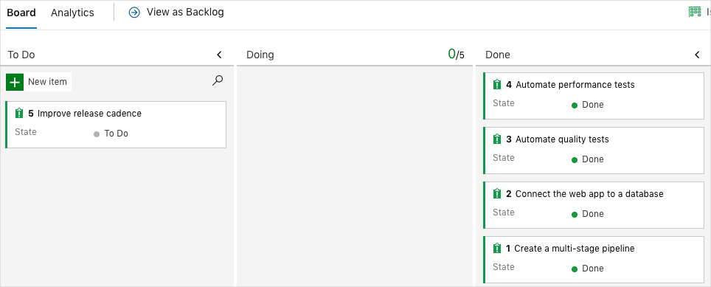

### Disable the pipeline

Each module in this learning path provides a template. You can run the template to create a clean environment for the duration of the module.

Running multiple templates gives you multiple Azure Pipelines projects. Each project points to the same GitHub repository. This setup can trigger multiple pipelines to run each time you push a change to your GitHub repository, which can cause you to run out of free build minutes on our hosted agents. So it's important to disable or delete your pipeline before you move on to the next module.

#### Disable the pipeline

Disable the pipeline so that it doesn't process further build requests. You can later reenable the build pipeline if you want to. Choose this option if you want to keep your DevOps project and your build pipeline for future reference.

To disable the pipeline:

1. In Azure Pipelines, navigate to your pipeline.
2. From the drop-down menu, select **Settings**:



1. Under **Processing of new run requests**, select **Disabled** and then select **Save**.

Your pipeline will no longer process build requests.